|  |
| --- |
| **Table of Contents**  Section 1: Introduction ………………………………………………………………………………………………… 3    Section 2: Analysis ………………………………………………………………………………………………… 3   * 1. Initial client interview ………………………………………………………………………………………. 3   2. Background information ………………………………………………………………………………….. 4   3. Secondary client interview ……………………………………………………………………………….. 6   4. Looking at the current file sharing and chatting software in the market………….... 8   5. Questionnaire and data analysis……………………………………………………………………….. 16   6. Research on compression …………………………………………………………………………………. 22   7. Research on encryption …………...…………...…………...…………...…………...…………........ 23   8. Storyboard…………...…………...…………...…………...…………...…………...…………...…………. 25   9. Objectives…………...…………...…………...…………...…………...…………...…………...…………... 28   Section 3: Design ………………………………………………………………………………………………… 30   * 1. Design overview ……………………………………………………………………………………………. 30   2. Networking model…………………………………………….……………………………………………. 30   3. Communication of data…………………………………………….…………………………………….. 32   4. Storing user details in a database …………………………………………….……………………… 34   5. Storing files in a database …………………………………………….…………………………………. 38   6. Compression (including merge sort) …………………………………………….………………… 39   7. Encryption …………………………………………….……………………………………………………….. 50   8. Storing register request …………………………………………….…………………………………… 56   9. UML class diagram of circular queue …………………………………………….…………………. 58   3.10 Generating users. …………………………………………….……………………………………………. 58  3.11 UML class diagrams for users…………………………………………….……………………………. 59  3.12 Sending and storing messages…………………………………………….…………………………. 59  3.13 File structure…………………………………………….……………………………………………………. 61  3.14 Entity relationship diagram…………………………………………….………………………………. 62  3.15 Data flow diagram…………………………………………….……………………………………………. 63  3.16 Validation…………………………………………….…………………………………………………………. 66  3.16.1 Sign-in page validation …………………………………………….…………………………………. 66  3.16.2 Register request validation…………………………………………….……………………………. 67  3.16.3 Chat page validation…………………………………………….………………………………………. 67  3.17 Structure chart…………………………………………….…………………………………………………. 69  3.17 Designs …………………………………………….…………………………………………………………… 70  3.18 Details of system…………………………………………….……………………………………………... 74  Section 4: Code …………………………………………………………………………………………………………….. 75   * 1. App.py (server)……………………………………………………………………………………………… 75   2. Compression.py (Huffman compression) …………………………………………….………… 105   3. Encryption.py…………………………………………….……………………………………………………. 113   4. User requests.json…………………………………………….…………………………………………….. 119   5. Java Script files…………………………………………….………………………………………………….. 120      1. chat_page_logic.js…………………………………………….……………………………. 120      2. Encryption.js…………………………………………….……………………………………. 123      3. File_page_logic.js…………………………………………….…………………………….. 130      4. General_module.js…………………………………………….………………………….. 134      5. Register_page_logic.js…………………………………………….……………….…. 135      6. sign_in_page_logic.js…………………………………………….…………………………. 137   6. styles.css………………………………………………………………………………………. 141   7. HTML pages…………………………………………….………………………………………………….. 147      1. chat.html …………………………………………….………………………………………. 147      2. file.html…………………………………………….…………………………………………. 151      3. register.html…………………………………………….………………………………….. 156      4. sign_in.html…………………………………………….……………………………………. 161   Section 5: Testing ………………………………………………………………………………………………… 166   * 1. Video walkthrough………………………………………………………………………………………. 166   2. Testing the sign in page…………………………………………….……………………………………. 166   3. Testing register feature…………………………………………….…………………………………….. 171   4. Testing file sharing page …………………………………………….……………………………………. 179   5. Testing register requests page…………………………………………….………………………….. 192   6. Testing chatting page. …………………………………………….………………………………………. 194   Section 6: Evaluation ………………………………………………………………………………………………… 200   * 1. Client feedback……………………………………………………………………………………………. 200   2. Future improvements…………………………………………………………………………………. 202 |

Introduction

As part of my NEA coursework, I decided to make a file sharing and chatting application for my client (Anand Vaka) after thorough analysis and gathering requirements. The following document details how I built this application and evaluated it.

Analysis

I have chosen Anand Vaka as my client for my NEA software project-based course work. Anand is working as a senior software engineer for Photobox. I decided that I could look at what he does on a day-to-day basis with his responsibilities as a software engineer and see what I can do to improve his tools so that they can work efficiently.

As of now, I have not got a critical idea of what my client does, so I decided to ask the following questions as part of client interview. This would help me to understand my client’s current responsibilities and to identify some tasks which can be automated by making a software.

**Questions**

* What do you specialise in software engineering? What are the languages that you work in primarily and the frameworks you use?
* Who do you lead in your team and how does this work, is it a small team or a large team?
* What are your responsibilities in this team?
* How do you share the code you develop with the other team members?
* How do you share files with the data compiled as part of project discussions with rest of the team to use in software development? What are all the methods you use for communication?

Above questions were then asked to Anand Vaka when I met him.

Initial client interview

Me - What do you specialise in software engineering? What are the languages that you work in primarily and the frameworks you use?

Anand – I specialise in both frontend and backend development and have been working for Photobox since 2013. Nowadays I work in many programming languages, however I do mostly use JavaScript. Other programming languages that we use include TypeScript. On server side, we use ‘node.js’ as a runtime environment to execute JavaScript code (outside of a web browser). On client side, browser is used to run the JavaScript. For frameworks we use ‘Koa.js’, this is being hailed as the next generation Node.js framework. With Koa, building different webservices like APIs becomes fun and easy since it can efficiently deal with HTTP middleware with a stack-like method. We use Git as a version control software. Amazon Web Services infrastructure is used to deploy our code and to run our application on AWS servers. We use cucumber as a testing framework to support Behaviour Driven Development (BDD).

Me - Who do you lead in your team and how does this work, is it a small team or a large team?

Anand – I am part of a team called scrum team that consists of 7 people. Each member in scrum team is responsible for delivering the tasks planned in the sprint cycle. There are multiple scrum teams working across the same project and all teams work collaboratively to deliver a common goal in the project. The total people that would work together on the website is about 200.

Me - What are your responsibilities in this team?

Anand – Well there are multiple responsibilities I have; this includes tasks related to frontend and backend application development. However, the main responsibility include delivery of all Quality Assurance functions and release management. As part of QA, I create automated tests using modern JavaScript, node.js, and frameworks like cucumber. I am responsible for creation, maintenance, and enhancement of test frameworks with the latest application functionality. Also, I perform functional, regression, exploratory and end to end tests to make sure that the latest changes are in-line with the agreed acceptance criteria. Furthermore, I take care of release management to release the software to production environment.

Me - How do you share the code you develop?

Anand – Well for sharing the code, we use a software known as GitHub which allows me to push code from my terminal to a server that my team members can access.

Me - How do you share files with the data compiled as part of project discussions with rest of the team to use in software development? What are all the methods you use for communication?

Anand - We go through the requirements received from stake holders, discuss initial design and possible solutions, and then capture them into files. The data captured in files are shared in an app called slack to discuss further with other team members. It keeps all the chat history so anyone can go back and look at previous messages.

After completing this initial interview, I researched into both his company, his responsibilities, and the general software that he uses on the internet to get more exposure. Below is the summation of this research as a background information.

Background information

Name of client: Anand Vaka

Job position: Senior software engineer at PhotoBox

PhotoBox is an online photo printing company that was founded in 2000 by Graham Hobson. They sell multiple personalised products such as photobooks, mugs, calendars, phone cases, etc. They acquired Moonpig in 2011 and since then has become the PhotoBox group. It has around 1000 employees working under its company.

Anand Vaka is a senior software engineer located in PhotoBox London headquarters. He has been working there since 2013 and has been working on both frontend and backend applications. He primarily works on a programming language known as JavaScript and, he does use other languages such as TypeScript. When working in the backend, he typically works in the framework known as Koa.js. He also uses AWS (Amazon Web Services) cloud computing where the code is deployed for the website to run.

He is part of scrum team consisting of 7 members. This is a rather small team, and so are tightly knit in the way that they work together and the software that they develop/use reaches each other incredibly fast. My client said there are multiple scrum teams working across the project with a team size of 5-7 and all teams work collaboratively to deliver the project goals. Anand’s primary responsibility covers complete Quality Assurance functions. The QA aspect has many stages to it from analysis to testing followed by releasing the software to the production environment. QA ensures that that the feature that is released is bug free and is in-line with the stake holders’ expectations. The term “stakeholder’ refers to the people or groups affected by a software development project, stakeholders exist both within the organization and outside of it. Input from stakeholders tells the company what kind of software is needed, suggesting ideas for features or problems it needs to solve. For test automation their team uses a framework called cucumber which supports behavioural driven development. He also checks if the software passes the regression tests using automated tests to make sure that the existing functionality still works and there are no unintended side effects after integrating the new features into the application.

Another responsibility that Anand Vaka has is that release management. This means that he supervises the whole project from when the idea comes to mind all the way to the day of release. This means that he sees how different bits of software goes through different teams which include design, development, the test environments, test automation, etc.

Due to the nature of the code that he writes, the software must be secure when it is sent around the teams so that it is not intercepted by some other hacker.

As he shares the software, the website he uses should have some level of encryption. He typically uses the website known as GitHub as they have secure SSH verification. The fact that they require a token to use this on the terminal, it allows for it to be much more secure due to two step verification. Also because of the size of the file, compression software must be used as it allows for there to be more files in a smaller server space.

Another piece of software that he uses is called Slack and this is where he discusses with his team about the software when working remotely (which is most of the time due to Covid-19) nowadays. This also has a secure encryption software so that hackers can’t intercept the companies’ sensitive data.

This is the base information that I gathered from talking with talking with my client. To get more information, I decided that it would be better to ask him certain questions so that I will know what exactly his problems are while writing software for his teams and what things that I can do to help him and his team. I also decided that as the project goes on, I will keep my mind open to things that I can add that will be of use to the public. Once this project is over, I am considering making any solution available to the public for free as some form of a website or application. However, my main priority will always be to make my software for my client Anand Vaka.

Getting more answers through questions

For the questionnaire, I decided to make two sets of questions that will be answered. I will use first set of questions to ask my client to get the main idea on how to structure a solution to the problem that he has. The second set of questions will be a set of questions that will be answered by general software engineers so that I can get an idea of what most people like about the current market software and how I can make any potential solution to this for both my client and later for the general software engineers.

So, for my first set of questions, it will be to my client Anand Vaka. There are multiple ways that I can take information from questions such as:

* Asking him to answer questions on a piece of paper.
* Taking a face-to-face interview
* Make him type up answers on a word document.

I settled on a face-to-face interview because of the ability to ask more questions at the interview, if there is a clear thing that he wants to improve in software. Also, previous projects that I have done, I find that a human-to-human interaction yields the best results.

First, I need initial questions that I will ask him and then, based on the answers that he will give me I will ask some more questions.  
  
Questions.

* Describe how the software used in your project is stored and how the discussions related to code development is passed to each other?
* Describe in detail the most effective features of the software and why they are useful especially for your team.
* Describe in detail the worst part of the software that you use and why it is so bad when it comes to using it with your team.
* What series of additions would you like to be added to any new software that could be made for you so that you can work efficiently?
* What is the most important addition to the software that you require?

I then went to my client and asked him these questions. Here is the transcript.

Secondary client interview

Me - Describe how the software used in your project is stored and how the discussions related to code development is passed to each other?

Anand – We use a software version control system called Git where we store the software. We use GitHub to host Git repositories. This can then be used by anyone in my team. GitHub is directly connected to my terminal using a personal access token that I must regenerate every 6 months. It is usually a big process and time consuming to use GitHub if we are trying to just upload small files which contains information from initial project discussions. We also use Slack, which is a messaging service that allows us to talk to each other effectively without delay.

Me - Describe in detail the most effective features of the software and why they are useful especially for your team.

Anand – I’d say that one of the most effective features is, ability to store and share the initial code and the project discussions with each other. I think of how easy Slack is to communicate with each other and that is what is crucial to me to work in such a large company.

Me- Describe in detail the worst part of the software that you use and why it is so bad when it comes to using it with your team?

Anand – To be honest, when it comes to pushing code to GitHub, it takes a bit of time because you must navigate through the terminal and push certain files onto the server. It is especially hard when you are a beginner and there is a steep learning curve to use git. For large files, we would use git, but for smaller files a small file sharing application that can upload files using the file explorer would work better. A small chatting application on the side along with file sharing option would make the communication between team members easier. Encryption would be a must because security is very important for the work as we are dealing with sensitive data.

Me- I understand that you want the files that are sent to be small. What would you say is the max size of these files that you want to send?

Anand- Maybe less that 2MB as those are usually the size of small programs that we send to each other.

Me - What series of additions would you like to be added to any new software that could be made for you so that you can work efficiently?

Anand – Well, to be honest there are a few things that I wanted to add to this bespoke software such as an integrated system where everyone can chat with each other, like an integrated Slack when you sign in. I thought it would be a lot more efficient as you just need to sign into one website and all the things that you need are right there, a place to upload files and a place to talk with other members of your team. Another useful addition would be a way for people to register into the website.

Me- Maybe we could create a way for a certain user with higher privilege to verify the register request.

Anand- That would be fantastic, maybe a feature where they are put into a queue and then the admin is able to make them an admin, another type of general user, or just reject them. That would be perfect for my system.

Me - What is the most important addition to the software that you require?

Anand – When uploading files, it should be simple, where the user can just select the files in the file explorer rather than the terminal. Maybe a GUI system where we can just upload and download data to our system.

Me – I understand that you were previously talking about files upload to your internal servers, I was thinking of some compression software that would minimise the space the code takes in the servers.

Anand – Honestly, that seems like a great idea. Server space is not cheap and if we just put on large amounts of data, it takes up a lot of space and so money. Any form of compression would be useful. Maybe something like Huffman Coding, but that something for you to figure out I suppose.

Me- Could you give me a proposed amount of time that you want something like this to be compressed by. Also, to test this out, maybe you could give me an example file to test the compression effectiveness.

Anand- I cannot give any files that is from my work, but I can give a coding notebook that I wrote in a text file, you could test that out. Maybe a file like this should take about 3 milliseconds to compress.

Me – That would be perfect, perhaps you could forward it to me later?

Anand- Sure thing!

Me- Thank you so much for this interview, it was very useful.

Anand – Thank you for taking up this project, you can ask any questions it the future if you want.

What I gathered from this interview

* My client wants a software where he can communicate with his team members.
* His team members should be able to upload to this website.
* There should be a form of communication between users.
* The communication should be secure.
* There should be some form of compression of the files so that server space is minimised.
* When uploading the file, it shouldn’t be like git where they use the terminal to push files but using the file explorer and other GUI options.

My client has mentioned that he uses GitHub to hoist the files he uploaded on git.

Looking at current software in the market

I decided to do some research on current available software in the market so that I can take ideas for features to add to my software.

My client mentioned about GitHub which is a web-based Git repository hosting service. Here is the investigation for GitHub.

GitHub

What is GitHub?

GitHub is a web-based Git repository hosting service, which offers all the distributed revision control and source code management (SCM) functionality of Git. It provides access control for several collaboration features such as bug tracking, feature requests, continuous integration, and task management. GitHub has over 200 million repositories. Following is the description of important features that a GitHub has.

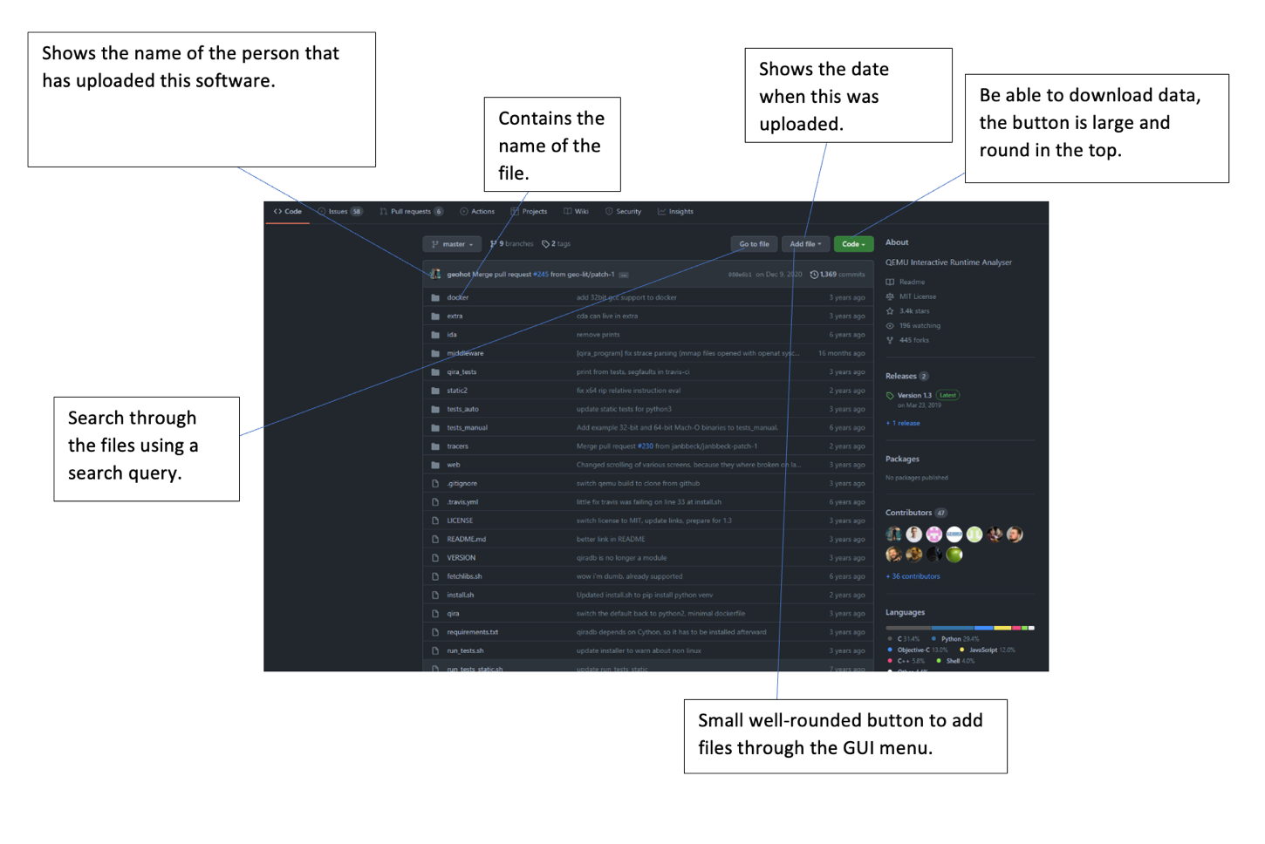

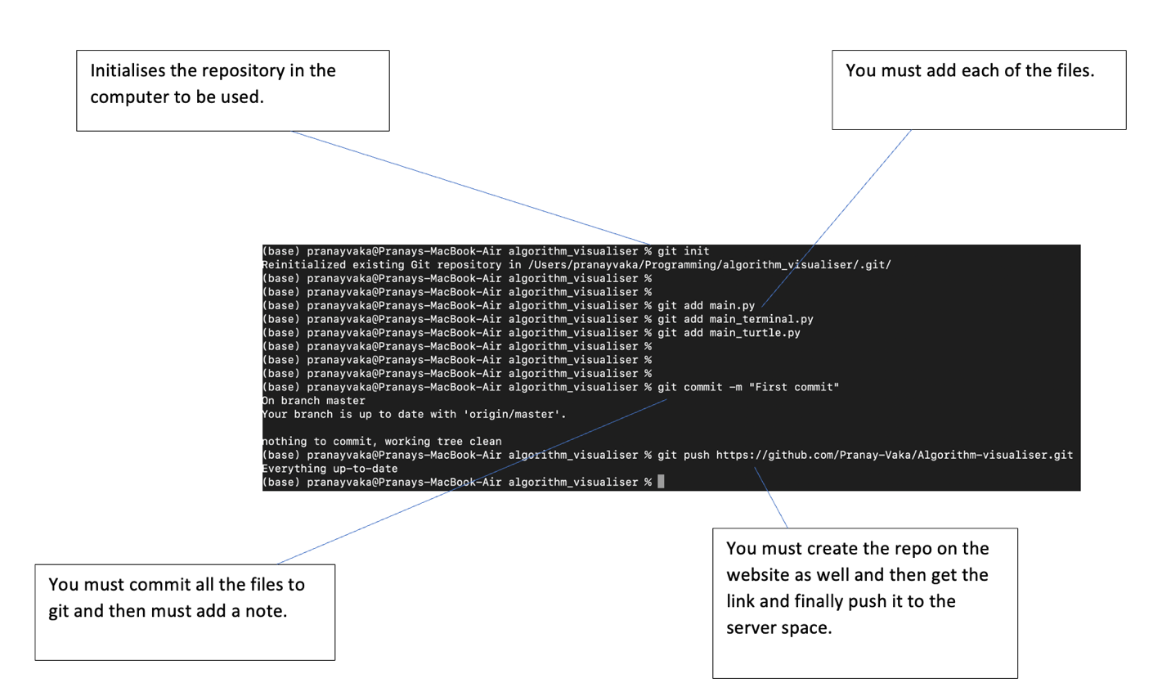Here is the command line interface that my client dislikes for uploading small files to share with his other team members.

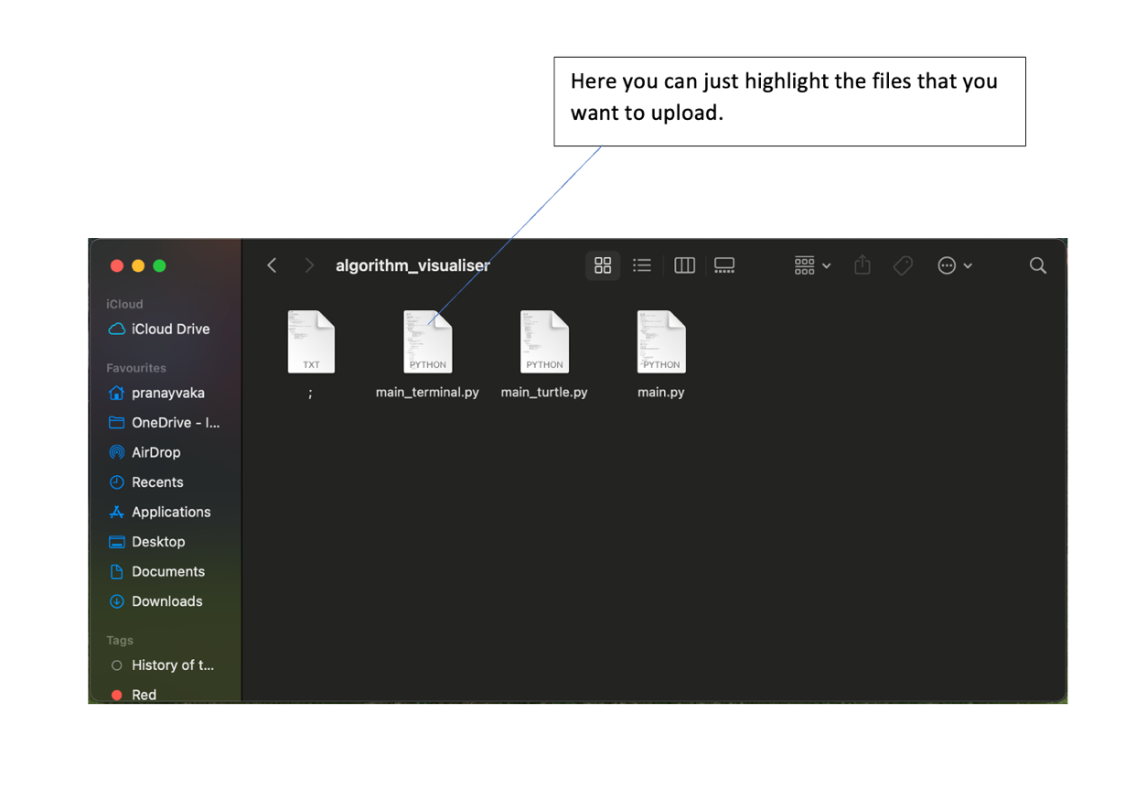  
As my client said, he doesn’t want the thing in the terminal where you must specify each of the files that he wants to upload. He just wants to select a set of files that he needs to upload. In the git version, you must initialise the repository, add the files and commit them. This entire task takes quite a long time. It would be easier to just upload the files using a simple application that contains the file explorer.

There is another application that hosts git and that is known as Bitbucket.

Bitbucket

Bitbucket is a git-based hosting platform for repositories, owned by Atlassian. It is written in python using the Django framework. It was created in 2008 by Jesper Noehr. There are many things that can be done with Bitbucket such as pull requests, pushing to the server, etc.

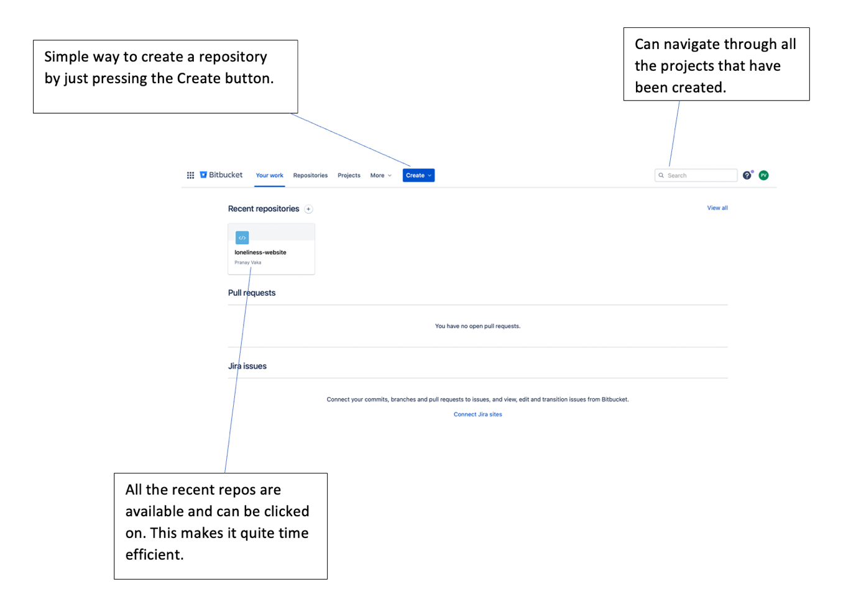

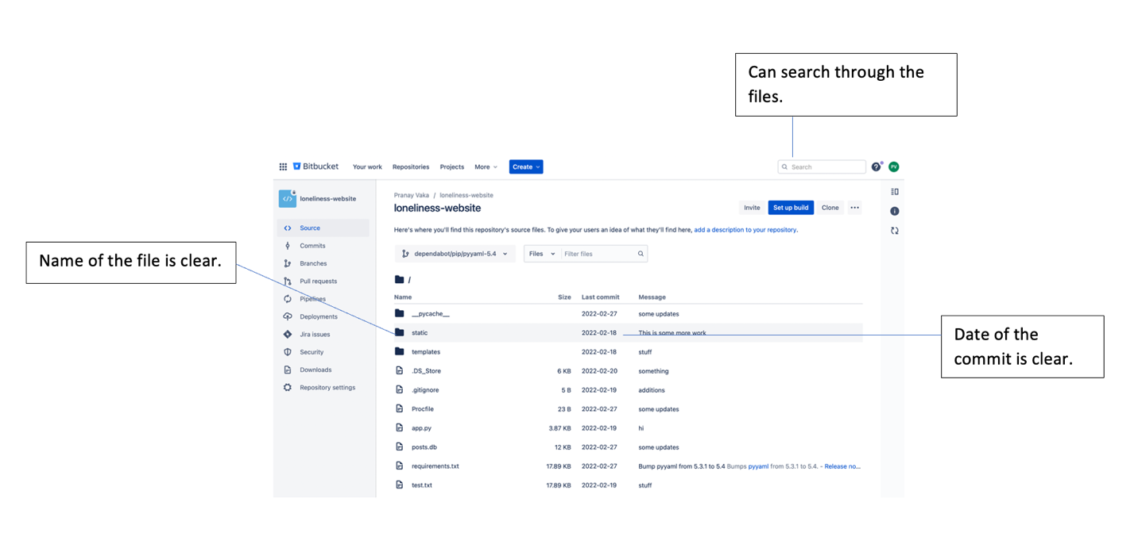

Compared to GitHub, Bitbucket seems a little more minimalistic and has less details about the repo. For example, in GitHub there were details such as the percentage of the programming languages that are used in the files. It specifies the number of people watching the repo at the time and the number of commits that are being used.

When it comes to my client and his team, I don’t think that unnecessary details such as the percentage of programming languages used will really help, but details such as a timestamp and username of person that used would help. I think I will do a questionnaire later that asks the average software engineer who uses git about what they use and what helps to increase their productivity. Because I am sending this questionnaire to many people, it will be multiple choice so that I can plot them on a chart and view them.

For the questionnaire to general software engineers, I was thinking of asking questions such as:

* How do you send files to other people in your team, through Bitbucket, GitHub or something else (please specify)?
* When you are uploading files for your teammates, would you rather use the terminal, or your file explorer?
* When you are looking at your teammate’s repos, do you like it to be minimalistic where you can just look at the basic details or where there are lots of details about the repo such as the number of people watching the repo, the percentage of the programming languages that are used, etc.

I will later expand on this questionnaire.

Messaging platforms

Slack

Slack is a messaging website that was created in 2013 by Steward Butterfield, Eric Costello, Cal Henderson and Serguei Mouarchov. It was originally created as a tool for a game known as Glitch and was later released to the public. It is usually used in the software industry to communicate effectively.

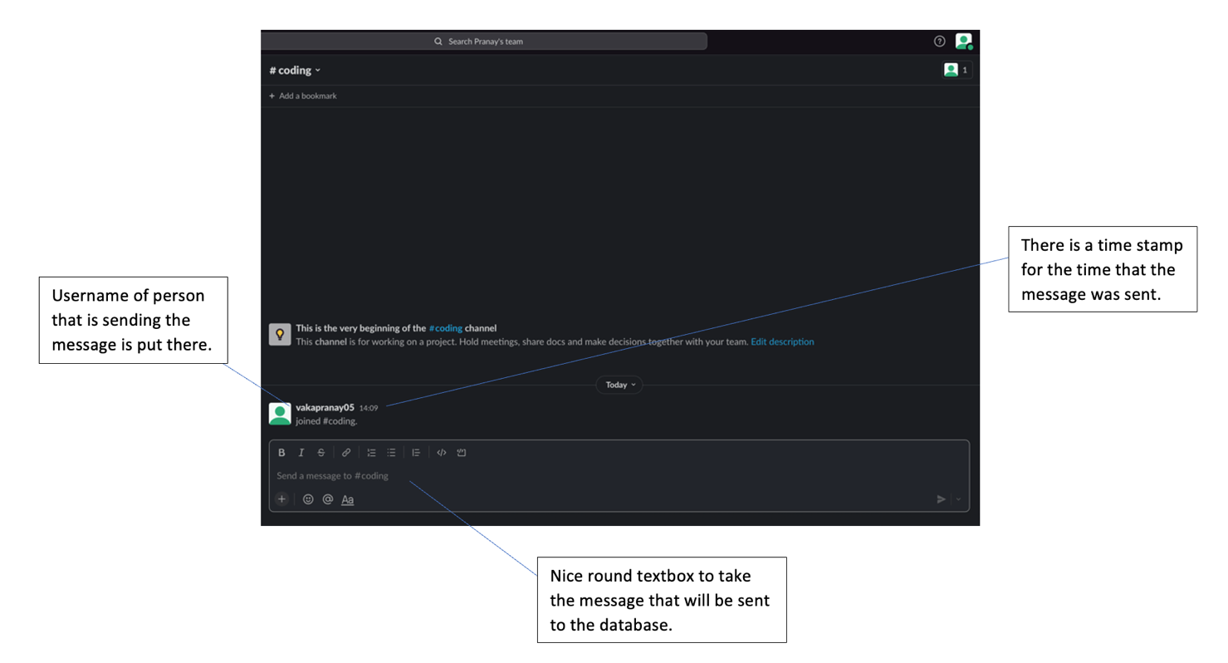

Slack has many great features including the messaging feature where they send messages to the database to store. It updates the data live for all the users those are connected. There is useful metadata that is used such as username and timestamps. This would be useful for my client as he and his team need to be able to know which user sent something and when they sent it.

Discord

Discord is a messaging service that was created in the year 2015 by Jason Citron and Stan Vishnevskiy. It was created primarily for communication when gaming but is used for other things such as studying and in software industry. It allows communication between people using a messaging service and allows quick communication.

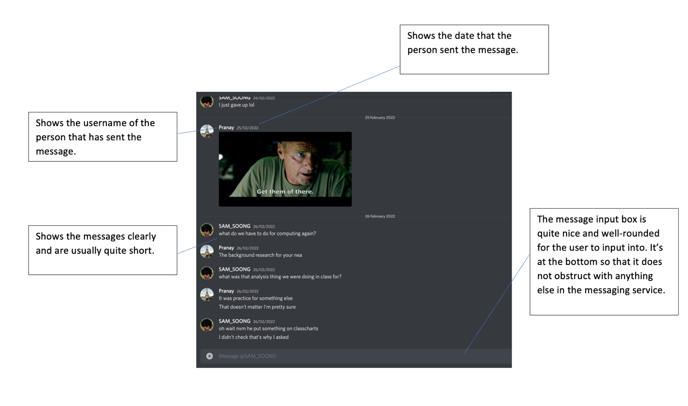

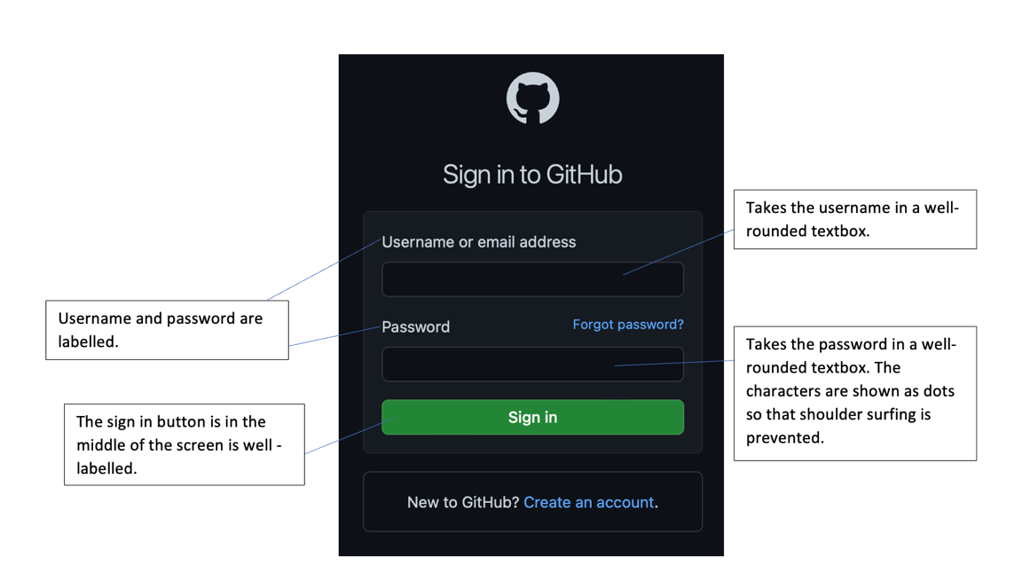Sign – in feature

From my research I have also found that the best way to create a username is with a minimum of 5 characters and a maximum of 14. This was because when I saw the different character limits, Twitter, Facebook, and Instagram had these character limits.

So, in total, from the research that I have done, I have created a questionnaire as shown beneath:

* How do you communicate with other people in your team, through Bitbucket, GitHub or something else?
* When you are uploading files to your team members, would you rather use the terminal, or the file explorer?
* When you are looking at your team members’ repos, do you like it to be minimalistic where you can just look at the basic details or where there are lots of details about the repo such as the number of people watching, the percentage of the programming languages that are used, etc.?
* Would you prefer a software application to be a website, or something you prefer to be downloaded like an app on the app store?
* Would you be willing to sacrifice speed slightly, so that you can compress files into smaller size?
* For any software that you use, do you like lighter or darker accented colours?
* When using the chat, is it useful to save the chats history for more than 3 months?

I posted these questions in social media groups in an app known as Reddit, to popular programming forums. This way, I could get data from software engineers. I then took the data from the questionnaire they filled out and analysed it to get a grasp of what the software should look like. I then analysed each pie chart and gathered some information.

Questionnaire data analysis

How do you communicate with other people in your team, through Bitbucket, GitHub or something else?

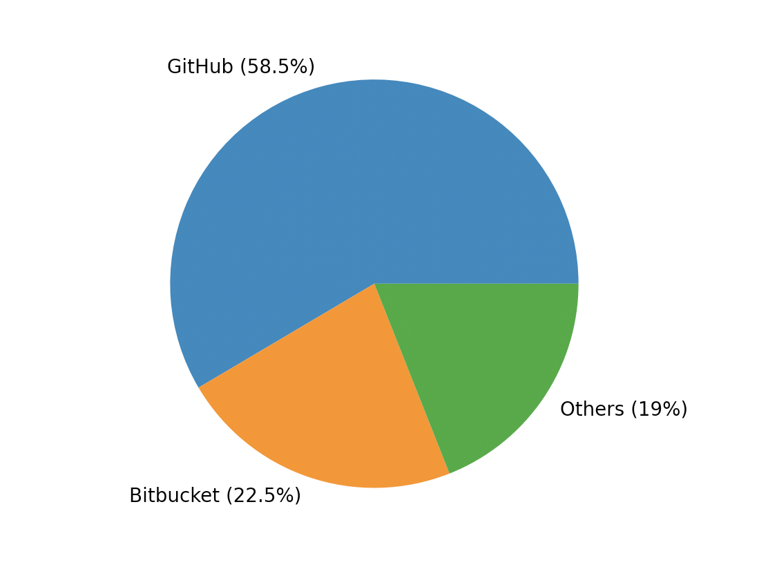

From this I can tell that GitHub is the most popular git hosting platform and then is bitbucket. I also know from personal programming knowledge that most programmers use this hosting platform. This is perfect as my client uses this software too so I can take more inspiration from this software as it seems to have great features. I will use my previous analysis of the GitHub page to factor into my design such as how the data of each of the repo is displayed (like the number of commits, description, etc.) Perhaps, it is because when the person looks at each person’s account or repo, the information is already there and so can easily be seen and therefore increases speed. However, it seems that there is still a large proportion that uses Bitbucket, and so perhaps minimalistic design is still valued as scene on how the repos are displayed. When it comes to others, they were largely software like GitLab, Source Forge which mostly looks like Bitbucket, which causes me to think that minimalistic design should be considered when making this software.

When you are uploading files to your teammates, would you rather use the terminal, or your file explorer.

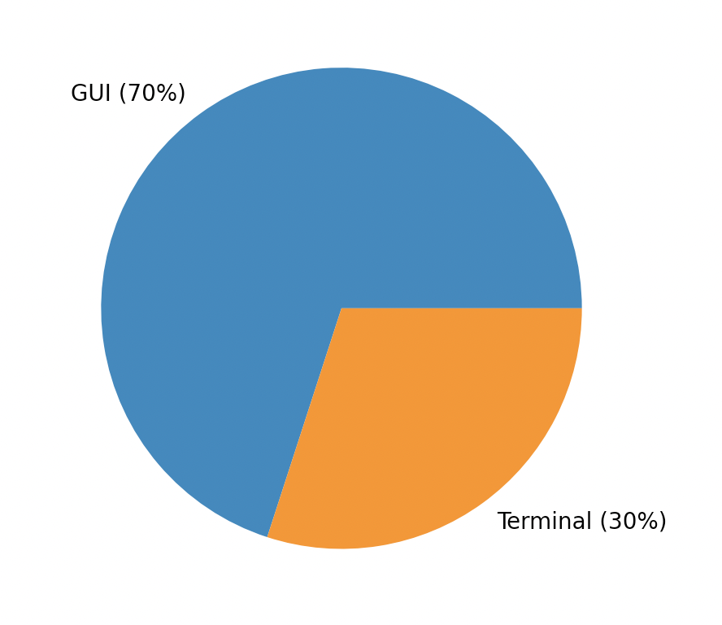

From this data, it seems that most software engineers like to use a GUI instead of a terminal when it comes to uploading files. This shows that software engineers tend to like using the file explorer over the terminal. This will factor into my project by making the file upload so that the user can use GUI, instead of the terminal.

When you are looking at your teammate’s repos, do you like it to be minimalistic where you can just look at the filename, or some more details such as who uploaded it, the date that it was uploaded, etc.

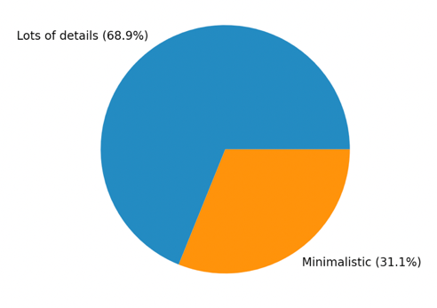

This choice of lots of details reinforces my initial point that software like GitHub is used because of the details that are clearly visible on the screen. It allows for the person to just get any information they want by just looking at the repo or user rather than clicking on certain things to get those details from the software.

Would you rather the software to be a website, or something you must download like an app on the app store?

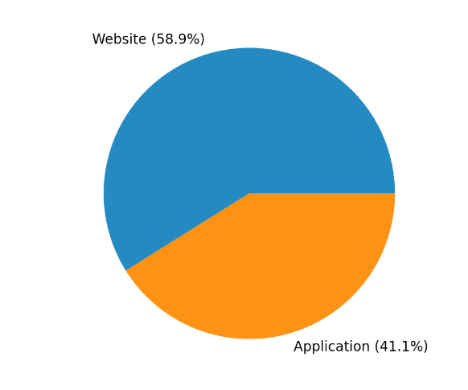

So, this pie chart suggests that most people want a website rather than an application that you must download. This one surprised me as I expected more people to want an application, as you can then use it without needing to type it into the browser every time. However, when thinking about it, it does make sense as it prevents the need to download the application and waste space. Also, a lot of companies prevent the download of apps onto company devices, so just accessing it on a browser seems easier. When thinking about coding this, I obviously need to use HTML, but rather than using JavaScript, I was thinking of using python alongside flask to make it dynamic. I can use JavaScript for what the user sees and any encryption that needs to be done on the client side. There is still quite a chunk of people that would like an application and so when thinking about what I could do after this project, I will talk about this statistic and how I could make a new version that can be downloaded.

Would you be willing to sacrifice speed slightly, so that you can compress files into smaller size?

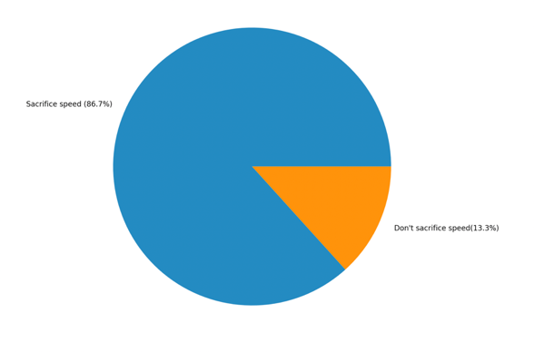

A large majority says they would sacrifice speed partially. Clearly, most software engineers understand that just a few seconds of compressing a large file could save a lot of money for the user as server space is rather expensive. I will most likely compress this file on the server that hosts all the code files and messages as this will be what they will be paying for.

For any software that you use, do you like lighter or darker accented colours?

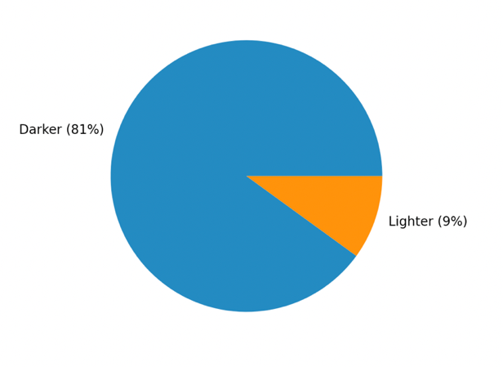

This was more of a design question and hasn’t got much to do with the software, but I asked this to get an idea of what colours I should use. Darker colours do make sense as they tend to be easier on the eyes and when seeing other programmers, they tend to have darker colours for their software like IDEs. So, this would probably be what I use for the background.

When using the chat, is it useful to save the chats history past the 3-month point?

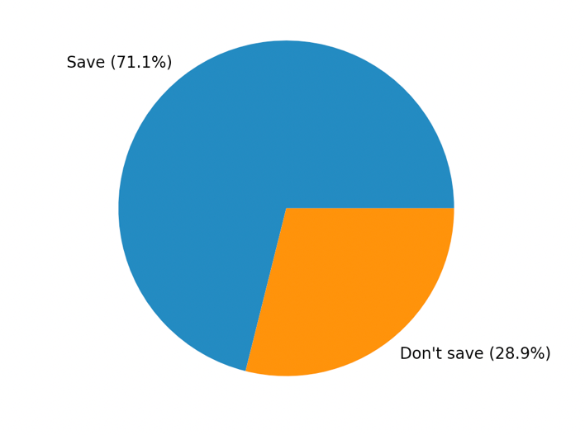

This also surprising to me as before, as we saw in the compression pie chart, people would sacrifice speed to save space, so I thought people would want to delete the messages. But then when thinking about it, for a lot of software engineers, these projects that they do could last over a year and so they could want to go back to get a reference from discussions that were done in the past. I was thinking of a way to delete the messages, but it seems that people want it all to be saved.

As I have previously said, I will factor the survey results in my design phase as I want this to also have a way of being used by general software engineers. Most of the results that I got agreed with my client and so I can comfortably use the survey results to supplement evidence in why I should include certain features.

Research on the encryption and compression methods

There are many types of encryption and compression methods that can be used. When it comes to compression algorithms, there are two types of compression which is lossless and lossy compression. In lossy compression, bits of data are lost when compression is applied to the file. It is used on photos because similar looking colours are just made the same, which is indistinguishable for the most part to the human eye. We cannot use this on files with text, as it would cause syntax errors. Lossless compression reduces the number of bits used by the file, without a reduction information in the files. This is used for files with text in them. This is what we must use for files that are being uploaded as they will be using code which is text.

Huffman coding

I got the information for Huffman coding from the Wikipedia.

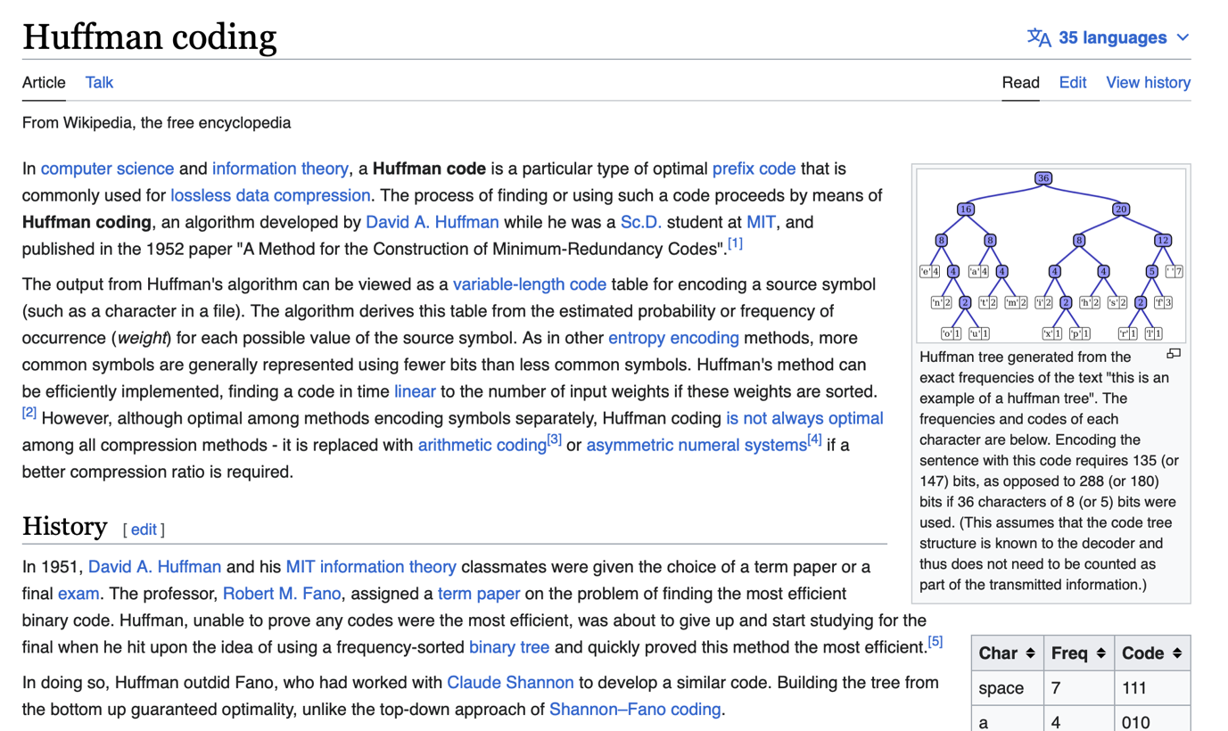

Huffman Coding is lossless compression algorithm where characters in data are organised by their frequency. They are then organised into a binary tree. The most frequent characters would be stored at the top of the binary tree and the least frequent characters are stored at the bottom of the binary tree. The is means that the more frequently used characters are stored with less bits and the least frequency used characters are stored with more bites. This takes less data to store the data as instead of using one byte for one character, it is a series of bits that is represented by the characters on the tree.

The time complexity if this is O(nlog(n)) because for each of the characters, it would take O(log(n)) time to encode them, so for all the characters in the data, it would be O(nlog(n)).

The simple process of the Huffman compression would be:

* Start with making the characters into nodes, including frequency and character.
* Put them into a list, where they are organised based on the frequency (highest frequency would be at the top of the list)
* Get the first two nodes and then create a new internal node with the two nodes while summing the frequency and the characters.
* Push that onto the list
* Repeat until there is only one node in the list, which would be the root node of the binary tree.
* All the leaf nodes would be the characters in the data.
* Get the binary representation of the leaf node characters of the characters, by traversing through post order traversal, where every time we get the leaf node, we push that code onto the list.
* We then take the data and then convert it into the binary representation.

We would take that binary representation and then store it into a database. We can decompress by using the same tree.

Encryption

Got the information for RSA encryption on Wikipedia. Here is the page.

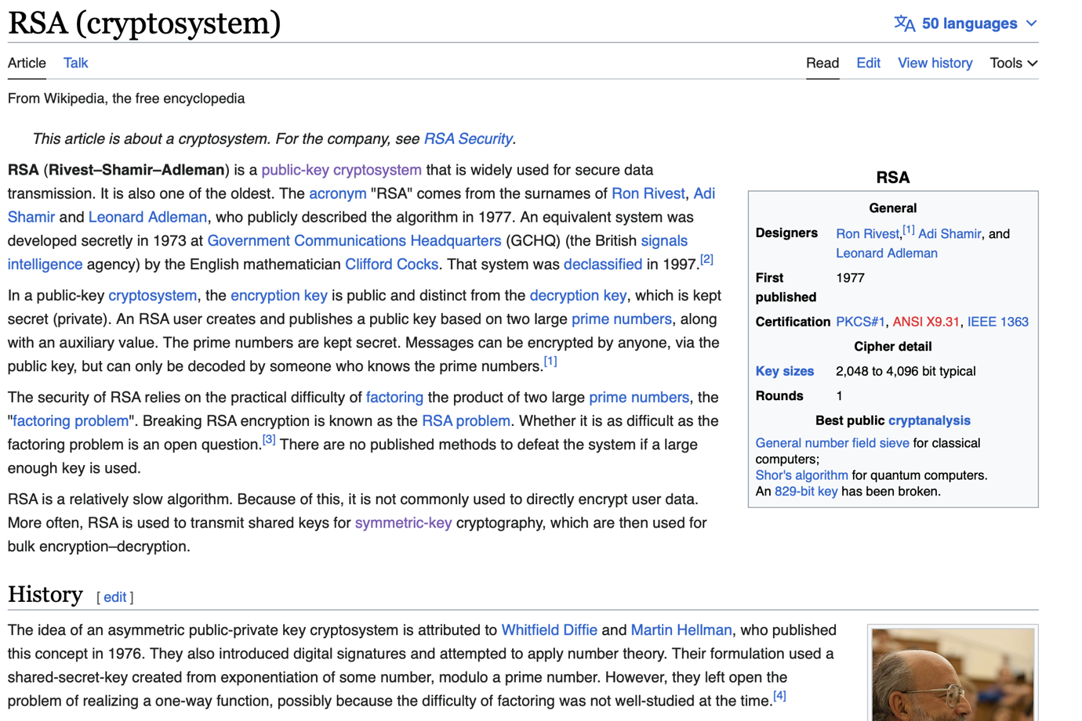

This is an asymmetric encryption method where we generate a public and private key. The private key is stored on the receiving and the sender encrypts the data through using the public key. The private key decrypts the data.

This is more secure because there is no key exchange of a key that could decrypt the data. This would make the process of sending data through the messaging service more secure. The process for doing this would be a series of mathematical steps:

* Generate two large numbers.
* Check if these are prime through a primality test. The one that is most often used is the Miller-Rabin test. This takes the number and then puts it into the following algorithm (found on Wikipedia.)

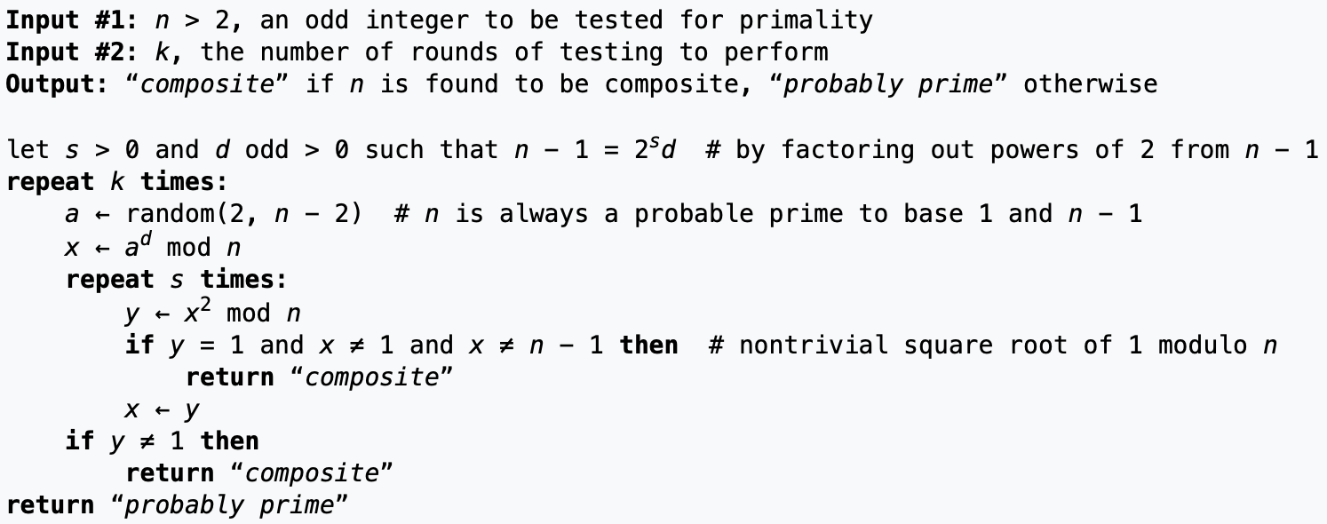

The above algorithm will repeat a certain number of times (repeats 40 times for optimal check.) and returns if the algorithm is probably prime.

* If the number is prime, then multiply then both together to get n.
* N would be part of the private and public key.
* 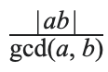We then calculate the Carmichael function by taking the totient of both p and q where the totient of p is p-1 and totient of q is q – 1. The Carmichael function is represented as:

Gcd() is the greatest common divisor of two numbers

* This value is kept secret.
* We then would choose a value e which is between 2 and the value in the Carmichael function that we calculated before. This is randomly generated and then we check if the greatest common divisor between e and the Carmichael function equals to 1. If it is 1 then it is co-prime and we can proceed with the next step, otherwise we would repeat the steps. E is part of the public key
* 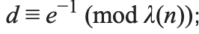Then we finally determine d by finding the modular multiplicative inverse of e modulo of the Carmichael function. This is calculated by the following equation.
* D is then kept secret as it is part of the private key.

Storyboard

I am now going to draw storyboards to illustrate the basic idea of my website. The idea and design will probably change around in the design process, but the basic concepts will remain.

Sign in page and register page.

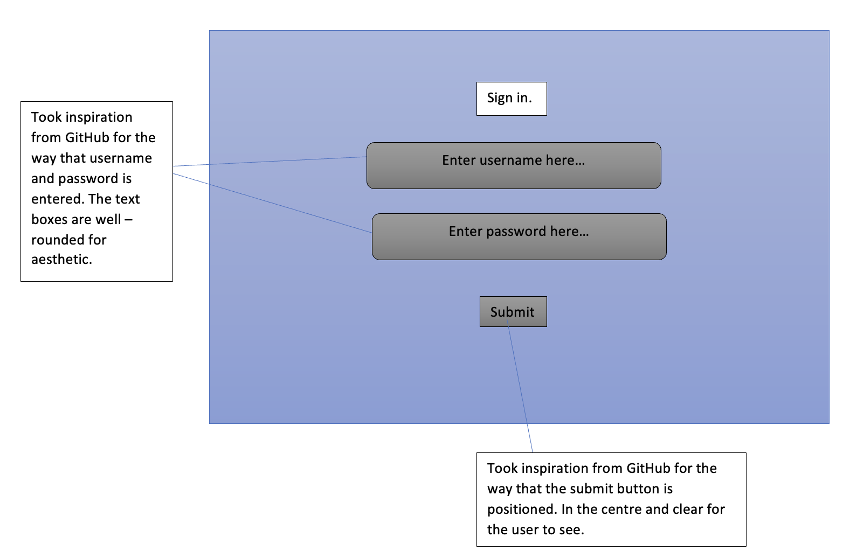

File sharing page

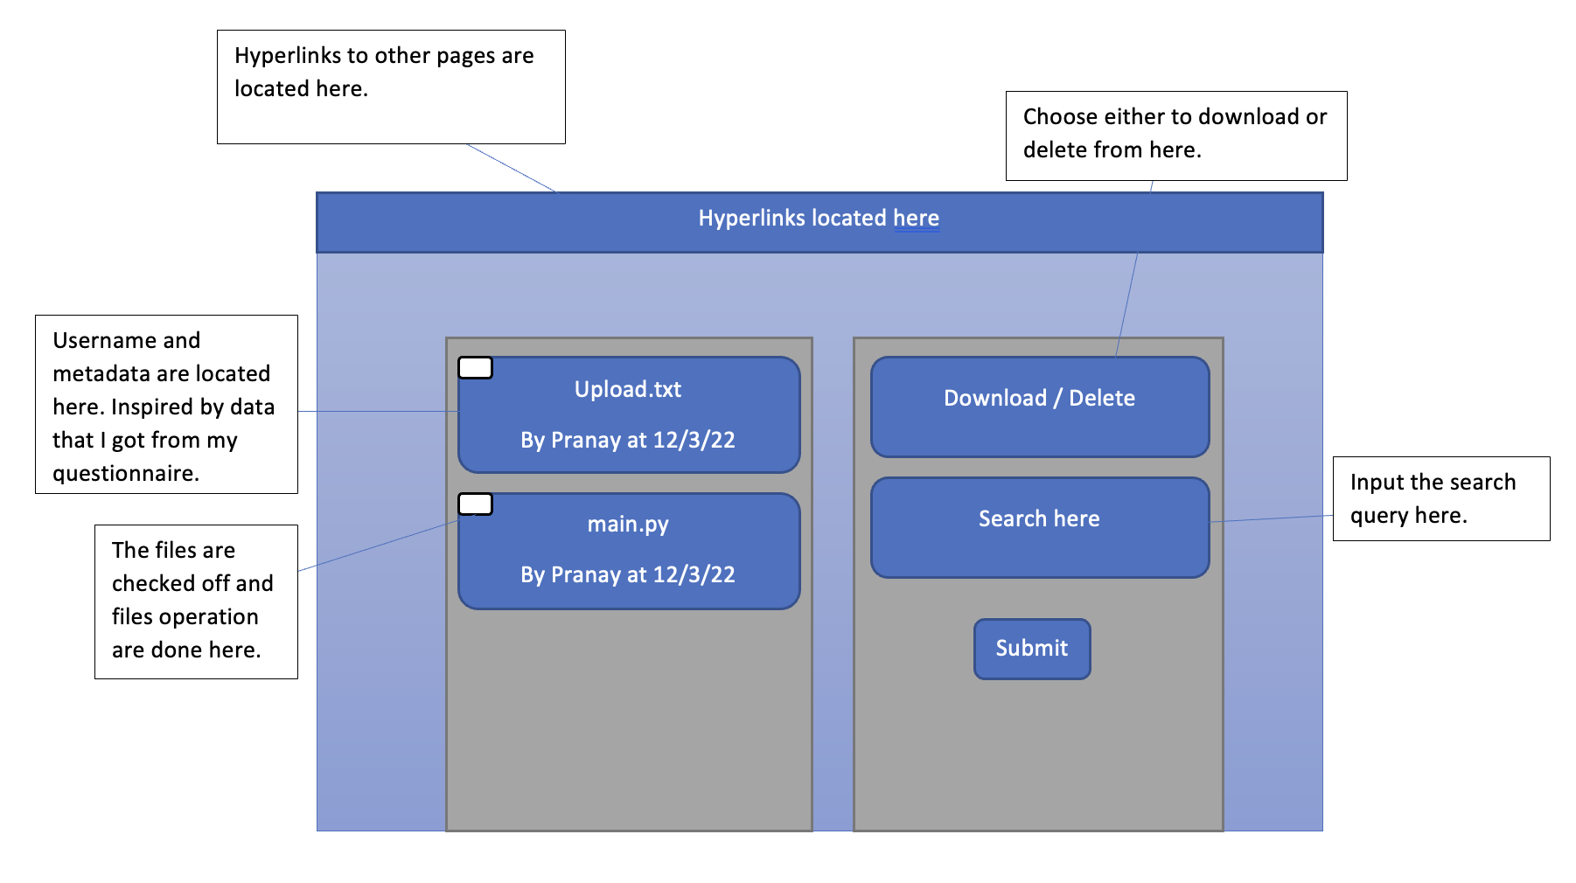

Register requests page.

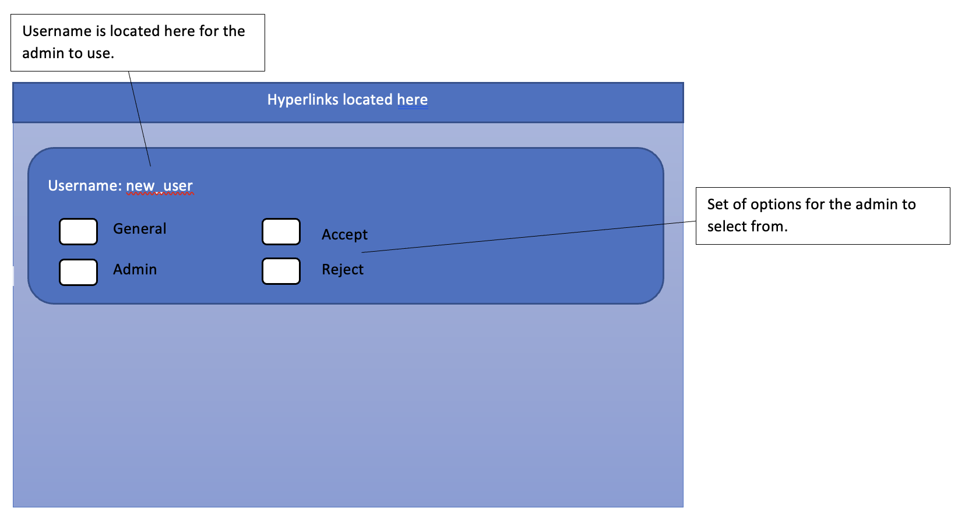All the admins can check of any of the register requests that was sent in. Here is how it was sent in.

Chat page

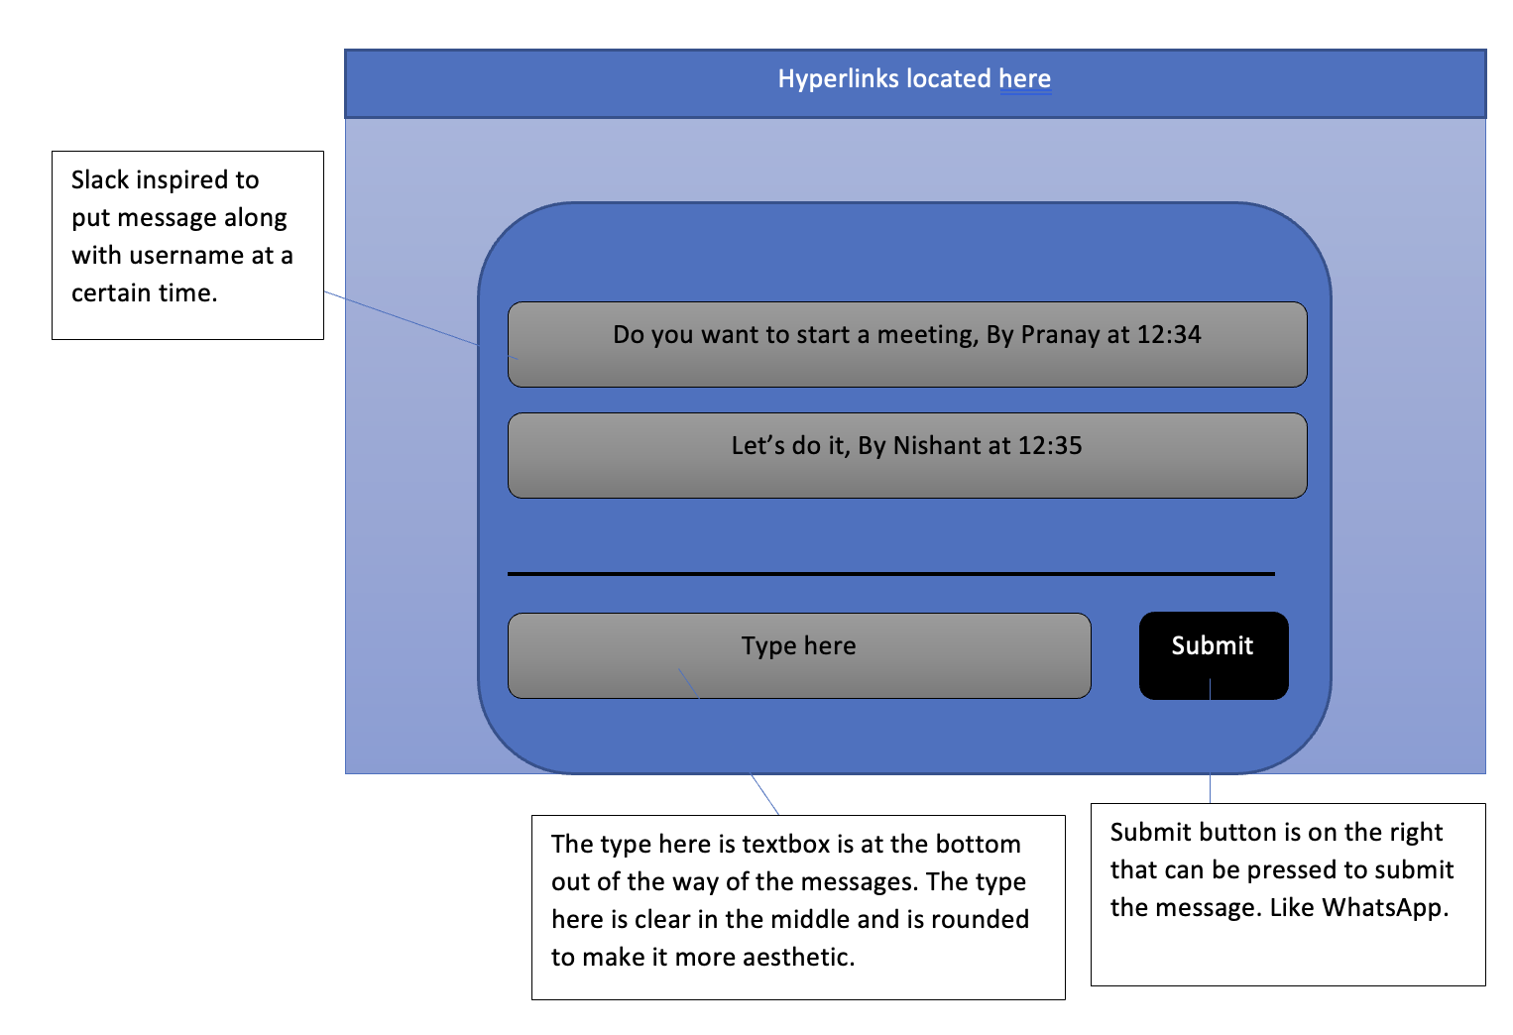

From all this information, I have decided a list of objectives that I wanted to make, based on the research of my client and the questionnaire that I sent out.

Objectives

1. Make sign in feature for the users  
   1.1) The user has username, password, and privilege.

1.2) The two types of privilege are admin and general

1.3) Use error handling to respond to the client if the username was authenticated or not

1.4) The password would be replaced by dots when typing it to prevent shoulder surfing and seeing the user credentials

1.5) When the user is authenticated then they are taken to the file sharing page

1.6) Encrypt the data that is being sent to the user

1. Make register feature for the client.

2.1) The client must enter the username and password that they want for their profile.   
2.2) The server takes the username and checks if it already exists in the database. Sends the appropriate error message if it exists.  
2.3) If the username is shorter than or equal to 4 characters or longer than or equal to 18 characters, sends the appropriate error message.

2.4) If the fields are empty or have spaces in them, then the username is rejected, and the appropriate error message is sent

2.5) If the username is unique and the password is valid then we will take the data and push it onto the register queue

2.6) If the register queue is full then the error message will pop up

2.7) Encrypt the data that is being sent to the server side.

1. Make file sharing page.

3.1) Be able to upload file from the client side

3.2) Take the data and compress it through compression

3.3) Store both the compressed file data, tree, file name, username of person who made it and date that it was made in an SQL database

3.4) Each of the files will be stored with a randomly generated id to quickly access the data

3.5) When storing the data, check if the randomly generated id exists in the database to check for duplicates.

3.6) Create a delete option for the user so that selected files will be deleted if chosen.

3.7) Be able to download multiple files, that will decompress and store the data in the file format it was found in

3.8) Search through the database based on a certain search query. For the search query, we will use regular expression that allow for as many spaces possible between letters and still will match with it.

3.9) If another client updates the server by deleting or uploading a file, change the current user’s website live so that it shows how the files have changed

3.10) Upload a maximum of 2 MB files.

1. Make chat page.

4.1) Client encrypts message using the public key that was provided by the server

4.2) Server receives message and then decrypts it

4.3) Messages stored on the database, alongside the username and time that it was sent

4.4) The chat page will update live for all the users

1. Authenticate register requests.

5.1) Admins can choose to add the user request as an admin or general user.

5.2) Admins can reject the request instead

5.3) These requests are stored in some form of a queue

5.4) Once the decision is made by the admin, it is cycled to the next user request in the queue

5.5) If the queue is empty, then show, queue is empty

1. Make general and admin user.

6.1) There is a general and admin user

6.2) The person is chosen to be general or admin depending on the choice when they are registered by the admin user.

6.3) The admin gets to accept a user or reject them

6.4) The general user gets redirected back to the file page if they try and access the register requests page.

1. Compress the file that my client sent me.

7.1) Be able to compress the file that my client sent me within 3 milliseconds.

7.2) Compressed file should take up less than 70% of the original file size.

7.3) Check if a file over 1MB can be compressed within 20 milliseconds

1. Encrypting the data

8.1) The keys that are generated need to be random every time to ensure security. This would be checked by generating keys 3 times and checking if they are random.

8.2) Make sure that time it takes to send encrypted data to the server is less than 3 milliseconds

1. Multiple users should be able to sign in at the same time and communicate at the same time.

9.1) Two users of different privileges should be able to sign in at the same time.

9.2) Two users should be able to communicate to each other at the same time in the chat application. When chat is sent from one user, it appears on the other users chat page.

9.3) When one of the users uploads a file, the other user should see the file upload on the file uploads section.

1. Make the application as web app (got this from questionnaire.)

Design

Overview

For this project, what I am going to make is the following:

* Sign in page for users

This sign in page will have a username textbox and a password textbox for the user to enter their details into

* Register feature.

This is a feature, that after validating some details will take the username and password that was entered and then will append it to the register requests queue.

* File sharing page.

This will have a way of being able to upload and download files that have been selected. There is metadata that displays the username and the date and time of when the file has been uploaded. There are checkboxes to mark the files that file operations should be done to. There is a search query button that searches through the files and returns all the files with that search query match. There is both a download and delete button for the user to choose from

* Chatting application

The users can talk to each other live without needing to refresh the page. There would be metadata for the message that is sent such as the username, the date, and the time that it was sent at. This would utilise encryption techniques so that the data that is sent will be secure. In the next pages I will discuss which of the encryption techniques I will use.

* Register requests page.

This page will only be valid for the admin users to get into. For this the admins will be able to check off users that they want to accept or reject. This is stored in the queue.

These are just the basic outlines of the things I need to have in my program. All the programs’ data structures, algorithms and a level processing are discussed in this next design section.

Networking model

Peer to Peer

There is a method of sharing data known as peer to peer. With this the data can be shared to each other and each of the users store their own data. Each of the computers have the same power as any other computer. This means that there is no one powerful computer that provides all the data. These are usually used for short networks and so are not used for big networks where there is a constant stream of data as each of the computer are the clients and we don’t expect the clients to have very powerful computers.

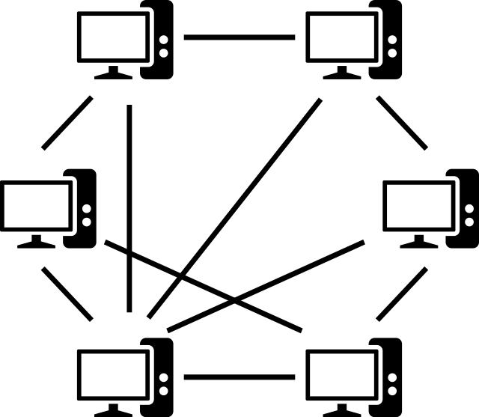

We could use this for the users to communicate to each other, but there is another version of networking known as client server model.

Client server model

This is a networking technique where there is a server which is a powerful computer that provides data to other users that connect to the computer. The complex algorithms are done to the data is done by the server and the client just shows the data that to the user and takes in commands that will be executed by the server. This can be used in both small and large networks.

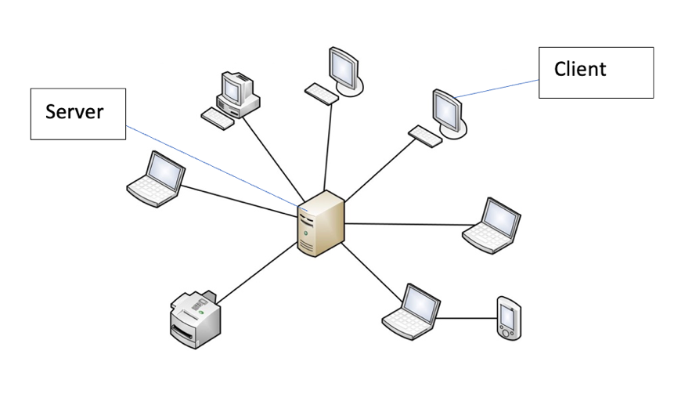

Compare P2P and client server model.

For the peer-to-peer network, it makes the process of making the network cheaper as there is no need for a powerful computer in the middle to execute the algorithms.

However, for peer to peer, the data is stored on the client’s computer which means that it could be compromised as it would not have the same security as the server. Furthermore, since the data must be stored on the users file system, it would take up a lot of their space.

The peer-to-peer model would also need for each computer to execute complex algorithms to encrypt their files and compress their data. This would increase latency and makes sharing data slower.

The client server model would overcome this as the server would store the data and since it is a powerful computer, it would execute the complex algorithms quickly and hence decrease the latency.

In conclusion, I will be using the client server model for the network due to the advantages I have proposed above.

Communication of data

For the communication of data, there are two methods that I can use: WebSocket and REST. Both use HTTP in them to talk to the receiver.

REST

For this there are the get, put, post, and delete requests. This means that there is a request and response from the server to the client. This is usually got quite a large overhead in the packets to take more data. If you want to see the updates for this data, you will need to refresh the page and see how the website changed. The data that is sent is unidirectional and is based on requests. You would also need to create a new TCP connection for each of the REST commands, which increases latency.

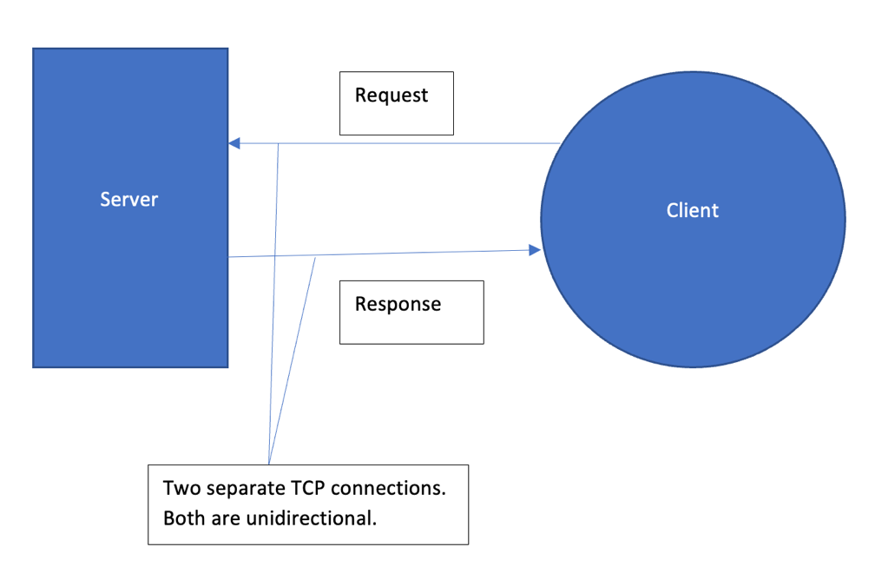

WebSocket

For this version of the data transfer, the data is shared through a single TCP connection which is bidirectional, meaning that the data can go both ways on the same connection. It uses the HTTP protocol for the initial handshake between the server and the client. This uses the concept of events to talk to each other. To send the data, JSON is used that is read on both ends as dictionaries. The user does not need to refresh the website for the data on the website to change. This uses the full duplex concept.

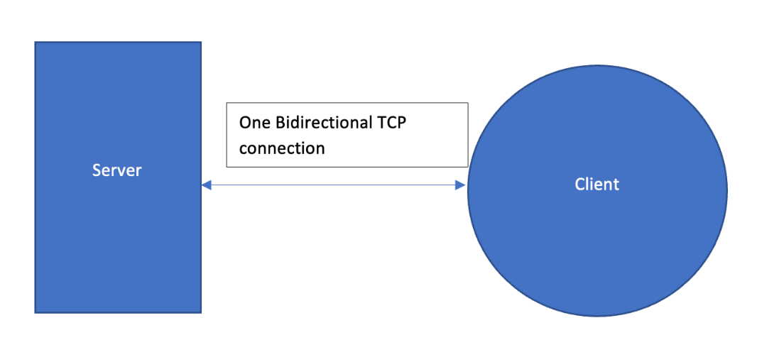

Comparing WebSocket and REST

When I see what my client wants, we see a live file sharing system, where it can be seen what has been updated and deleted to the server. We also have a live chatting system where each of the users can see what the other is saying.

If we use REST for this, then it would mean that the user would have to refresh the page to see the messages that have been sent on the room. This would be quite an ineffective way of sending messages as it should be updated in real time. The same goes for file sharing as the users should know the files that are always on the server rather than needing to refresh the page. WebSocket would mean that there would be no need to refresh the page.

Furthermore, using REST would mean that there is a new TCP connection that is created each time, increasing the latency of the website, and so slowing it down. The single TCP connection created by the WebSocket would speed this up.

In conclusion, I will be using the WebSocket as it would mean that I can update my website live and it would decrease the latency.

Storing user details in database

For the user details, there is three things that I need to store for the user. This is:

* Username
* Password
* Privilege

To store this data, I will be using an SQL database for this. This will store them in the database with usernames, password and privilege being the columns.

Initially, I decided that the columns in the database would look like this:

|  |  |  |
| --- | --- | --- |
| **Username** | **Password** | **Privilege** |
| Pranay | Pass | Admin |
| Andrew | Tate | General |
| Someone else | Qwerty | General |

With this the data would be stored without any noticeable order. This would mean that when we query through the database it would be in linear search.

Linear search

This would have O(n) time complexity where n is the number of users that are stored in the database. With this the greater the number of users the longer it would take to query the file.

For example if the database had 200 users then the best time complexity would be O(1) and a worst time complexity of O(200) where 200 is the number of users in the database.

One example of this query would be the following SQL statement:

SELECT Username, Password, Privilege FROM credentials WHERE Username = “Andrew”;

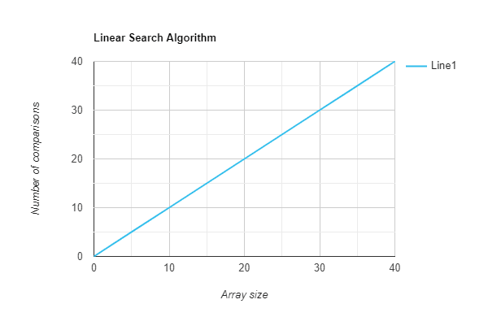

As we can see with the graph, with a larger number of users, there will be more data to look through and so would take more time to go through them. This would keep increasing and would not be feasible for large code bases.

This would mean that with larger users there would be longer query times which would make this system slow. My client says that he wants the program to work quick for large number of users (about 200). This would make the linear lookup unfeasible.

The alternative: Hash table

To have quicker lookup time I would need something with constant lookup times so that when there is a query then the database can quickly look up the database for lots of users. One example would be the hash table.

A hash table would have a constant time complexity of O(1) as it takes the username that wants to be queried, uses a hash function and then creates an output which would be the index of the credentials in the database.

First, we need to create a hash function that would take the username and output a certain hash.

For this I decided to take the username and then multiply the decimal values for them together. This would create a large integer.

Then we need to create a specific index, so we just take this large number and mod is by a prime number. We use a prime number as this would mean that the index for the user credentials would be more well distributed along the table when storing the values. The prime number that we would mod it against would be the number of indexes that are on the table. My client has decided that there should be 7 users but wants it extendable to about 200 in case more people enter the team. A prime number that is close to this is 223, so I will choose the prime to be the modulus.

Pseudocode for the hash function

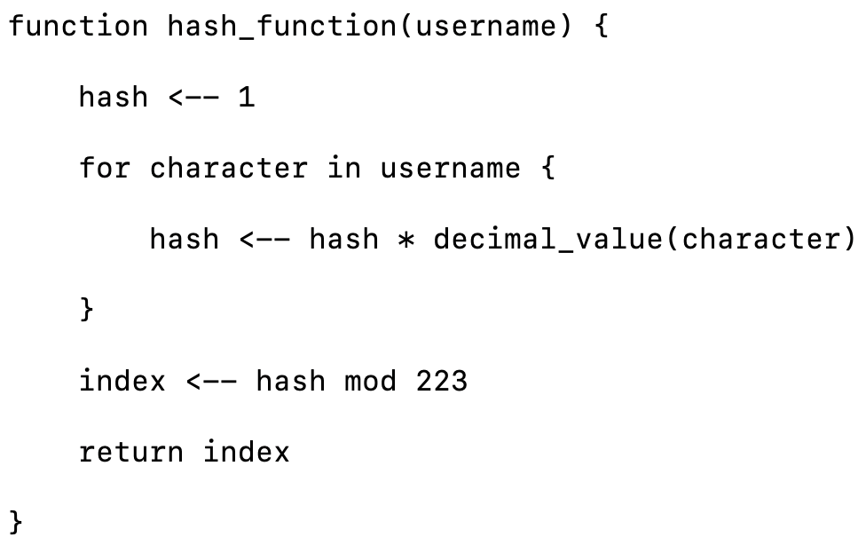

The database would store the values like this:

|  |  |  |  |
| --- | --- | --- | --- |
| Index | Username | Password | Privilege |
| 140 | Pranay | Pass | Admin |
| 152 | Andrew, Tristan | Top_g_123, | Admin |
| … | … | … | … |
| 223 | Nishant | Qwerty | general |

An example of an SQL statement to get a user file is:

SELECT * Username. Password, Privilege from credentials where index = 140

This would return back Pranay.

We can see the time complexity represented on this graph as well.

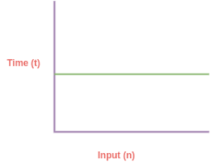

Collision solution: Chaining

However, one issue that can arise from this is that there could be collisions that when the hash function returns the same hash. To overcome this, I made each of the rows to have arrays which is known as chaining. This means that if there is a collision then it is appended to the array. If there is more than one user in the array, then there is a linear search algorithm that searches the specific username that has been queried. This shouldn’t have much of an effect of on the speed of querying as there would not have been many collisions and even if there are collisions then the array will be short. This would have a time complexity of O(n) for the number of users stored in the same array as represented by this graph below:



Comparing the two solutions

When comparing the linear search against the hash table, the hash table is clearly more efficient with its O(1) time complexity versus the linear searches O(n) time complexity. The hash table only uses the O(n) time complexity when there is a collision and even then, the length of the list in that index is typically small so would not affect the time complexity very much. However, an issue that may arise is that the hash table may take up a lot of space because of the empty space reserved by the indexes. So, to combat this we made sure that we used around the same number of indexes that my client has said there would be (he said around 200, but we used 223 as it’s a prime number and using a prime number would improve efficiency).

In conclusion we will be using the hash table as it is much more efficient.

Storing the files in the database

For the files that are uploaded to the database, we can store the file as it is in the database. This would mean that it would take up lots of space as the code files tend to be quite large. For example, if the file was about 1 MB, then the amount of data that was stored in the database would be 1 MB. This is largely inefficient and would waste precious server space. To save space, I will compress the file.

There are two methods that I am thinking of which are RLE dictionary compression and Huffman compression.

Run Length Encoding dictionary compression.

To compress data this takes the data and then where there are repeating characters, it stores the character along with the frequency. Here is the pseudocode for it.

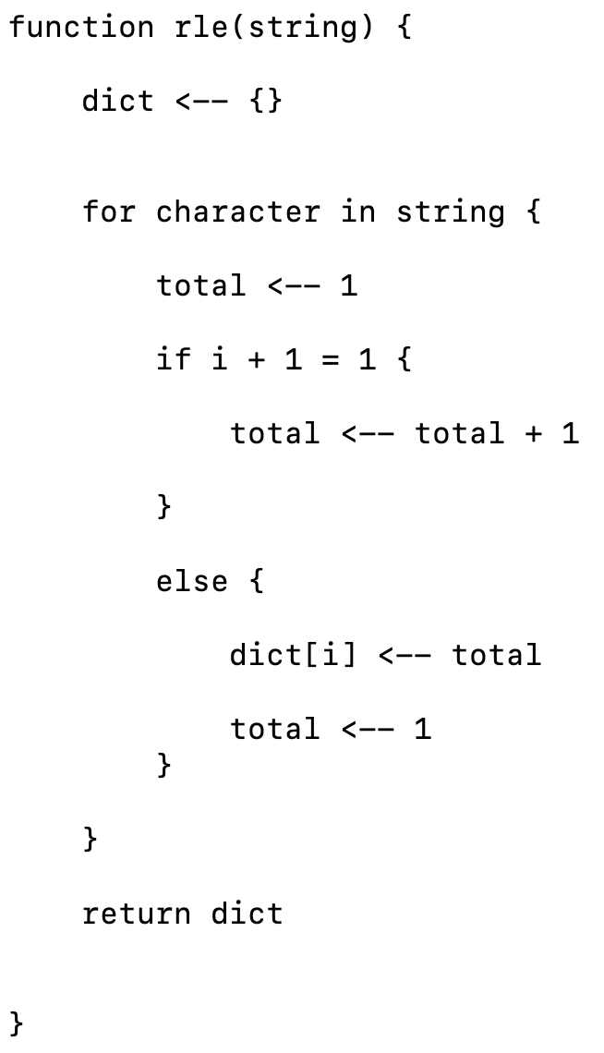

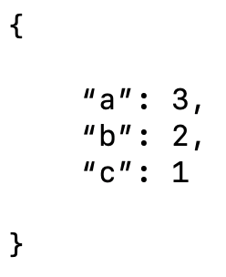The Compressed form would be:

For the efficiency, it would work better if there were large amounts of data in the string that repeat rather than variation. One example of something that would work well is “aaaaaaaaaaabbbbbbbbdddddd” as there is lots of repeated data as opposed to “abcdefghijk” as there are large amounts of variation.

For my client, his code files have a lot of variation in them as usually they are in words like print and function. These words do not have frequently repeating letters so are not good for run length encoding.

The alternative: Huffman compression

Huffman compression is a lossless data compression algorithm where the data is taken in and then stored on a binary tree. This means that the data is accessed using 1s and 0s, 1s representing the right branch and the 0 representing the left branch.

The most frequent character in the data is stored as leaf nodes near the top of the tree so that it takes less time to access this leaf node and has less bits that represent it. This would make storing the data more efficient as one character would be represented by 8 bytes but using 1s and 0s would reduce the space that it would take to store the data.

For example, this data: “aaaabbc”

Would be stored as in a tree data structure like this:

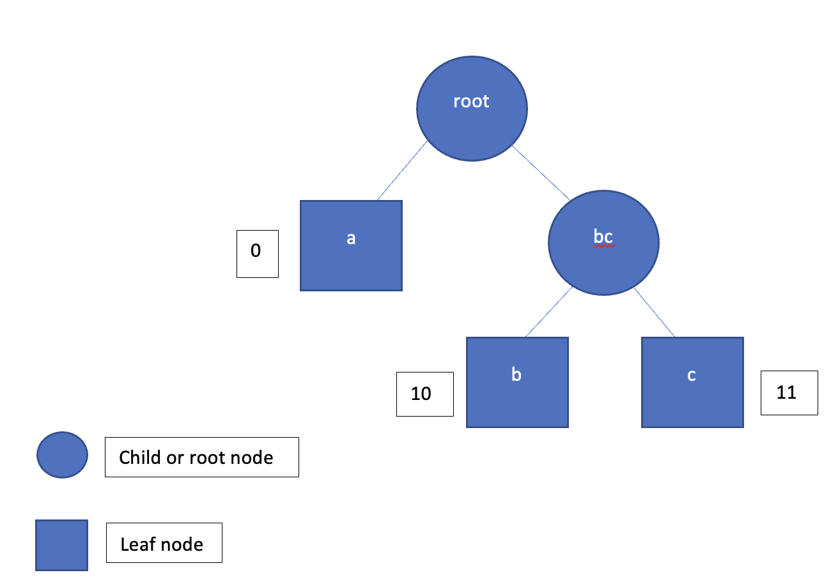

This would then be stored as 0000101011 rather than “aaaabbc”

The frequency of the characters would be represented as {“a”: 0, “b”: 10, “c”: 11}

“aaaabbc” = 7 bytes = 56 bits

“0000101011” = 10 bits

Here we can observe that the file difference is nearly 1:6. For large files, there would be about 2:1 difference between them.

Pseudocode

For the compression logic, we would first need to take the data and find the frequency of the characters in the data:

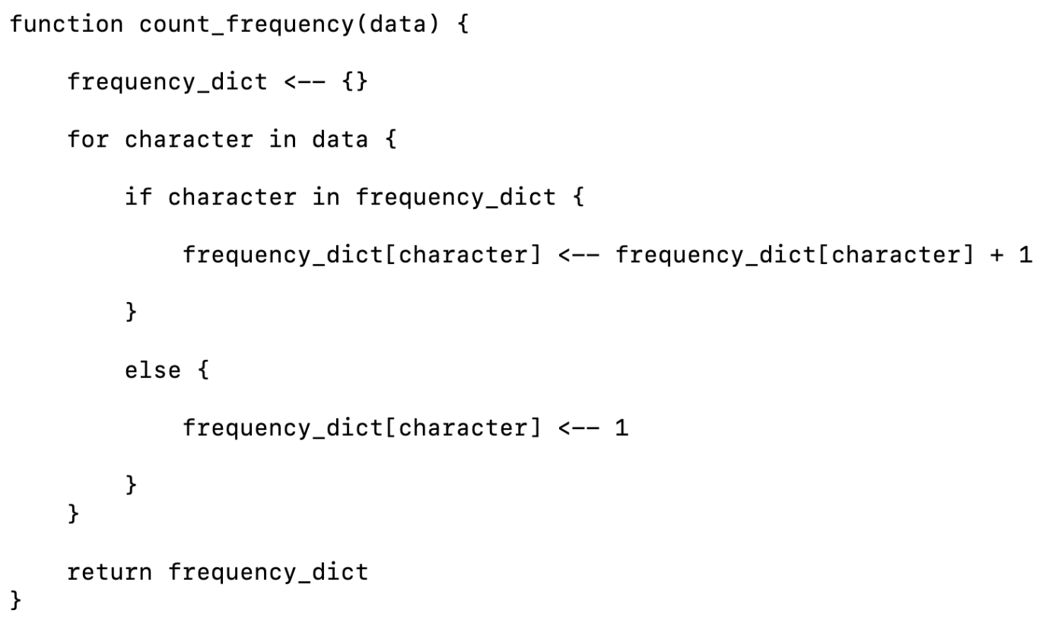

When we store the compressed data, we would store this frequency dictionary so that it can be analysed later and converted into a tree and then the coded data can be decoded.

We then need to take this frequency tree and then create a binary tree where the characters are stored. But first to do this we need to create a node that would be stored on the tree.

The node has a left and right branch that by default reads None, meaning that it does not have another nod there. We also have a check_if_leaf method as this will check if the node is a leaf since leaf nodes will have no child nodes attached to it. This will come in useful later when we check for the leaf nodes as this would be the characters that we are searching for in the tree.

Here is the pseudocode the class of such node:

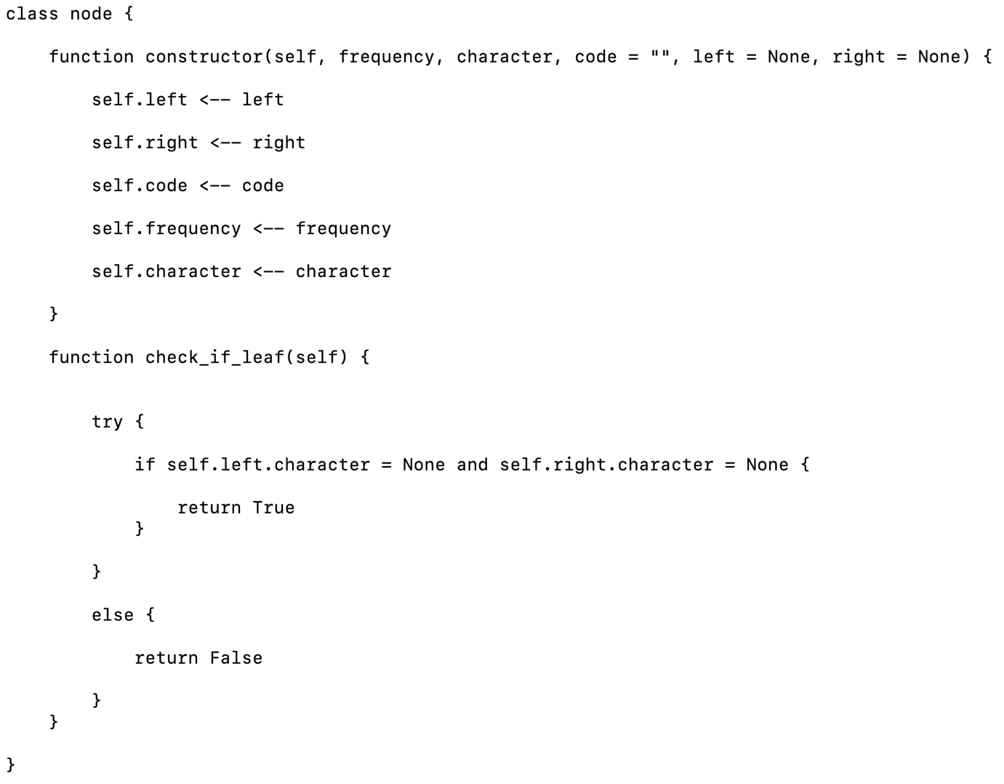

This next part of the program would take the count frequency and then create a list of nodes that added to the tree.

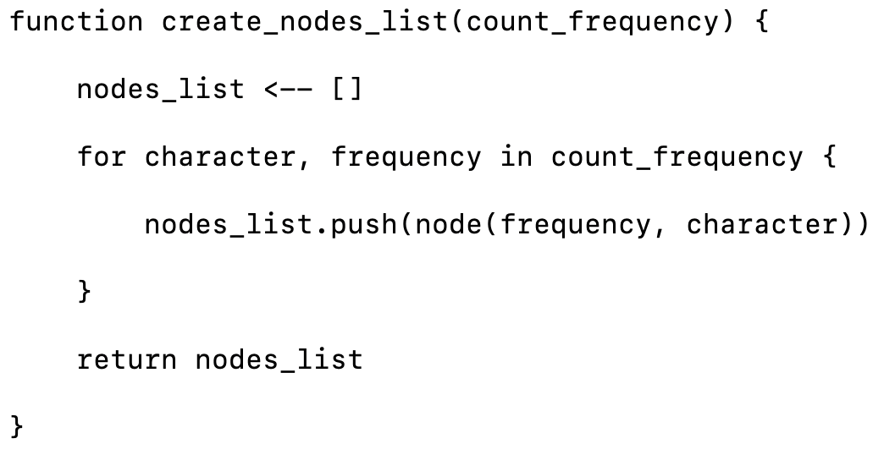

Merge sort

Then we need to write a sorting algorithm to sort the data based on the frequency. There are different algorithms that we can use, but I will choose between merge sort and bubble sort.

Then we need to write a merge sort algorithm to sort the nodes based on frequency, so that the most frequently used data is at the top of the list and so that they have less bits in the code. This merge sort algorithm is recursive to optimise algorithm at sorting the data. It does this by splitting up the elements in the list and then merging the data together based on the frequency. This has a time complexity of O(nlogn)

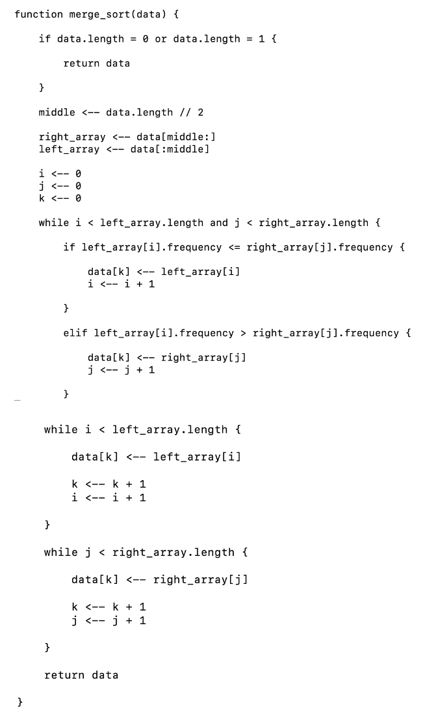

Alternative: bubble sort

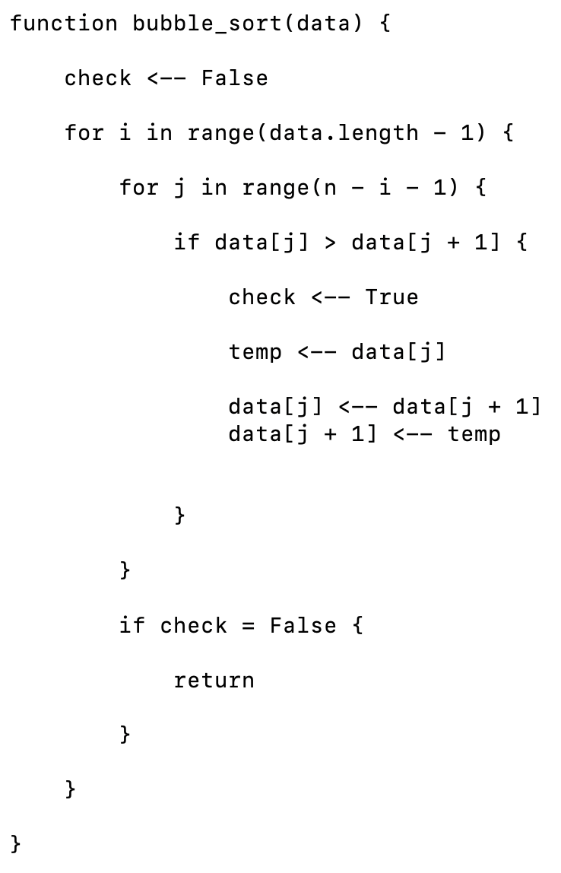

This is the bubble sort sorting algorithm. There is a comparison between two elements in the list and if the second one is smaller, they are both switched. This stops once there are no swaps made in the list.

Comparing the two algorithms

The time complexity for bubble sort is O(n2) as there are two different loops that are running nested in one another. But for the merge sort has a time complexity of O(nlog(n)) where n is the number of elements in the list. We can compare the two algorithms by the graph here.

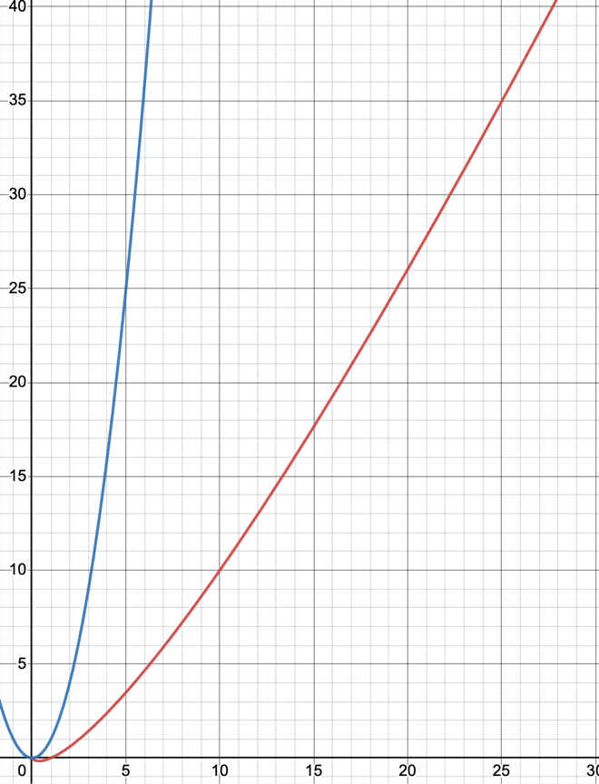

The blue chart represents the O(n2) and the red represents the O(nlog(n)). As we can see, with large amounts of data, the bubble sort takes more time (as it’s its polynomial time) than the merge sort (as it’s logarithmic time). I know that we will be working with large amounts of data, like files with lots of different characters, so using merge sort would work better. Therefore, using merge sort would be better in this scenario.

Continuation of the pseudocode for the Huffman compression

Then we would need to generate the tree that will be used for the coding of the data. To do this we would take the list of nodes that was generated and then sort them using the sorting algorithm that we have decided above (merge sort.) Then we would take the first two nodes in the list and make a new node that would be the parent of the two nodes. This will happen until there is only one node left in the list which is the root node for the entire tree. This is then traversed to generate the encoded data for the data that is to be compressed.

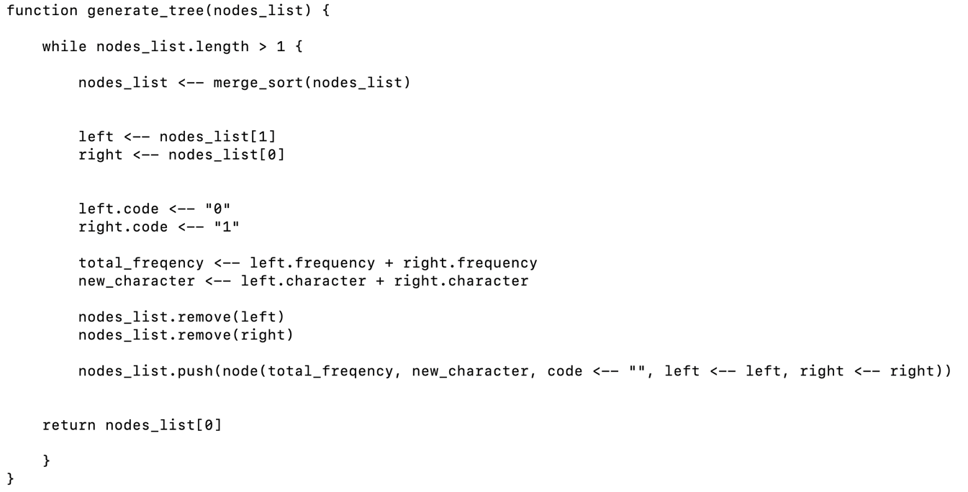Traversing the tree: Post order traversal

To convert the data, we need a function that would traverse the tree and then convert each of the characters to their representation in 1’s and 0’s. This is then appended to a dictionary and where we can return later. Here I will be using a post order traversal so that we can get the child nodes of the tree. Post order traversal is done through first going to the left node, then, if there is no left node, going to the right, and if it were a leaf node, we would append its details to the code dictionary. As this would be a character that would be represented on the list. This process is recursively done.

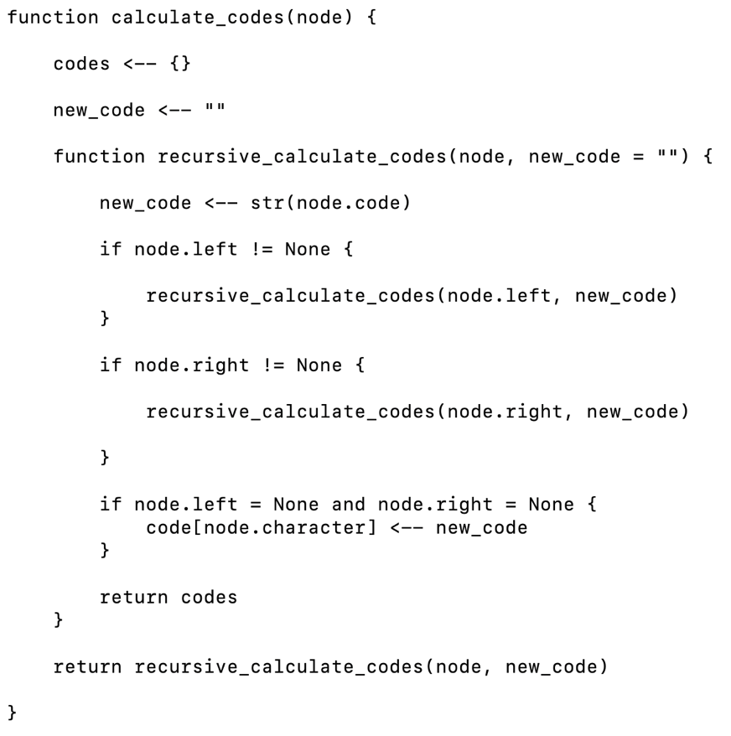

Using the coded dictionary from above, we will convert that data into a binary string. This function below represents the logic to make this. This would return the coded data that we would store into the database.

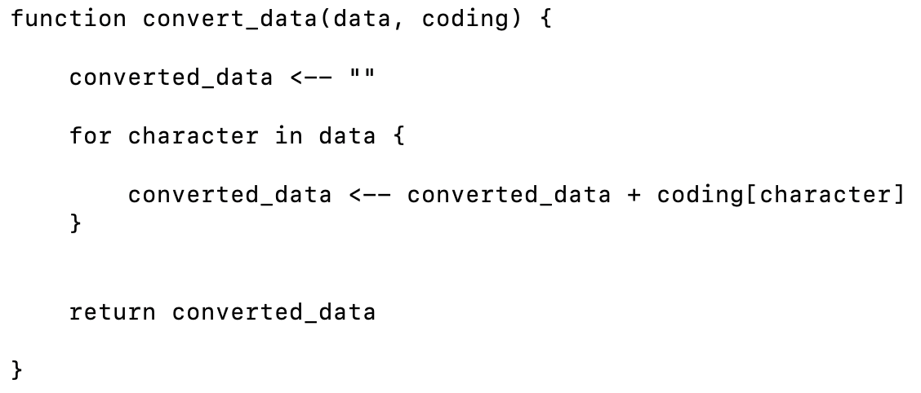

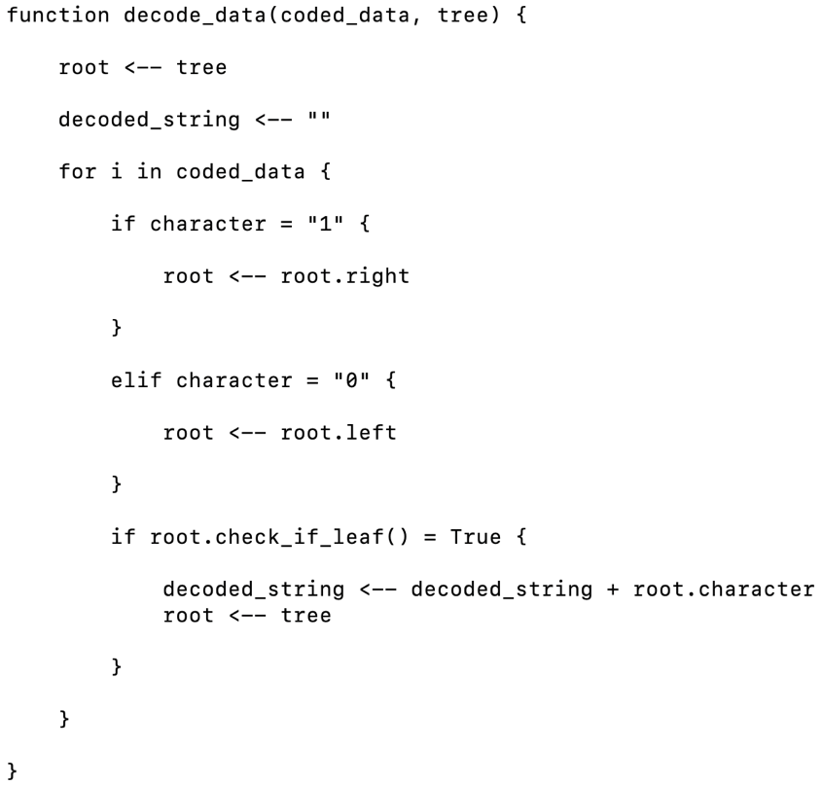Finally, we would have to write a function that would decode the data using the tree. This would require us to take the coded data and then if the value in the code is 0 then we would traverse down the left branch of the tree and if there is a 1 then we would traverse down the right branch of the tree. If the value is a leaf node, then we know that it is the character that we are looking for and we append that character to the final string of decoded data. We would then start from the root of the tree for the rest of the values.

That is the whole of the Huffman compression algorithm.

Comparing complexity of the run length encoding and the Huffman compression algorithm.

The time complexity for run length encoding is O(n) because the code iterates over the data one at a time and replaces it and adds it to the dictionary of characters.

However, when it comes to Huffman compression, it would take O(long(n)) time complexity to search for the minimum frequency in the list and if n is number of characters in the list, then it would take an overall time complexity of O(nlog(n)).

Red is the O(n) and blue is the O(nlog(n)). We can clearly see that with large amounts of data, the O(n) will be more efficient than the O(nlog(n)) so the run length encoding has better time complexity for the data for compression. However, there is much more space saved in the file when we use the Huffman compression algorithm. For my client, as we mentioned for our objectives, he wants there to be as much server space saved rather saving on time, therefore, using Huffman compression would make more sense in this case. We will test the that the Huffman compression is more efficient using the file of data that my client has provided.

Encryption

Both the sending of the passwords and the chat app will utilise the encryption so that data can be securely sent over the internet without intercept. I have discussed two different algorithms that I can use here and shown which one is the better to use.

First algorithm: Caesar cipher

Caesar cipher is a type of encryption algorithm where there is a shift value for the characters in a list, so that when you encrypt the data, each of the characters are shifted to the corresponding letter down the ascii table.

For example, here is the pseudocode:

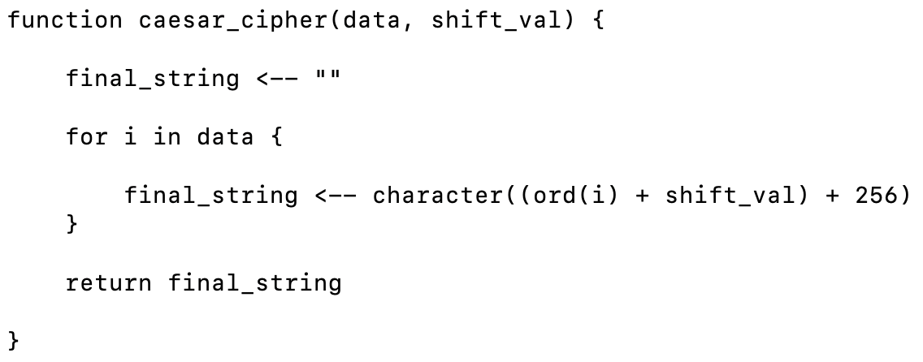

This will shift the values by the parameters that is specified, so if we use caesar_cipher(“abc”, 2)

Then it would return ‘cde’ as the output. For the recipient to decrypt the data, we must send the shift value (the key) one time over the internet. This is known as the key exchange. Because there is only one key, this is known as symmetric encryption. This would be much weaker than the alternative, which is asymmetric encryption. This would make it very insecure as anyone can just intercept the key and decrypt the messages. Also, the Caesar cipher is quite simple to decrypt compared to the alternatives, even if it is symmetric encryption.

The Caesar cipher has a time complexity of o(n) where n is the number of characters in the data.

Alternative: RSA encryption.

The RSA encryption algorithm is an asymmetric encryption algorithm.

Asymmetric encryption has a public key and private key (which are mathematically related) that is generated on both the sender and recipient. There is only the key exchange of the public keys, which can used by anyone, and the private key is stored on the user which cannot be sent anywhere.

To send the data securely to either side, the public key of the recipient is used to encrypt the data and then this encrypted data is sent to the recipient. The recipient can then take this encrypted data and then decrypt it by using its own private key. This makes encryption a lot more secure as suddenly, there is no key exchange where the sensitive keys are vulnerable to intercept.

One of the most widely used encryption algorithm that is used is known as the RSA (Rivest-Shamir-Adleman) encryption algorithm. This uses the public and private key method that I have specified.

To use this, we would have to generate two large prime numbers, we can do this by randomly generating a value and checking if it is prime. First, we would generate a random prime number with a certain number of bit length:

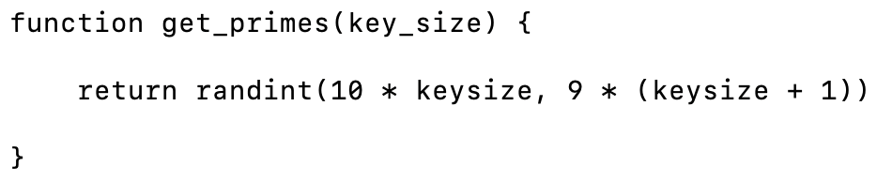

The we would need to check if the numbers are prime by using prime number checker. There are multiple algorithms to use, such as the Baille-PSW primality test and the Miller – Rabin test.

Here we will use the Miller Rabin test, which will return if the number is composite or prime. For the more efficient version of the algorithm, we will use the version that will return if the number is highly probable prime or composite. If we used the method where the prime was 100% guaranteed to be prime, it would have a time complexity of O((log n)4)

The time complexity of the Miller Rabin test if we use the probabilistic test, it would have a time complexity of O(k log3 n), where k is the number of times that the test is done to check if the number is actually prime. The probabilistic test for the Miller – Rabin test is theoretically quicker than the deterministic miller – Rabin test so that is what we will be using in this case.

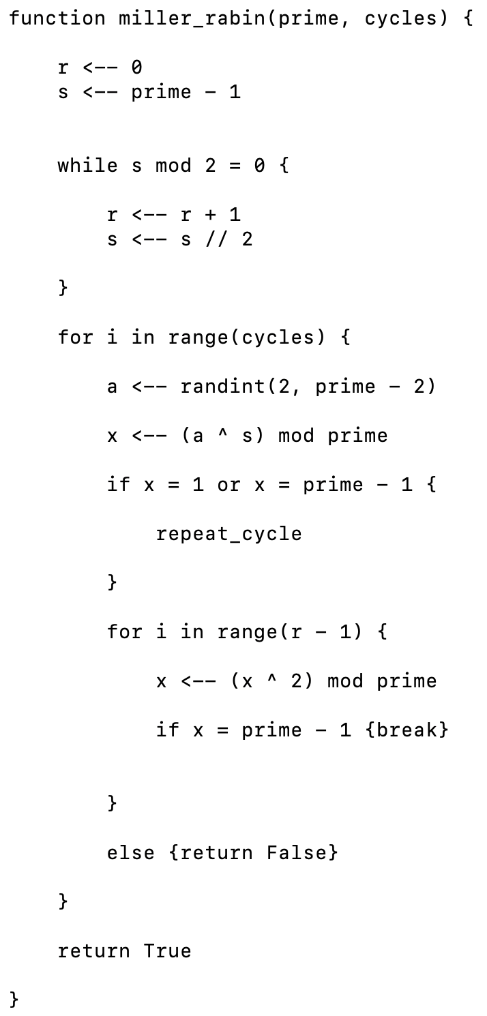

Before we check if the value is prime, we check if the number is factors of low primes, because this low _prime test will take much less time. If we check and in the low primes and it doesn’t return that it is a factor, then we do the miller-rabin test, which takes longer. The low primes test is O(n), where n is the number of low primes in the list.

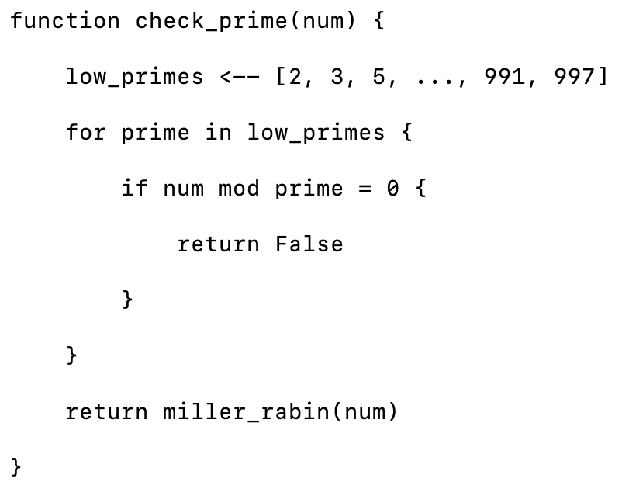

Now that we can generate large prime numbers, we must use this to generate two large prime numbers p and q, which will then create N which is the multiple of the two values which we will call the prime_product. We will then get phi(n) of the two values using the totient formula: (p - 1)(q – 1)

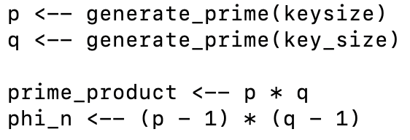

Then we need to take the generate a random public key with the same key size as the values that we generated before and check if its coprime to the phi(n) that we calculated from the totient before. To check if they are co-prime, we will make a greatest common divisor function and if the greatest common divisor for both is 1, then it is co-prime. If this is true, then the randomly generated value will be the public key that everyone will use on the client side to encrypt the data.

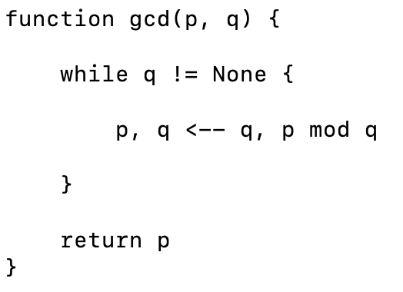

To generate the private key, we will need to take the public key and the phi(n) that we generated and find the modular inverse of the values. This is done through using the following algorithm.

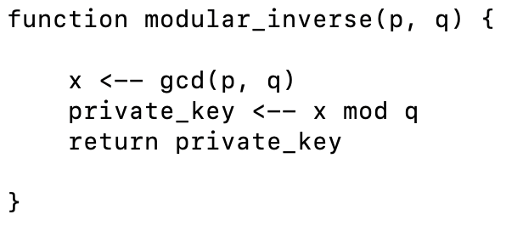

Then with this the private key is returned. This stored safely on the server where no one else can see it.

Then we need to be able to encode any data that comes in on the client side. To do this we have to calculate the decimal value of the individual characters in the string and then find the modular exponent of the decimal value with the public key and the prime product.

((char ^ public_key) mod prime_product).

Here is the pseudocode for this.

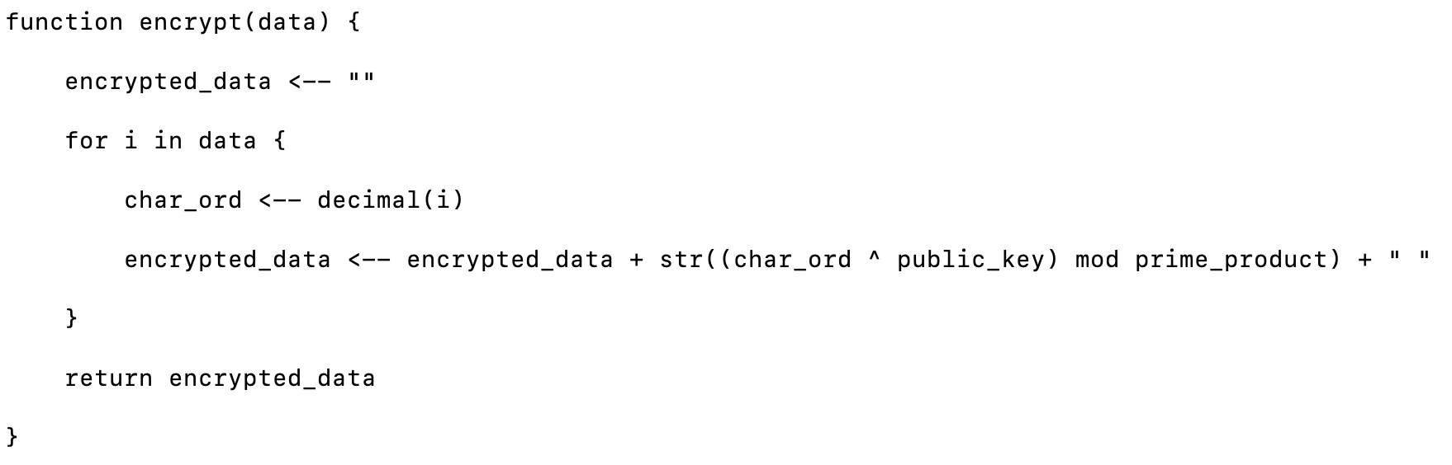

This would have O(n) time complexity where n is the number of characters in the string.

Finally, we would have to be able to decrypt the data through a function. This uses the same concept as the encoding, but instead we would take the data and then find the modular exponent using the private key instead of the public key.

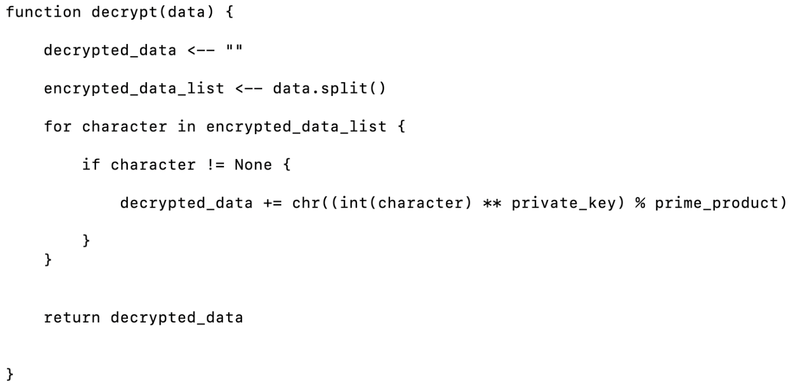Here is the pseudocode for this decoding function.

This also has a time complexity of O(n) where n is the number of encrypted characters in the list

Comparing the Caesar cipher to the RSA encryption algorithm

When we compare the Caesar cipher to the RSA encryption algorithm, we can compare the security of both the algorithms together. For the Caesar cipher, it is known as symmetric encryption where there is only one key (the shift value) that is used to encrypt the data. The first vulnerability in this is the fact that we would need to send the key over the internet which is vulnerable to intercept by hackers. They can then take this key and then easily decrypt the encrypted data that was sent over the internet. Even without key, it is easy to decrypt the data by using frequency analysis as we know that certain characters appear with a certain frequency in sentences. By figuring this out, we can then now which character corresponds to this and once we have found out the shift value for one of the characters, we have found the key.

However, RSA encryption overcomes the problem of hackers intercepting the data as only a public key is shared, which you can only encrypt data through, not decrypt. The private key is then stored on the server and is not shared to anyone, so no one can intercept the key and decrypt it. Therefore, it is much more secure to use the RSA encryption algorithm.

How to store the register requests

There are going to be some register requests that will be stored. This will be stored into a queue that is stored for the admin users to be able to tick off to authenticate and add to the database of credentials (the hash table.) For this we would need to create a type of queue. I have decided to make a circular queue with a fixed length. This means that there is no wasted data as with a normal queue, the list just gets indefinitely longer, clogging up space in the server. We also don’t allow for many people to register at once so that there isn’t a huge number of users that are on the server. If there are lots of people applying at one, a lot of the space on the server would be used up, so making a queue of a fixed length would mean that only a given amount of people can apply.

Below is the pseudocode for such a data structure. This would be encapsulated into a class as the queue constantly changes. We should always encapsulate what varies.

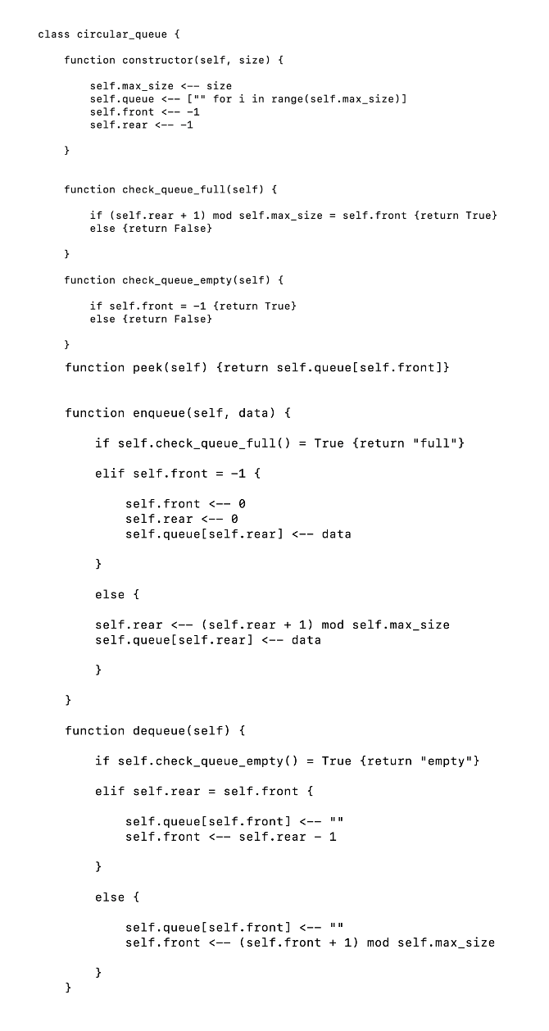

UML class diagram of circular queue

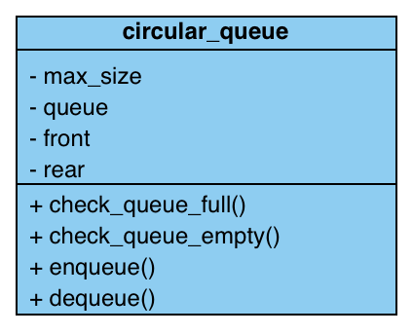Both the enqueue and dequeue will have a time complexity of O(1) as we only need to add or remove one value to the end of the queue and we already know that place since we have a pointer pointing to that memory location.

Generating users

I have decided to make two different types of users: Admin and General. The admin user will be able to authenticate any of the register requests that are sent in, so only the admin has the decision when it comes to storing users. The general user will not have this kind of privilege. I have encapsulated both types of users into their own classes as there would be many different types of users that are connected to the server at once. If something is repeated, then we will encapsulate this into a database.

The admin would be inherited from the general user. The general user would have the basic methods and properties: the username, and the privilege for one. For the methods there are the get username, get privilege, and set username and set privilege. The admin would be inherited from the general user and would have more of the functionality for being able to manipulate the register requests.

UML class diagrams for users

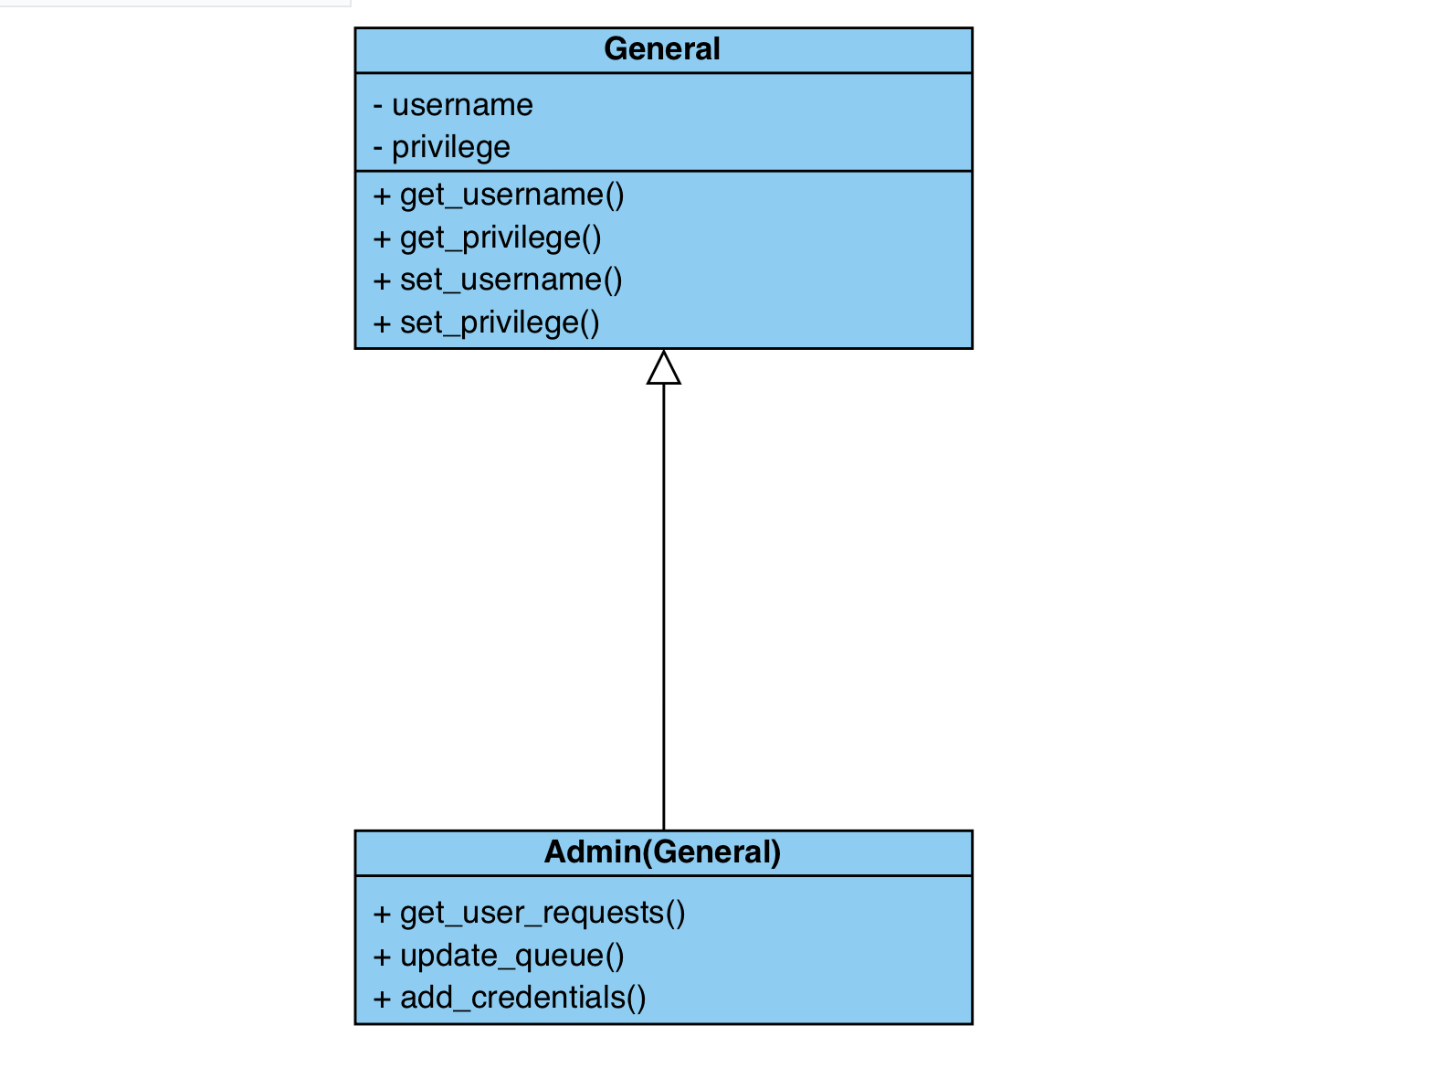

Sending and storing messages

We also need to add a chatting feature to the app. This will be done through taking the messages and then storing them into an SQL database. This done by taking three different details from the user which is the:

* Message content
* Username over the user sending the data.
* Date and time that it was sent.

For the user to be able to see the chat log, the client will request for the chat log from the server. The server will then send the data to the client and display it onto the website. Below is the table representation of how the data will be stored in the SQL database. We would also need to decrypt the message using the RSA decryption method that I described previously.

|  |  |  |
| --- | --- | --- |
| **Username** | **Message** | **Datetime** |
| Pranay | “Hello what is the next project that we need to complete” | 12/03/2023. 12: 30 |
| Andrew | “We need to update the API” | 12/03/2023. 12: 31 |
| Pranay | “Ok, let’s have a scrum meeting tomorrow” | 12/03/2023. 12: 32 |
| Andrew | “Sure thing” | 12/03/2023 12: 33 |

This is then read and sent on the WebSocket to the client so that it appears on their website in real time. An SQL statement to add another message to the database would be:

INSERT INTO general_room VALUES (“Pranay”, “Hello”, 12/03/2023 12: 33)

This is known as a parameterised SQL statement as we use the user defined values before we input the data.

File structure

For the server, I am using Flask to store the files in the server. Flask is a program that can serve the data to any client that connected to it, including HTML for the website, storing data into the database, sending, and receiving HTTP requests and connecting to the client using WebSocket. This means that the file structure needs to be in a certain format so that flask can read the data and serve it to the user or do some processing using the algorithms programmed in python. This includes:

* Static folder to store styling and JavaScript logic for the WebSocket on the client side.
* Templates folder to store the HTML files.
* App file to serve data.
* Compression file for the compression logic
* Encryption file for the encryption logic
* Database file to store the tables.
* JSON file to store the user requests for the circular queue.

On the next page is the file structure for such a system.

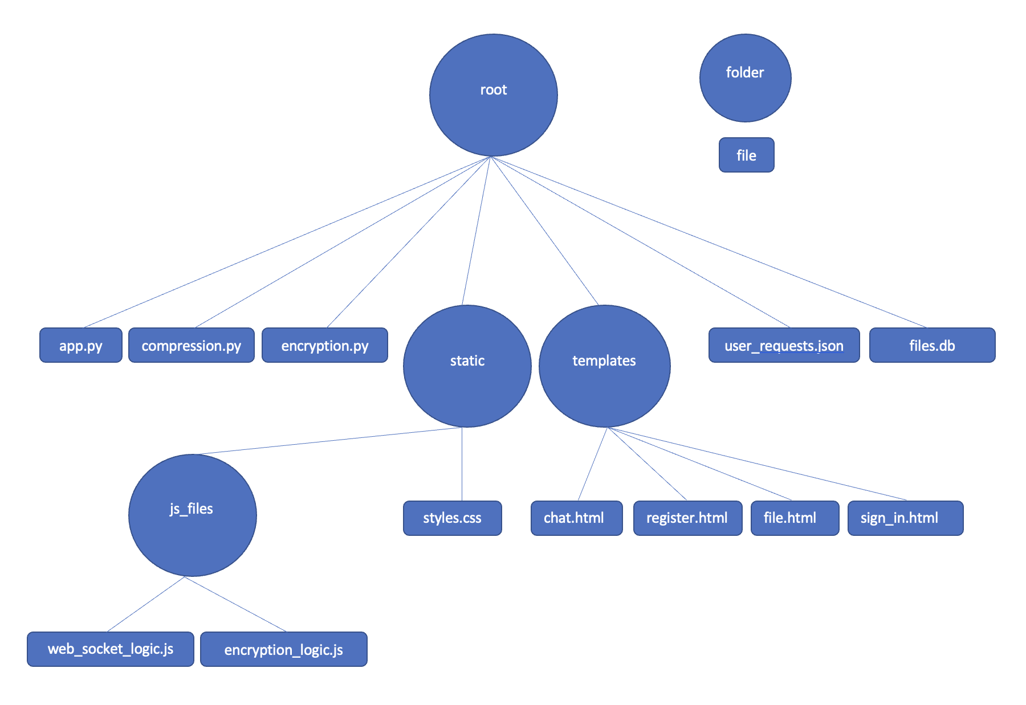

Entity relationship diagram

This is the entity relationship diagram for all the tables that are stored. For this, we would have one user that we identify in the credentials database. This would have a one-to-many relationship with the files as one user can have many files. There is also a one-to-many relationship form the credentials to the messages database as one user can have many messages that are stored in the database.

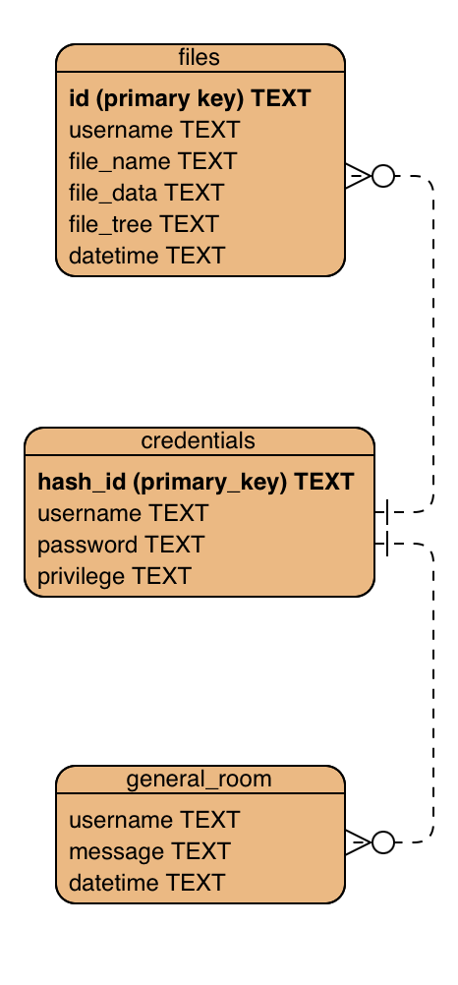

Level 0 data flow diagram for the entire program

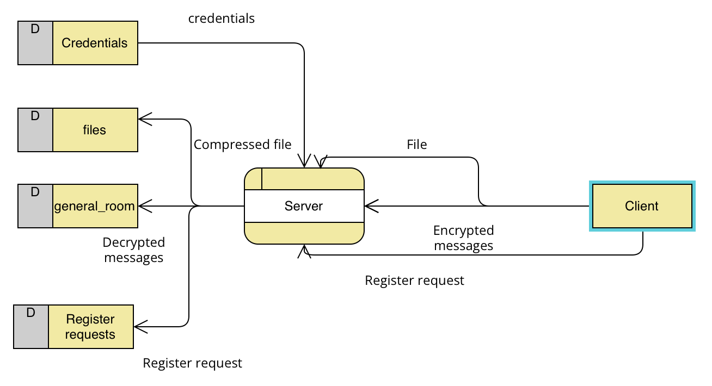

Level 1 flow diagram for the sign in page

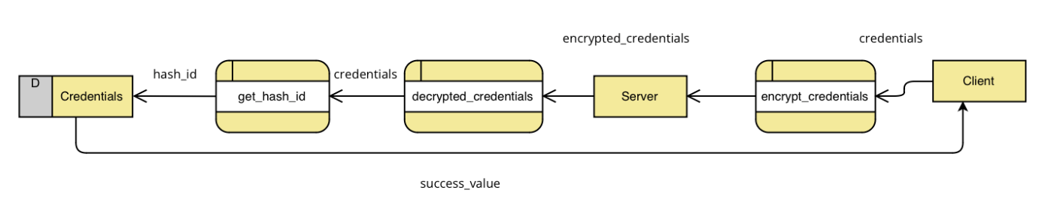

Level 1 flow diagram for file page

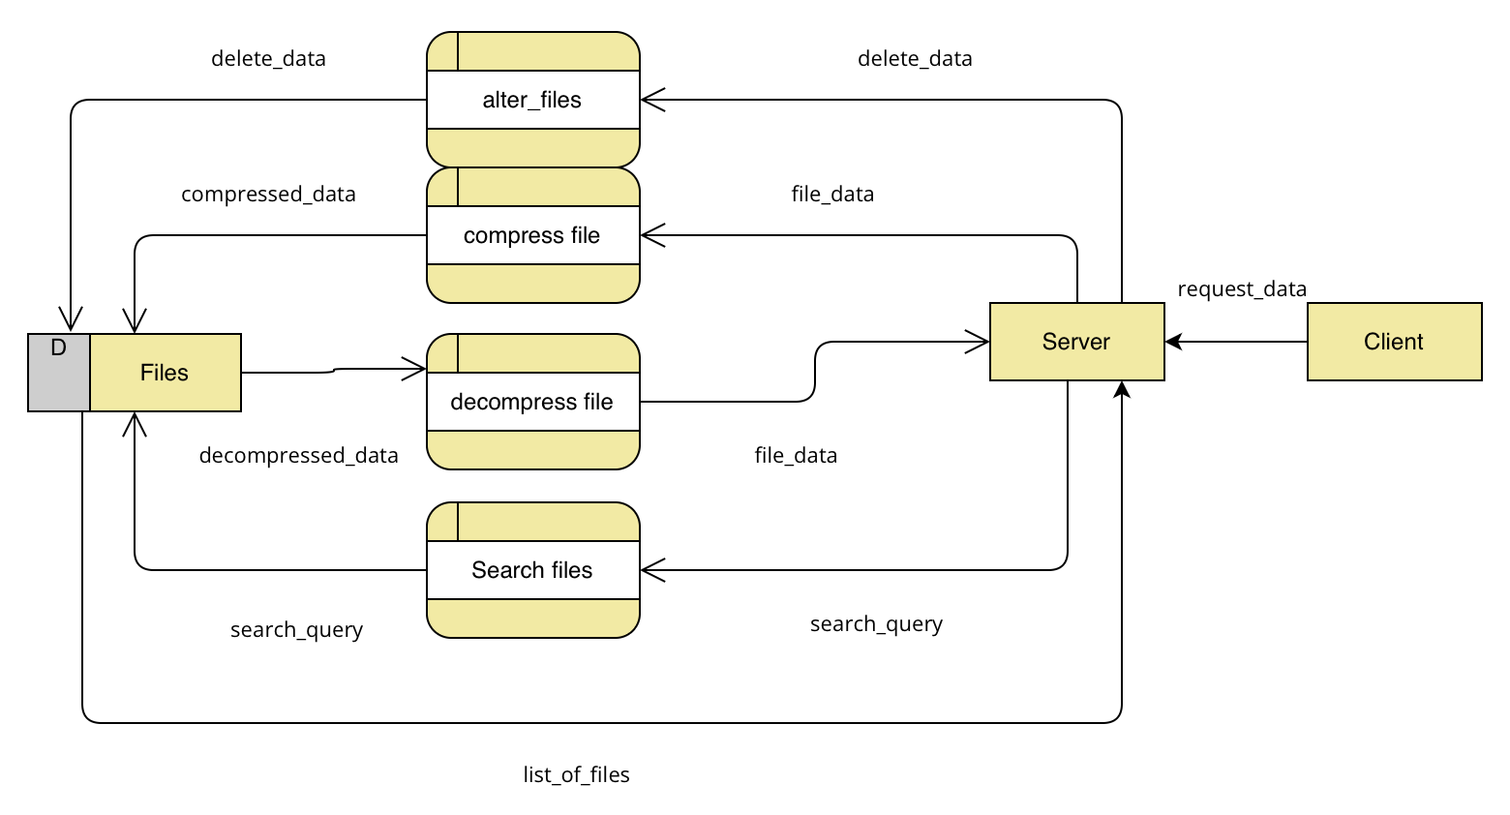

Level 1 flow diagram for chat page

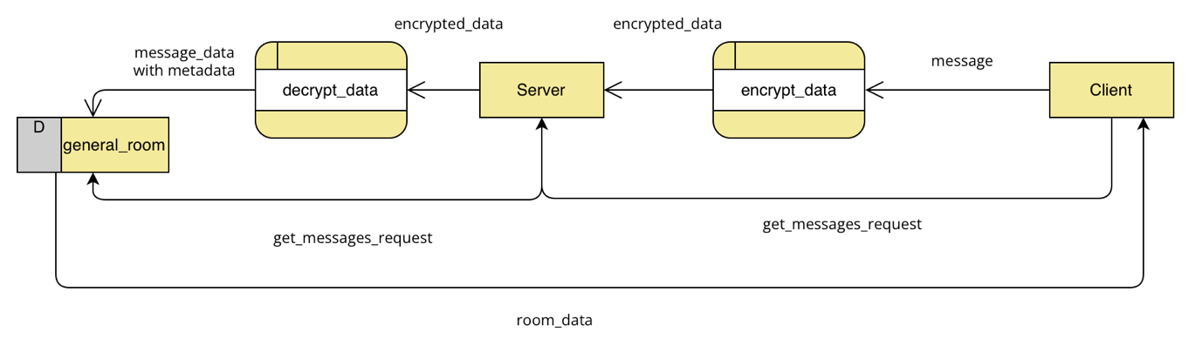

Level 1 flow diagram for register requests

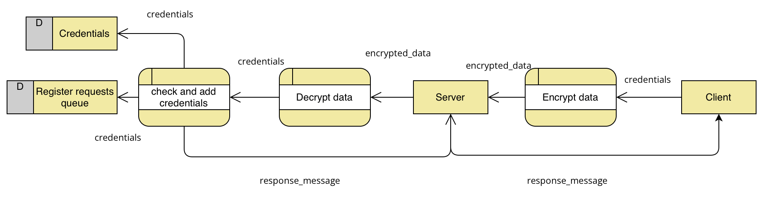

Validation

Here is a list of validation techniques that I am going to implement into the program for each of the pages:

Sign-In page validation

* Fields have some data or there will be a suitable error message.
* If the sign in is false, then it returns that the credentials is false.
* If the username does not exist, then it returns that username does not exist.

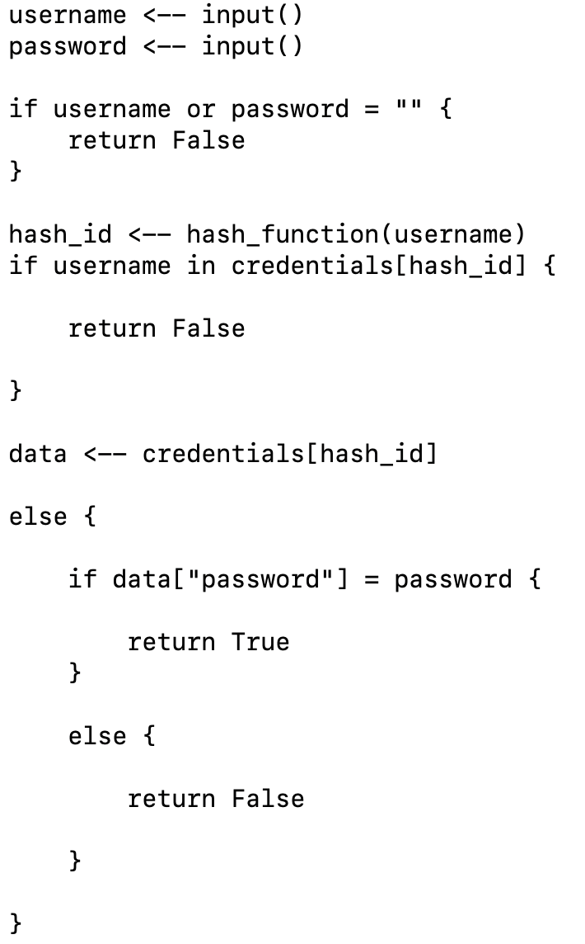Pseudocode for sign in page validation.

Register requests validation.

For the register requests there are multiple things that we need to check for before we can append it to the register requests queue for the admins to tick off. This includes:

* Check if any of the data fields are empty.
* Check if the username of the request exists in the register requests queue.
* Check if the username of the request exists in the credentials database already.
* Check if the register queue is full.
* Check if either the username or the password less than or equal to 4 characters.
* Check if the username or password is greater than or equal to 18 characters. This is to prevent the username being ridiculously long as someone could input 100000 characters into the database and take up lots of memory space + increase latency.
* Check if the data has any space in them.

If any of this is true, then it will send a HTML alert box to that user and include the reason that the registering isn’t working.

Pseudocode for this register request validation

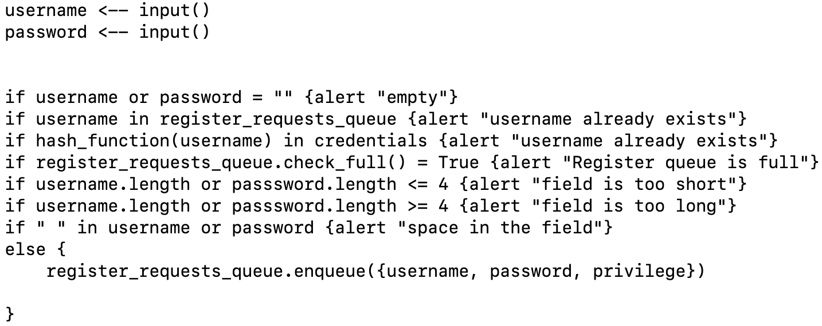

Chat page validation

For this page, we would need to validate the data that is being sent by the user to the server. These are two things, which are:

* Check if the message field is empty and return the suitable error message.
* Check if the message is more than or equal to 800 characters and send an error message if this is the case. This is to prevent the data from getting long and taking up lots of the server space.

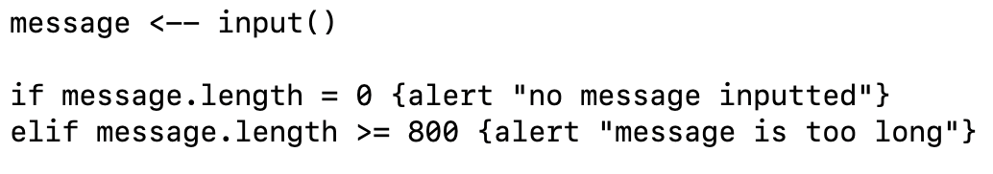

Structure chart located on the next page.

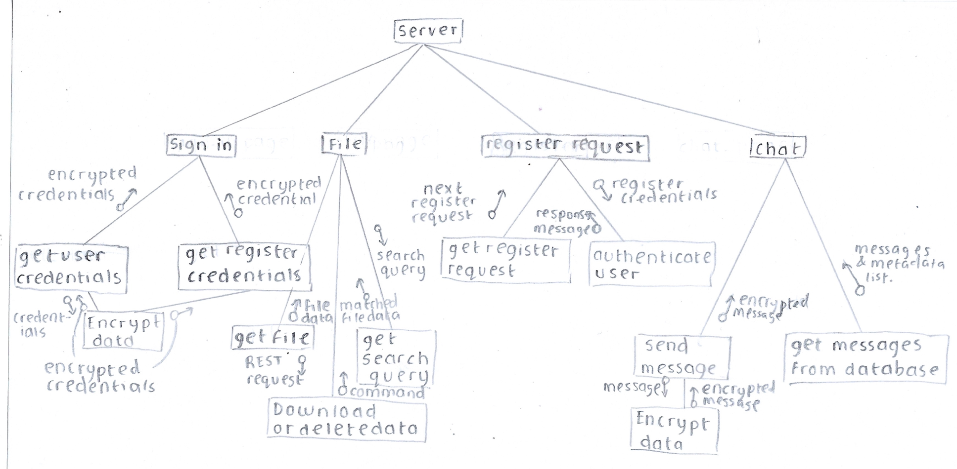

Designs

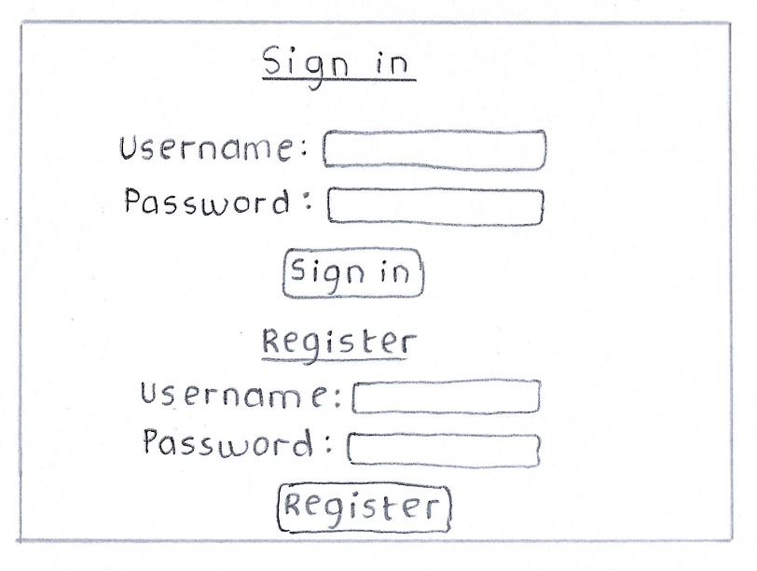

First, we have the sign in page that contains both the sign in and the register functionality. There are two large buttons that are stored in the middle that is easy for the user to click and use. One of the things that this page needs to do is throw alert messages if there are certain errors, including empty fields, incorrect credentials and for the register if the user exists in the first place. This would be thrown up using the HTML alert message. Below are a few examples of this alert message.

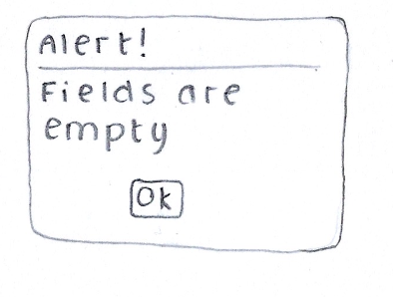This is the alert message if the fields in either the register or the sign in are empty. The user would need to click ok to get rid of them.

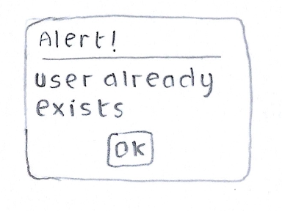

The next example for an alert message would be if the user already exists in either the database of credentials or already in the register queue.

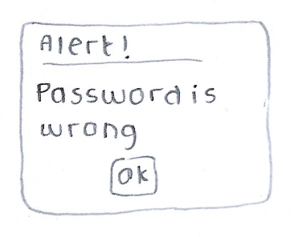

Another example is if the password is wrong, then the alert message would be that the password is wrong. This would pop up on only the user’s screen. All these alert boxes are examples of validation.

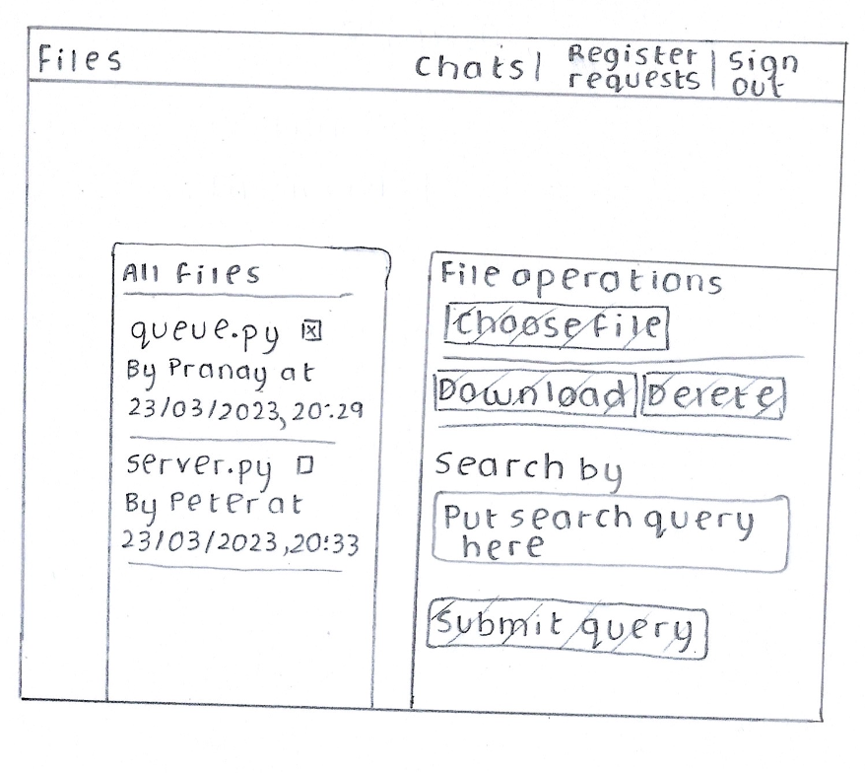

This next design would be for the file sharing page. This would store the files on the left side of the page and the different operations that can be done on the right side of the page. The way that the files will be stored has been inspired by the GitHub design that I have evaluated in my analysis, as it stores the name of the file along with the username. There is a checklist to mark off the files that we want to mark which files that we want our delete or download commands to affect.

On the right side of the page is the file operation centre where we can complete multiple commands to the files that we see. There is the download and delete button, which is located near the middle of the screen, which is easier for the user to see. Then there is the search by text box which takes in data that we can search the database by. Then we finally have the submit query button which searches the database through with the data that the user has given. This will use regular expression to make the pattern matching better. Both the files and the files operations are separated by columns and given labels on top of them so that it is easy to see which side does what.

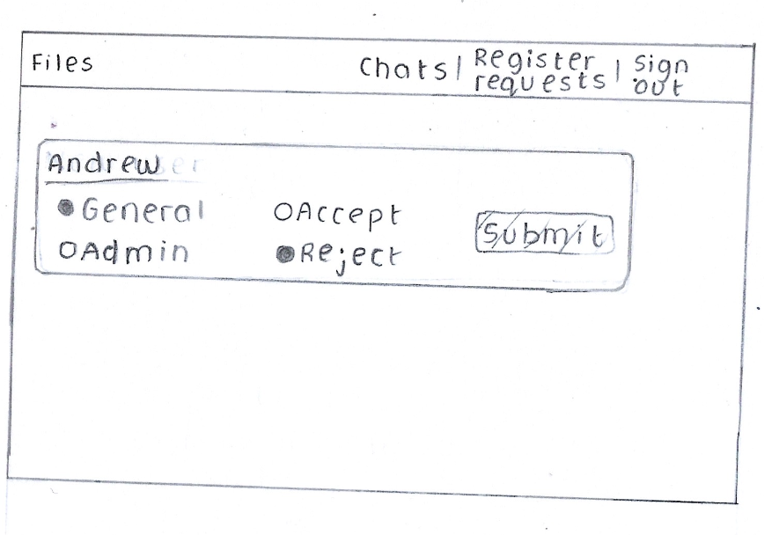

Then we have the register requests page, where we can see who in the register queue wants to be validated next. This would appear for all the admins and would include a radio checkbox to choose if they want the user to have general privilege or admin privilege. Then there is another radio checkbox for either accept or reject the user. These are both located in the centre of the screen so that it is easy for the user to see. There is a shaded submit button on the right side for the user to see once they have made their choices, they can submit. Once this is done, all the operations to add the user to the credentials hash table will be done and then the website will get the next register request for the user to see.

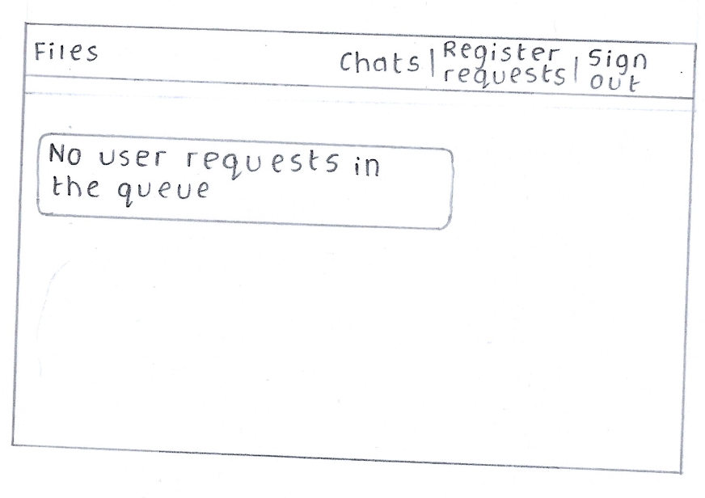If in the case there is no more requests in the queue, the program will check is the queue is empty and then return to any admins, trying to add users that there are no more user requests in the queue. Then, the next time someone requests to be registered, the website will update with that request credentials username.

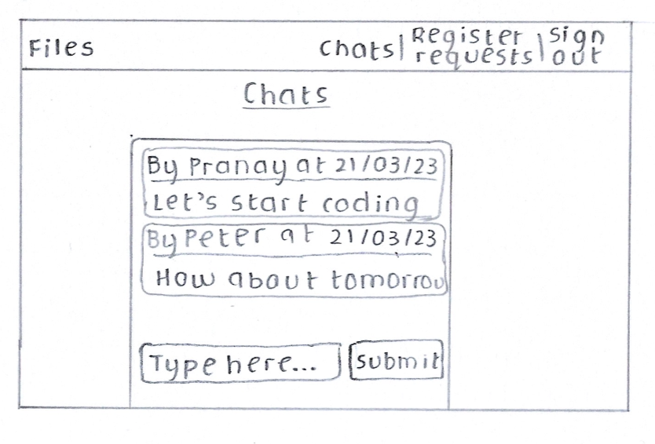

Then we have the chat page. Here we have a chat page that was inspired by WhatsApp, which is a popular messaging service. We would have the messages and the details in bubbles to differentiate the different messages. When someone presses the submit button, anything that is in the text box will be sent to the server encrypted to validate the message. Then if the message is valid, website will update all the users with the message that was sent. This includes metadata like the username of person that sent it and then date that it was sent at. Alongside this, the page would immediately scroll to the bottom of the page as soon as someone sends a message so that the user does not need to scroll to see the messages. These are all possible through WebSocket’s as the page immediately refreshes. When the submit button is sent, the data in the text box is removed so that new data can be sent in, and we don’t need to delete that data and then submit again. Centring all the data in the middle of the screen makes it easier for the user to see the data and messages.

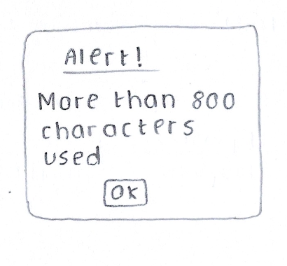

Here is one of the alert boxes that would be thrown up if there are more than 800 characters that are used. The user would need to press ok and then split up the message into different messages so that it doesn’t take up too much space in the server and so that the message is clear and concise for the other users to see.

Details of system

Server: Flask  
client-side programming: JavaScript

To run the server type: python app.py

Example details to sign in (for admin user):

Username: pranay  
password: pass

For general user:

Username: Peter  
password: new_password

**App.py (server)**

* random module to be used for the generation of the ids of the user.
* flask for the server, along with render_template for rendering the html and url_for for getting the url for certain links on the website.
* flask_socketio to connect websockets for the client side and the server side.
* datetime to store the current date and time for the messages and file uploads.
* compression file contains the compression logic for the Huffman compression that I wrote about.
* Sorting for the merge sort algorithm that I used.
* Encryption for the RSA encryption algorithm that I wrote.
* Sqlite3 to be able to handle the connection to the SQL tables that I made.
* JSON to manipulate the JSON data in the register requests that I made.
* AST that evaluates strings making them into dictionaries or lists
* Re is a regular expression library that I used to evaluate the search query and search through the file names.

Contents of file

**Use of parameterised SQL: 225, 247, 275, 303, 551, 569, 636, 765**

**Use of regular expression: 607**

**Use of hash function: 256 (this will take the string and generate a hash id for the index on the table. This is for the credentials table and takes the username)**

**Classes and inheritance: 177, 197, 724 (one for room, one for general and one for admin)**

**Circular queue for the register queue: 28**

**Use of JSON and dictionaries: 126, 174, 234, 239, 244, 378, 549, 817**

**Encryption and decryption: 14 387, 388**

**Linear search: 148, 587**

**Compress file (Uses compression logic in different file): 648, 690.**

**Decorators: 383, 417, 457, 464, 497, 509, 562, 623, 685, 717, 777, 783, 807, 835.**

**List operations: 64, 78, 81, 233, 238, 243, 532, 582, 609, 640, 749**

**Error handling: 37, 45, 267, 394, 436, 792**

**Uses the client server model.**

**Code**

1: import random

2: from flask import Flask, render_template, url_for, request, redirect

3: from flask_socketio import SocketIO, emit

4: import datetime

5: import compression

6: import sorting

7: import encryption

8: import sqlite3

9: import json

10: import ast

11: import re

12:

13:

14: public_key, private_key, prime_product = encryption.generate_keys() # This will generate the private key, public key and prime product

15:

16:

17:

18: def create_user(username, privilege): #¬†Creates the user object depending on the privilege

19:

20: if privilege == "admin":

21: return Admin(username, "admin")

22:

23: elif privilege == "general":

24: return General(username, "general")

25:

26:

27:

28: class circular_queue: # Circular queue class for the register requests

29:

30: def __init__(self, size):

31:

32: self.max_size = size

33: self.queue = ["" for i in range(self.max_size)]

34: self.front = -1 #contains the index of the element to be dequeued next

35: self.rear = -1 # contains the index of the element to be enqueued next

36:

37: def check_queue_full(self): #¬†Checks if the queue is full by checking if the modulus of the rear is equal to the front, meaning its full

38:

39: if (self.rear + 1) % self.max_size == self.front:

40: return True

41:

42: else:

43: return False

44:

45: def check_queue_empty(self): #¬†If the front pointer is -1 then its empty list

46:

47: if self.front == -1:

48: return True

49:

50: else:

51: return False

52:

53: def get_data_in_order(self): #¬†Gets the data in order, excluding empty elements to put into the json file

54:

55: new_list = []

56:

57: front = self.front

58: rear = self.rear

59:

60:

61: if front <= rear:

62: distance = rear - front

63: for i in range(distance + 1):

64: new_list.append(self.queue[front])

65: front += 1

66:

67: final_list = [i for i in new_list if i != ""]

68:

69: return final_list

70:

71:

72: elif front > rear:

73:

74: distance = self.max_size - self.queue.count("")

75: for i in range(distance):

76: if front + 1 > self.max_size:

77: front = 0

78: new_list.append(self.queue[front])

79:

80: else:

81: new_list.append(self.queue[front])

82: front += 1

83:

84: final_list = [i for i in new_list if i != ""]

85:

86: return final_list

87:

88:

89:

90: def peek(self): #¬†Gets the next value in the queue

91: return self.queue[self.front]

92:

93:

94:

95: def enqueue(self, data): #¬†Checks if the queue is full, or else will enqueue to the list

96:

97: if self.check_queue_full() is True:

98: return "full"

99:

100: elif self.front == -1:

101: self.front = self.rear = 0

102: self.queue[self.rear] = data

103:

104: else:

105: self.rear = (self.rear + 1) % self.max_size

106: self.queue[self.rear] = data

107:

108: def dequeue(self): #¬†Checks if the queue is empty, else will dequeue from the list

109:

110: if self.check_queue_empty() is True:

111: return "empty"

112:

113: elif self.rear == self.front:

114: self.queue[self.front] = ""

115: self.front = self.rear = -1

116:

117: else:

118: self.queue[self.front] = ""

119: self.front = (self.front + 1) % self.max_size

120:

121: user_requests = circular_queue(10) # There can be a maximum of 10 people that register

122:

123:

124: def initial_queue_update(): #¬†Will update the queue with all the values already in the json file containing register reqeuests

125:

126: with open("user_requests.json", "r") as file:

127:

128: data = json.load(file)

129:

130: for i in data["requests"]:

131: user_requests.enqueue(i)

132:

133:

134: initial_queue_update()

135:

136:

137:

138:

139: def check_username_in_queue(username): #¬†This function checks if the queue is in register queue already for anyone that is trying to register

140:

141: in_queue = False

142:

143: queue = user_requests.get_data_in_order()

144:

145: if user_requests.check_queue_empty() is True:

146: return False

147:

148: for i in queue: #¬†Does a linear search

149:

150: if i["username"] == username:

151: in_queue = True

152:

153: else:

154: in_queue = False

155:

156: return in_queue

157:

158:

159:

160:

161: app = Flask(__name__) #¬†Makes the server in flask

162: app.config['SECRET_KEY'] = f"{str(private_key)}"

163: socketio = SocketIO(app, max_http_buffer_size = 1000 * 1000 * 2) # means that 2 MB of data can be passed in the header

164:

165:

166:

167: def update_user_requests(): # this will update the register queue with json values in register requsts

168:

169: user_queue = user_requests.get_data_in_order()

170: final_data = {"requests": user_queue}

171:

172:

173: with open("user_requests.json", "w") as file: # dumps it into the register request page

174: json.dump(final_data, file, indent = 4)

175:

176:

177: class General: #¬†General class for user with general privileges

178:

179: def __init__(self, username, privilege): # constructor that takes these values

180: self.username = username

181: self.privilege = privilege

182:

183: def get_username(self): #¬†gets the username values

184: return self.username

185:

186: def get_privilege(self): # gets the privilege

187: return self.privilege

188:

189: def set_username(self, username): #¬†sets the username

190: self.username = username

191:

192: def set_privilege(self, privilege): # sets the password

193: self.privilege = privilege

194:

195:

196:

197: class Admin(General): # Inherits from the general class and gets all the properties and methods

198:

199: def __init__(self, username, privilege): # Constructor

200: super().__init__(username, privilege)

201:

202:

203:

204: def get_user_requests(self): #¬†Gets the user requsts that only the admin can do

205:

206: with open("user_requests.json", "r") as file:

207:

208: return json.load(file)

209:

210:

211: def update_queue_with_json(self, data): # updates the queue with the values from the user reqeusts in json

212:

213: for i in data["requests"]:

214: user_requests.enqueue(i)

215:

216:

217: def add_credentials(self, username, password, privilege): # adds the credentials to the class

218:

219: connection = sqlite3.connect("files.db") # adds to an sqlite3 table

220:

221: crsr = connection.cursor()

222:

223: username_id = hash_function(username) # creates the hash value

224:

225: sql_command = f"""SELECT username, password, privilege FROM credentials WHERE hash_id = "{username_id}";""" # selects the username, password and privilege based on the hash id

226:

227: crsr.execute(sql_command)

228:

229: data = crsr.fetchall() #¬†stores the data in the variable

230:

231:

232: usernames_list = (ast.literal_eval(data[0][0]))["usernames"]

233: usernames_list.append(username)

234: new_usernames = {"usernames": usernames_list} #¬†stores the updated username

235:

236:

237: passwords_list = (ast.literal_eval(data[0][1]))["passwords"]

238: passwords_list.append(password)

239: new_passwords = {"passwords": passwords_list} # stores the updated passwords

240:

241:

242: privileges_list = (ast.literal_eval(data[0][2]))["privileges"]

243: privileges_list.append(privilege)

244: new_privileges = {"privileges": privileges_list} #¬†stores the updated privileges

245:

246:

247: sql_command = f"""UPDATE credentials set username = "{new_usernames}", password = "{new_passwords}", privilege = "{new_privileges}" WHERE hash_id = "{username_id}";"""

248: # sql command that updates the table

249: crsr.execute(sql_command)

250: connection.commit()

251: connection.close()

252:

253:

254:

255:

256: def hash_function(data): #¬†generates the hash function bassed on username

257:

258: total = 1

259:

260: for i in data:

261:

262: total *= ord(i)

263:

264: return total % 223 #¬†hash id is between 0 and 223

265:

266:

267: def check_if_username_exists(username): #¬†function checks if the username exist by generating hash id and searching that index

268:

269: connection = sqlite3.connect("files.db")

270:

271: crsr = connection.cursor()

272:

273: username_id = hash_function(username)

274:

275: sql_command = f"""SELECT username FROM credentials WHERE hash_id = "{username_id}";"""

276:

277: crsr.execute(sql_command)

278:

279: data = crsr.fetchall()

280:

281: usernames = (ast.literal_eval(data[0][0]))["usernames"]

282:

283: connection.close()

284: # returns if the username exists

285: if username in usernames:

286:

287: return True

288:

289: else:

290:

291: return False

292:

293:

294: def authenticate_user(username, password): # returns a boolean if the the password is correct

295:

296:

297: connection = sqlite3.connect("files.db")

298:

299: crsr = connection.cursor()

300:

301: username_id = hash_function(username) #¬†makes hash id for the username id

302:

303: sql_command = f"""SELECT username, password FROM credentials WHERE hash_id = "{username_id}";""" #¬†gets the useranme and passwords at that index

304:

305: crsr.execute(sql_command)

306:

307: data = crsr.fetchall()

308:

309: usernames = (ast.literal_eval(data[0][0]))["usernames"]

310:

311: passwords = (ast.literal_eval(data[0][1]))["passwords"]

312:

313: connection.close()

314:

315: if username == []: return False

316:

317: index = 0

318:

319: for i in usernames:

320:

321: if usernames[index] == username:

322:

323: break

324:

325: else:

326:

327: index += 1

328:

329:

330: try: actual_password = passwords[index]

331: except: return False

332:

333: if actual_password == password: return True

334:

335: else: return False

336: # returns if the password is correct at that index

337:

338:

339:

340:

341: def return_credentials(username): # returns the password and privilege for a certain password

342:

343: connection = sqlite3.connect("files.db")

344:

345: crsr = connection.cursor()

346:

347: username_id = hash_function(username)

348:

349: sql_command = f"""SELECT username, password, privilege FROM credentials WHERE hash_id = "{username_id}";"""

350: # sql statement to get the usernames, passwords and privilegs for the credentials in a certain hash index

351: crsr.execute(sql_command)

352:

353: data = crsr.fetchall()

354:

355:

356: usernames_list = (ast.literal_eval(data[0][0]))["usernames"]

357:

358: passwords_list = (ast.literal_eval(data[0][1]))["passwords"]

359:

360: privileges_list = (ast.literal_eval(data[0][2]))["privileges"]

361:

362: connection.close()

363:

364:

365: if usernames_list == []: return False

366:

367: index = 0

368:

369: for i in usernames_list:

370:

371: if i == username:

372: break

373:

374: else:

375: index += 1

376:

377:

378: return {"username": username, "password": passwords_list[index], "privilege": privileges_list[index]}

379:

380: # returns a json for the websocket to return

381:

382:

383: @socketio.on("handle_credentials") #¬†on the handle credentials event we get the data

384: def handle_credentials(data):

385:

386: global user

387: username = encryption.decrypt(private_key, prime_product, data["username"]) # decrypts the encrypted username

388: password = encryption.decrypt(private_key, prime_product, data["password"]) # decryptd the encrypted password

389:

390: if username == "" or password == "":

391: emit("error_handler", "empty") #¬†checks if the fields are empty

392:

393:

394: elif check_if_username_exists(username) is True: #¬†checks if the username exists and sends error message if so

395:

396: if authenticate_user(username, password) is True: # authenticats the user

397:

398:

399: if (return_credentials(username))["privilege"] == "admin": # updates the credentials as admin with the user, if the user exists and updates the sesssion

400:

401: socketio.emit("update_credentials", {"username": username, "privilege": "admin"})

402:

403: else:

404: socketio.emit("update_credentials", {"username": username, "privilege": "general"}) # otherwise will update the user as general privilege

405:

406: emit('redirect', {'url': url_for("file_page")}) # redirects to the file page if the user is authenticated

407:

408: else:

409: emit("error_handler", "wrong_password") #¬†emits the wrong password if the password is wrong

410:

411: else:

412:

413: emit("error_handler", "wrong_username") # emits the wrong username if the username does not exist

414:

415:

416:

417: @socketio.on("handle_register") #¬†works on the handle request event

418: def handle_register(data):

419:

420: username = encryption.decrypt(private_key, prime_product, data["username"]) #¬†decrypts the register username and register password

421: password = encryption.decrypt(private_key, prime_product, data["password"])

422:

423: banned_characters = [" ", "\"", "\'"]

424:

425:

426: if (username == "") or (password == ""): #¬†if it is empty then will return that it is empty

427: emit("register_error_handler", "empty")

428:

429: elif (len(username) <= 4) or (len(password) <= 4): # if the the length of the fields are less than or equal to 4 then return error

430: emit("register_error_handler", "not_enough_characters")

431:

432: elif (len(username) >= 18) or (len(password) >= 18): # if the characters are longer than 18, then returns error

433: emit("register_error_handler", "too_many_characters")

434:

435: elif user_requests.check_queue_full() is True: # check if the queue is full and sends error if it is

436: emit("register_error_handler", "queue_full")

437:

438:

439: elif any(i in (username or password) for i in banned_characters) is True: # if the username or password has a space then returns error

440: emit("register_error_handler", "banned_characters")

441:

442:

443: elif check_username_in_queue(username) is True: #¬†if the register request already exists in the register queue then returns that it is already used

444: emit("register_error_handler", "username_in_queue")

445:

446:

447: elif check_if_username_exists(username) is True: # checks if the username already exists

448: emit("register_error_handler", "username_in_database")

449:

450: else:

451:

452: emit("register_error_handler", "successful") #¬†if all the validation is successful then will enqeueu to the queue

453: user_requests.enqueue({"username": username, "password": password})

454: update_user_requests()

455:

456:

457: @app.route("/", methods = ["GET", "POST"])

458: def sign_in_page(): # returns the html for the sign in page

459:

460: return render_template("sign_in.html")

461:

462:

463:

464: @socketio.on("update_requests") # adds to the credentials database if the admin checks them off

465: def update_requests(data):

466:

467: user = create_user(data["real_username"], data["real_privilege"])

468:

469: if data["decision"] == "true":

470:

471: if user_requests.check_queue_empty() is False:

472:

473: new_user = user_requests.peek()

474: user_requests.dequeue()

475:

476: user.add_credentials(new_user["username"], new_user["password"], data["privilege"])

477:

478: update_user_requests()

479:

480: else:

481: pass

482:

483:

484: elif data["decision"] == "false":

485:

486: if user_requests.check_queue_empty() is False:

487:

488: user_requests.dequeue()

489: update_user_requests()

490:

491: else:

492: pass

493:

494:

495:

496:

497: @socketio.on("get_requests")

498: def get_requests(): # gets the next value in the queue

499:

500: if user_requests.check_queue_empty() is True:

501: emit("handle_requests", "empty")

502:

503: elif user_requests.check_queue_empty() is False:

504: emit("handle_requests", user_requests.peek()["username"])

505:

506:

507:

508:

509: @app.route("/register_requests", methods = ["GET", "POST"])

510: def register_requests_page(): # gets the register request html page

511:

512: return render_template("register.html")

513:

514:

515:

516: def get_id_values(): # gets the ids of the files in the database

517:

518: connection = sqlite3.connect("files.db")

519: crsr = connection.cursor()

520:

521: sql_command = f"""SELECT id FROM files;""" # gets all the ids from the files in the database

522:

523: crsr.execute(sql_command)

524:

525:

526: raw_data = crsr.fetchall()

527:

528: id_data = []

529:

530:

531: for i in raw_data:

532: id_data.append(i[0])

533:

534: connection.commit()

535: connection.close()

536:

537: return id_data # gets the list of the id data

538:

539:

540: def file_insert_data(id_data, username, file_name, file_data, file_tree): # inserts the data into the database

541:

542:

543: connection = sqlite3.connect("files.db")

544:

545: crsr = connection.cursor()

546:

547: now = datetime.datetime.now()

548:

549: date = {"day": now.strftime('%d'), "month": now.strftime('%m'), "year": now.strftime('%Y'), "hour": now.strftime('%H'), "minute": now.strftime('%M')}

550:

551: sql_command = f"""INSERT INTO files VALUES (?, ?, ?, ?, ?, ?);""" # parameterised sql query to insert into the table

552:

553: crsr.execute(sql_command, (id_data, username, file_name, file_data, str(file_tree), str(date))) # inputs the data

554:

555: connection.commit()

556:

557: connection.close()

558:

559:

560:

561:

562: @socketio.on("get_html_data")

563: def get_html_file_data(data): # gets all the data from the files list

564:

565: connection = sqlite3.connect("files.db")

566:

567: crsr = connection.cursor()

568:

569: sql_command = f"""SELECT * FROM files;""" #¬†gets all the file data

570:

571: crsr.execute(sql_command)

572:

573: raw_data = crsr.fetchall()

574:

575: data_to_send = []

576:

577: for i in raw_data:

578:

579: raw_date_time = ast.literal_eval(i[5])

580: final_datetime = f"{raw_date_time['day']}/{raw_date_time['month']}/{raw_date_time['year']}, {raw_date_time['hour']}:{raw_date_time['minute']}"

581:

582: data_to_send.append({"id": i[0], "username": i[1], "file_name": i[2], "datetime": final_datetime, "raw_datetime": raw_date_time}) # makes a dictionary with the details

583:

584: if data["search_query"] == "": # if there is nothing in the search query then just return everything

585: pass

586:

587: elif data["search_query"] != "":

588:

589: temp_data_to_send = []

590:

591: for file in data_to_send:

592:

593: final_search_string = ""

594:

595: search_string = data["search_query"]

596:

597:

598: for character in search_string:

599:

600: if character == " ":

601: final_search_string += " *" # puts this as the regular expresssion so that all there can be multiple spaces and it would still do a pattern match

602:

603: else:

604: final_search_string += character

605:

606:

607: if bool(re.search(final_search_string.lower(), file["file_name"].lower())) is True: # does the regular expresion search

608:

609: temp_data_to_send.append(file)

610:

611: else:

612:

613: pass

614:

615: data_to_send = temp_data_to_send

616:

617: data_to_send = sorting.merge_sort(data_to_send, sort_by = data["sort_by"])

618:

619: socketio.emit("alter_html_data", data_to_send)

620:

621:

622:

623: @socketio.on("download_or_delete_by_id") #¬†based on the download or delete command, the checked file will have an operation done to it

624: def download_or_delete_by_id(data):

625:

626: connection = sqlite3.connect("files.db")

627:

628: crsr = connection.cursor()

629:

630: if data["command"] == "download":

631:

632: download_data = []

633:

634: for id_data in data["id_list"]:

635:

636: sql_command = f"""SELECT * FROM files WHERE id = {id_data};"""

637:

638: crsr.execute(sql_command)

639:

640: download_data.append(crsr.fetchall()[0])

641:

642:

643:

644: for file in download_data:

645:

646: frequency_tree = ast.literal_eval(file[4])

647:

648: tree = compression.get_tree_from_count_freqeuency(frequency_tree)

649:

650: file_data_to_add = bytes(compression.decode_data(file[3], tree))

651:

652:

653: try:

654: with open(f"../Downloads/{file[2]}", "wb") as new_file:

655:

656: new_file.write(file_data_to_add)

657: except:

658: with open(f"/Downloads/{file[2]}", "wb") as new_file:

659:

660: new_file.write(file_data_to_add)

661:

662:

663:

664: connection.close()

665:

666:

667: if data["command"] == "delete":

668:

669: for id_data in data["id_list"]:

670:

671: sql_command = f"""DELETE FROM files WHERE id = {id_data};""" #¬†sql statement to delete data based on the id

672:

673: crsr.execute(sql_command)

674:

675: connection.commit()

676:

677: socketio.emit("delete_file_data", id_data, broadcast = True)

678:

679: connection.close()

680:

681:

682:

683:

684:

685: @socketio.on("send_file")

686: def send_file(data): #¬†gets the file and decompressses it

687:

688: user = create_user(data["username"], data["privilege"]) #¬†creates the user based on the session details of the user

689:

690: code, tree = compression.get_code_and_tree(data["file_content"])

691:

692: frequency_tree = compression.count_frequency(data["file_content"])

693:

694: existing_id = get_id_values()

695:

696: while True:

697:

698: new_id = str(random.randint(10000, 99999)) #¬†generates random string for the id of the file and checks if it exists

699:

700: if new_id not in existing_id:

701:

702: break

703:

704: file_insert_data(new_id, user.get_username(), data["file_name"], code, frequency_tree) #¬†subroutine will insert the file into the database

705:

706:

707: now = datetime.datetime.now()

708:

709: date = f"{now.strftime('%d')}/{now.strftime('%m')}/{now.strftime('%Y')}, {now.strftime('%H')}:{now.strftime('%M')}"

710:

711: # will emit the file data to the user so that it can be output to the website

712: socketio.emit("show_file_data_temp", {"id": new_id, "username": user.get_username(),"file_name": data["file_name"], "datetime": date}, broadcast = True)

713:

714:

715:

716:

717: @app.route("/file", methods = ["GET", "POST"])

718: def file_page(): #¬†returns the html for the file page

719:

720: return render_template("file.html")

721:

722:

723:

724: class Room: #¬†room class that stores the room data

725:

726: def __init__(self, room_name, content = []): # contains the room name and the content

727:

728: self.room_name = room_name

729: self.content = content

730:

731: def get_data(self): #¬†gets the room data

732:

733: connection = sqlite3.connect("files.db")

734:

735: crsr = connection.cursor()

736:

737: sql_command = f"SELECT * FROM {self.room_name};"

738:

739: crsr.execute(sql_command)

740:

741: raw_data = crsr.fetchall()

742:

743: connection.close()

744:

745: self.content = []

746:

747: for i in raw_data:

748:

749: self.content.append({"username": i[0], "message": i[1], "datetime": i[2]})

750:

751: return self.content # also updates the room data

752:

753:

754:

755: def insert_data(self, username, message): # inserts the data into the table

756:

757: now = datetime.datetime.now()

758:

759: datetime_as_string = f"{now.strftime('%d')}/{now.strftime('%m')}/{now.strftime('%Y')} {now.strftime('%H')}:{now.strftime('%M')}"

760:

761: connection = sqlite3.connect("files.db")

762:

763: crsr = connection.cursor()

764:

765: sql_command = f"INSERT INTO {self.room_name} VALUES (?, ?, ?);"

766: # the sql statement is paramterised

767: crsr.execute(sql_command, (username, message, datetime_as_string))

768:

769: connection.commit()

770:

771: connection.close()

772:

773:

774: general_room = Room("general_room") #¬†creates the general room

775:

776:

777: @socketio.on("get_encryption_key")

778: def get_encryption_key(): #¬†sends the public and the prime product to the client to encrypt the data

779: socketio.emit("save_encryption_key", {"public_key": public_key, "prime_product": prime_product})

780:

781:

782:

783: @socketio.on("get_messages")

784: def get_messages(): # gets the messages from the table

785:

786: data = general_room.get_data()

787:

788: socketio.emit("handle_messages_from_database", data)

789:

790:

791:

792: def check_message_valid(message): #¬†checks if the message empty or has too many characters

793:

794: if message == "":

795:

796: return False, "empty"

797:

798: elif len(message) >= 800:

799:

800: return False, "full"

801:

802: else:

803:

804: return True, "no_reason"

805:

806:

807: @socketio.on("handle_message")

808: def handle_message(data):

809:

810: user = create_user(data["username"], data["privilege"])

811: now = datetime.datetime.now()

812: datetime_as_string = f"{now.strftime('%d')}/{now.strftime('%m')}/{now.strftime('%Y')} {now.strftime('%H')}:{now.strftime('%M')}"

813: message = encryption.decrypt(private_key, prime_product, data["encrypted_data"]) #¬†decrypts the data using the private key and prime product

814:

815: validity, reason = check_message_valid(message) #¬†function checks if the data is valid

816:

817: final_data = {}

818:

819: if validity is False:

820:

821: final_data = {"response_message": reason}

822:

823: socketio.emit("handle_errors", final_data) #¬†sends error message to the client

824:

825: elif validity is True:

826:

827: general_room.insert_data(user.get_username(), message) #¬†if the message is valid, insert it to the database

828:

829: final_data = {"username": user.get_username(), "message": message, "datetime": datetime_as_string, "response_message": reason}

830: socketio.emit("live_update_messages", final_data, broadcast = True) #¬†updates the data to the website, broadcasts it to every client

831:

832:

833:

834:

835: @app.route("/chat", methods = ["GET", "POST"])

836: def chat_page():

837:

838: return render_template("chat.html") #¬†renders the chat page html

839:

840:

841:

842: if __name__ == "__main__":

843:

844: socketio.run(app, port = 8000, debug = True, log_output = True)

845:

**Compression.py (Huffman compression)**

**Classes that make node for binary tree: 3**

**Recursion: 40, 90**

**Merge sort to sort nodes by frequency: 90**

**Post order traversal to calculate the codes: 33.**

**Generate tree: 221.**

**Dictionary: 36, 75**

**Lists and list operations: 100, 101, 145, 148, 151, 178, 199**

**Exception handling: 20.**

1:

2:

3: class bin_tree_node: # binary tree node that will store the node data and for the character, frequency and the nodes that are connected to it

4:

5: def __init__(self, frequency, character, code = "", left = None, right = None): # If the node is a leaf then both the left and the right ndoes will be None type

6:

7: self.left = left

8:

9: self.right = right

10:

11: self.code = code

12:

13: self.frequency = frequency

14:

15: self.character = character

16:

17:

18: def check_if_leaf(self): # checks if the node is a leaf

19:

20: try:

21:

22: if self.left.character is None and self.right.character is None: #¬†if the left or right is a character then it is not a leaf

23:

24: return True

25:

26: except: #¬†if the node doesnt have a child node then there is an attribute error meaning its a leaf

27:

28: return False

29:

30:

31:

32:

33: def calculate_codes(node): # This will take the node and calculate the code for it

34:

35:

36: codes = {}

37:

38: new_code = ""

39:

40: def recursive_calculate_codes(node, new_code = ""): # recursively calculates the code for the data

41:

42: new_code += str(node.code) # will add the code to the total code

43:

44: if node.left is not None: # it will put priority for the left node of the queue

45: recursive_calculate_codes(node.left, new_code)

46:

47: if node.right is not None: # the right node has the next priority

48: recursive_calculate_codes(node.right, new_code)

49:

50: if node.left is None and node.right is None: # this means that it is a leaf node

51: codes[node.character] = new_code #¬†creates a leaf node

52:

53: return codes

54:

55: return recursive_calculate_codes(node, new_code)

56:

57:

58:

59:

60: def convert_data(data, coding): #¬†converts the data from the character to the converted data

61:

62: converted_string = ""

63:

64: for character in data:

65:

66: converted_string += coding[character] # uses the frequency dictionary to convert them

67:

68: return converted_string

69:

70:

71:

72:

73: def count_frequency(data): # this is to calculate the freqency of the characters and add them to a list

74:

75: freqency_dict = {}

76:

77: for character in data:

78:

79: if character in freqency_dict:

80: freqency_dict[character] += 1

81:

82: else:

83: freqency_dict[character] = 1

84:

85: return freqency_dict

86:

87:

88:

89:

90: def nodes_merge_sort(data):

91:

92: if len(data) == 0 or len(data) == 1: # will stop the merge sort if the list is empyt or has one element

93:

94: return data

95:

96: #This is the middle of the array and does floor division on it so that it is at an index

97: middle = len(data) // 2

98:

99: #This will split the data on the middle of the array

100: right_array = data[middle:]

101: left_array = data[:middle]

102:

103: #This will recurse the function until it has been sorted completely

104: nodes_merge_sort(left_array)

105: nodes_merge_sort(right_array)

106:

107: i = 0

108: j = 0

109: k = 0

110:

111: while i < len(left_array) and j < len(right_array): # there are two different arrays that store the values

112:

113: if left_array[i].frequency <= right_array[j].frequency:

114:

115: data[k] = left_array[i]

116: i += 1

117:

118: elif left_array[i].frequency > right_array[j].frequency:

119:

120: data[k] = right_array[j]

121: j += 1

122:

123: k += 1

124:

125: #This will check if there are any elements left in the left array

126: while i < len(left_array):

127:

128: data[k] = left_array[i]

129: i += 1

130: k += 1

131:

132: #This will check if there are any elements left in the right array

133: while j < len(right_array):

134:

135: data[k] = right_array[j]

136: j += 1

137: k += 1

138:

139: return data

140:

141:

142:

143: def create_nodes_list(data): # This will create a new list and append the list with all the nodes in the frequency

144:

145: nodes_list = []

146:

147: data_freqency = count_frequency(data) # This wil create a freqency dictionary

148:

149: for character, frequency in data_freqency.items():

150:

151: nodes_list.append(bin_tree_node(frequency, character))

152:

153: return nodes_list

154:

155:

156:

157:

158: def generate_tree(nodes_list): # takes the nodes list and then will make it into one tree

159:

160: while len(nodes_list) > 1: # the final node will have the whole tree so if there is 1 node then it is the whole tree

161:

162: nodes_list = nodes_merge_sort(nodes_list) # sorts the data so that the lowest freqency will be at the front

163:

164:

165: left = nodes_list[1] # the left one will be the second smallest

166: right = nodes_list[0] # the right one will have the smallest code

167:

168:

169: left.code = "0" # left node is represented by 0

170: right.code = "1" # right node is represented by 1

171:

172: total_freqeuency = left.frequency + right.frequency # new node will have the new total freqency

173: new_character = left.character + right.character # the new character is the total character

174:

175:

176: nodes_list.remove(left)

177: nodes_list.remove(right)

178: nodes_list.append(bin_tree_node(total_freqeuency, new_character, code = "", left = left, right = right)) #¬†creates the new node with the new total freqency and character

179:

180:

181: def get_code_and_tree(data): #¬†returns the code and tree

182:

183: nodes_list = create_nodes_list(data) # makes the nodes list with all the characters

184:

185: generate_tree(nodes_list) #¬†creates the tree

186:

187: tree = nodes_list[0] # the tree is the first node in the list

188:

189: data_with_freqeuency = calculate_codes(tree) #¬†gets the frequency from the characters

190: code = convert_data(data, data_with_freqeuency) #¬†gets the final code that uses the plain text data

191:

192: return code, tree # returns the encoded data and the tree

193:

194:

195:

196: def decode_data(coded_data, tree): # takes the coded data and the huffman tree

197:

198: root = tree #¬†we take the root to be the top of the tree

199: final_list = [] # the final list takes all the decoded data

200:

201: for character in coded_data: # iterates over the coded data

202:

203: if character == "1": # if the character is 1 then it will go to the right

204: root = root.right #¬†the new root is positioned to the right node

205:

206: elif character == "0": #¬†if the character is 0 then it is pointing to the left node

207: root = root.left # new root is at left node

208:

209: #¬†this will check if the node is a leaf node

210:

211: if root.check_if_leaf() is False:

212:

213: final_list.append(root.character) # the final list appends the new character

214: root = tree # the root is positioned at the tree

215:

216: return final_list # returns the final decoded list

217:

218:

219:

220:

221: def get_tree_from_count_freqeuency(count_frequency):

222:

223: nodes_list = []

224:

225: for character, frequency in count_frequency.items():

226:

227: nodes_list.append(bin_tree_node(frequency, character))

228:

229:

230: while len(nodes_list) > 1: # the final node will have the whole tree so if there is 1 node then it is the whole tree

231:

232: nodes_list = nodes_merge_sort(nodes_list) # sorts the data so that the lowest freqency will be at the front

233:

234:

235: left = nodes_list[1] # the left one will be the second smallest

236: right = nodes_list[0] # the right one will have the smallest code

237:

238:

239: left.code = "0" # left node is represented by 0

240: right.code = "1" # right node is represented by 1

241:

242: total_freqeuency = left.frequency + right.frequency # new node will have the new total freqency

243: new_character = left.character + right.character # the new character is the total character

244:

245:

246: nodes_list.remove(left)

247: nodes_list.remove(right)

248: nodes_list.append(bin_tree_node(total_freqeuency, new_character, code = "", left = left, right = right))

249:

250: return nodes_list[0]

251:

252:

253:

**Encryption.py**

**Random module will generate the prime number for the encryption.**

**A level processing and complex mathematical modelling.**

* **3(Miller-Rabin method that determines if a number is prime or not by using algorithm that I made)**
* **61 (calculates the greatest common divisor)**
* **71 (extended Euclidian algorithm that gets the greatest common divisor efficiently)**
* **83 (Calculates the modular inverse of two numbers)**
* **90 (Calculates the totient of two values)**
* **113 (checks if number is co-prime)**
* **130 (Calculates the modular exponentiation of values to encrypt.)**

**Linear search: 43**

**Recursion: 71**

1: import random

2:

3: def miller_rabin(prime, cycles): # 40 number of cycles to check primes is the optimum to be used here

4:

5: r = 0

6: s = prime - 1

7:

8: while s % 2 == 0:

9:

10: r = r + 1

11: s = s // 2

12:

13:

14: for i in range(cycles):

15:

16: a = random.randint(2, prime - 2)

17:

18: x = (a ** s) % prime

19:

20: if x == 1 or x == prime - 1:

21:

22: continue

23:

24:

25: for i in range(r - 1):

26: x = (x ** 2) % prime

27:

28: if x == prime - 1:

29: break

30:

31: else:

32: return False

33:

34:

35: return True

36:

37:

38:

39: def is_prime(n): # This will check if the number is prime using some small prime numbers as well

40: # This is a list of low primes from 0 to 1000

41: low_primes = [2, 3, 5, 7, 11, 13, 17, 19, 23, 29, 31, 37, 41, 43, 47, 53, 59, 61, 67, 71, 73, 79, 83, 89, 97, 101, 103, 107, 109, 113, 127, 131, 137, 139, 149, 151, 157, 163, 167, 173, 179, 181, 191, 193, 197, 199, 211, 223, 227, 229, 233, 239, 241, 251, 257, 263, 269, 271, 277, 281, 283, 293, 307, 311, 313, 317, 331, 337, 347, 349, 353, 359, 367, 373, 379, 383, 389, 397, 401, 409, 419, 421, 431, 433, 439, 443, 449, 457, 461, 463, 467, 479, 487, 491, 499, 503, 509, 521, 523, 541, 547, 557, 563, 569, 571, 577, 587, 593, 599, 601, 607, 613, 617, 619, 631, 641, 643, 647, 653, 659, 661, 673, 677, 683, 691, 701, 709, 719, 727, 733, 739, 743, 751, 757, 761, 769, 773, 787, 797, 809, 811, 821, 823, 827, 829, 839, 853, 857, 859, 863, 877, 881, 883, 887, 907, 911, 919, 929, 937, 941, 947, 953, 967, 971, 977, 983, 991, 997]

42:

43: for i in low_primes: # This will check if the number is a factor of the primes, returns false if so

44: if i == n or n % i == 0:

45: return False

46:

47:

48: return miller_rabin(n, 40) # If nothing passes then use the miller_rabin method. The optimum here is 40

49:

50:

51: def generate_large_prime(keysize):

52:

53: while True:

54: n = random.randint(10 ** keysize, int("9" * (keysize + 1))) # This will create a random integer in the specified range

55:

56: if is_prime(n) is True: # This uses the is_prime function to check if it's prime and then repeats the loop if its not prime

57:

58: return n

59:

60:

61: def gcd(p, q): # Will calculate the greatest common divisor for the two prime numbers

62: # Will find the largest natural number that divides both p and q

63: while q:

64: p, q = q, p % q

65:

66: return p

67:

68:

69:

70:

71: def egcd(p, q): # Extended eucledian algorithm, this is more efficient and utilises recursion

72:

73: if p == 0:

74: return q, 0, 1

75:

76: else:

77:

78: g, y, x = egcd(q % p, p)

79: return g, x - (q // p) * y, y

80:

81:

82:

83: def modular_inv(p, q): # This will return the private key as the public key % phi(n)

84:

85: g, x, y = egcd(p, q)

86: private_key = x % q

87: return private_key

88:

89:

90: def get_totient(p, q):# Takes the two prime numbers and finds the totient of them

91:

92: return (p - 1) * (q - 1)

93:

94:

95: def generate_keys(keysize = 3):

96: # e is the public key

97: # d is the private key

98:

99: public_key = 0

100: private_key = 0

101: prime_product = 0

102:

103: p = generate_large_prime(keysize) # Gets prime number of a certain length

104: q = generate_large_prime(keysize)

105:

106: prime_product = p * q # These are then mulitipied together so that we get a value that must be facrotoised by one of the prime numbers to be decrypted

107: phi_n = get_totient(p, q) # This will get the totient of the two values

108:

109: while True:

110: public_key = random.randint(10 ** keysize, int("9" * (keysize + 1)))

111: #public_key = random.randint(2 ** (keysize - 1), 2 ** keysize - 1)

112:

113: if gcd(public_key, phi_n) == 1: # This will check if they are co prime (they do not have a positive interger to divide each other by other than 1)

114:

115: break

116:

117: private_key = modular_inv(public_key, phi_n) # This creates the private key which requires the modular inverse method

118:

119: return public_key, private_key, prime_product

120:

121:

122:

123:

124: def encrypt(public_key, prime_product, data):

125:

126: encrypted_data = ""

127:

128: for char in data: #iterates over the characters in the data

129: char_ord = ord(char) #gets the unicode for it

130: encrypted_data += str((char_ord ** public_key) % prime_product) + " " #does modular exponation (a^b) % c to get the encrypted data

131: #print(str((char_ord ** public_key) % prime_product))

132: #print(math.pow(char_ord, public_key, prime_product))

133:

134:

135: return encrypted_data

136:

137:

138:

139: def decrypt(private_key, prime_product, encrypted_data): #this will take the encrypted data and decrypt it

140:

141: decrypted_data = ""

142:

143: encrypted_data_list = encrypted_data.split() #will split the data into parts that are used by the split function

144:

145: for character in encrypted_data_list: # iterates over the encrypted data list

146: if character:

147:

148: decrypted_data += chr(pow(int(character), private_key, prime_product)) # does modular exponation for the charcter codee, private key and the prime product

149: #decrypted_data += chr((int(character) ** private_key) % prime_product)

150:

151: return decrypted_data

152:

**User_requests.json**

Stores the requests in JSON file. Uses list to store the different values.

1: {

2: "requests": [

3: {

4: "username": "nishant",

5: "password": "new_password"

6: }

7: ]

8: }

**Java script files**

This stores the WebSocket logic for each of the page on the website.

**Chat_page_logic.js**

1: function scroll_to_bottom() {

2: $('.chat_container').scrollTop($('.chat_container')[0].scrollHeight)

3:

4: }

5:

6:

7: $(document).ready(function() {

8:

9: var socketio = io.connect('http://127.0.0.1:8000');

10:

11:

12: let public_key = 0;

13: let prime_product = 0;

14:

15: socketio.on("connect", function() { // gets the encryption keys

16: socketio.emit("get_encryption_key")

17: socketio.emit("get_messages") // gets the messgages from the room

18: });

19:

20:

21: socketio.on("handle_messages_from_database", function(data) { // iterates through the html data and creates thta message on the website

22: let html_data = ``

23:

24:

25: for (let i of data) {

26: html_data += `<div class="post_container" id="posts"><h4><b><u>By ${i["username"]} at ${i["datetime"]}</u></b></h4>

27: <p>${i["message"]}</p></div><hr class="hr_tag">`

28:

29: }

30:

31: $(".message_area").html(html_data)

32: scroll_to_bottom()

33:

34: })

35:

36:

37: socketio.on("save_encryption_key", function(data) { // saves the keys

38: public_key = data["public_key"]

39: prime_product = data["prime_product"]

40: })

41:

42:

43: $("#send_message").on("click", function() { // on the click of the submit button, the message is sent from the textox

44: let encrypted_data = encrypt(public_key, prime_product, $("#message_textarea").val()) // encrypts the data

45: $("#message_textarea").val("") // clears the data in the textbox

46: socketio.emit("handle_message", { "encrypted_data": encrypted_data, "username": sessionStorage.getItem("username"), "privilege": sessionStorage.getItem("privilege") })

47: })

48:

49:

50: socketio.on("handle_errors", function(data) { // handles the error messages

51:

52: if (data["response_message"] == "full") { }

53:

54: else if (data["response_message"] == "empty") { }

55:

56: })

57:

58:

59: socketio.on("live_update_messages", function(data) { // updates the messages based on the server response

60:

61: let html_data = ``

62:

63: html_data = `<div class="post_container" id="posts"><h4><b><u>By ${data["username"]} at ${data["datetime"]}</u></b></h4>

64: <p>${data["message"]}</p></div><hr class="hr_tag">`

65:

66: $(".message_area").append(html_data) // appends to the html file

67:

68: scroll_to_bottom() // scrolls to the botton if there has been an update

69:

70:

71: })

72:

73:

74: })

75:

**Encryption.js**

Stores the encryption logic to encrypt on the client side.

This is an example of A level processing.

1: function get_rand_int(min, max) {

2: min = Math.ceil(min);

3: max = Math.floor(max);

4:

5: return Math.floor(Math.random() * (max - min + 1) + min); // Thsi will be inclusive of both the min and the max value

6: }

7:

8: /*function miller_rabin(prime, cycles) {

9: let r = 0;

10: let s = prime - 1;

11:

12: while (s % 2 == 0) {

13: r = r + 1

14: s = Math.floor(s / 2)

15: }

16:

17:

18: for (let i = 0; i < cycles; i++) {

19: let a = get_rand_int(2, prime - 2)

20: let x = (a ** s) % prime

21:

22: if (x == 1 || x == prime - 1) { continue }

23:

24: for (let i = 0; i < r - 1; i++) {

25:

26: x = (x ** 2) % prime

27:

28: if (x == prime - 1) { break }

29:

30: }

31:

32: else { return false }

33:

34:

35: }

36:

37: return true

38:

39: }*/

40:

41:

42: function is_prime(n) { // This will check if the number is prime using some small prime numbers as well

43:

44: let low_primes = [2, 3, 5, 7, 11, 13, 17, 19, 23, 29, 31, 37, 41, 43, 47, 53, 59, 61, 67, 71, 73, 79, 83, 89, 97, 101, 103, 107, 109, 113, 127, 131, 137, 139, 149, 151, 157, 163, 167, 173, 179, 181, 191, 193, 197, 199, 211, 223, 227, 229, 233, 239, 241, 251, 257, 263, 269, 271, 277, 281, 283, 293, 307, 311, 313, 317, 331, 337, 347, 349, 353, 359, 367, 373, 379, 383, 389, 397, 401, 409, 419, 421, 431, 433, 439, 443, 449, 457, 461, 463, 467, 479, 487, 491, 499, 503, 509, 521, 523, 541, 547, 557, 563, 569, 571, 577, 587, 593, 599, 601, 607, 613, 617, 619, 631, 641, 643, 647, 653, 659, 661, 673, 677, 683, 691, 701, 709, 719, 727, 733, 739, 743, 751, 757, 761, 769, 773, 787, 797, 809, 811, 821, 823, 827, 829, 839, 853, 857, 859, 863, 877, 881, 883, 887, 907, 911, 919, 929, 937, 941, 947, 953, 967, 971, 977, 983, 991, 997]

45:

46: for (let i in low_primes) {

47: if (i == n || n % i == 0) { return false }

48: }

49:

50: if (n % 2 == 0) { return false }

51:

52:

53: //miller_rabin(n, 40)

54: }

55:

56:

57: function generate_large_prime(keysize) {

58:

59: while (true) {

60: let max_size = ""

61:

62: for (let i = 0; i < keysize + 1; i++) {

63: max_size = max_size + "9"

64: }

65:

66: max_size = parseInt(max_size)

67:

68: let n = get_rand_int(10 ** keysize, max_size)

69:

70: if (is_prime(n) == true) { return n }

71:

72: }

73: }

74:

75: function gcd(p, q) { // Will calculate the greatest common divisor for the two prime numbers

76:

77: while (q == true) {

78: p, q = q, p % q

79: }

80: return p

81: }

82:

83: function egcd(a, b) {

84:

85: if (a == 0) {

86: return b, 0, 1

87: }

88:

89: else {

90: let g = 0

91: let y = 0

92: let x = 0

93:

94: g, y, x = egcd(b % a, a)

95: return g, x - Math.floor(b / a) * y, y

96:

97: }

98: }

99:

100:

101: function modular_inv(a, b) { // This will return the private key as the public key % phi(n)

102:

103: let x = 0

104: let g = 0

105: let y = 0

106:

107: g, x, y = egcd(a, b)

108: let private_key = x % b

109: return private_key

110: }

111:

112: function get_totient(p, q) { //Takes the two prime numbers and finds the totient of them

113:

114: return (p - 1) * (q - 1)

115: }

116:

117: function generate_keys(keysize = 4) {

118: // e is the public key

119: // d is the private key

120:

121: let public_key = 0

122: let private_key = 0

123: let prime_product = 0

124:

125: let p = generate_large_prime(keysize) // Gets prime number of a certain length

126: let q = generate_large_prime(keysize)

127:

128: prime_product = p * q // These are then mulitipied together so that we get a value that must be facrotoised by one of the prime numbers to be decrypted

129: let phi_n = get_totient(p, q) // This will get the totient of the two values

130:

131: while (true) {

132: //e = random.randrange(10 ** keysize, int("9" * (keysize + 1)))

133: public_key = get_rand_int(2 ** (keysize - 1), 2 ** keysize - 1)

134:

135: if (gcd(public_key, phi_n) == 1) {// This will check if they are co prime (they do not have a positive interger to divide each other by other than 1)

136: break

137: }

138:

139: }

140:

141: private_key = modular_inv(public_key, phi_n) // This creates the private key which requires the modular inverse method

142:

143: return public_key, private_key, prime_product

144: }

145:

146:

147: function modular_exponentiation(base, exponent, modulus) { // This will find the modular exponation within the bounds of a javascript integer

148:

149: if (modulus == 1) { // If the modulus is one then it will be perfectly divisible and so would always return 0

150: return 0

151: }

152:

153: let result = 1

154: base %= modulus

155:

156: while (exponent > 0) { // The exponent must be positive for this to work

157: if (exponent % 2 == 1) // This will check if the exponent is an odd number

158: result = (result * base) % modulus

159: exponent >>= 1 // This will divide the exponent by 2 by right shifitng it once

160: base = (base ** 2) % modulus // squares the base and finds the exponential modulus

161: }

162: return result

163: }

164:

165:

166:

167: function encrypt(public_key, prime_product, data) {

168:

169: let encrypted_data = ""

170:

171: for (let i of data) { //iterates over the characters in the data

172: let char_ord = i.charCodeAt(0) // gets the unicode for it

173:

174: let new_char = (modular_exponentiation(char_ord, public_key, prime_product)).toString() // does modular exponation (a^b) % c to get the encrypted data

175:

176: encrypted_data += new_char + " " // will add it to the encrypted data

177: }

178:

179: return encrypted_data

180:

181: }

182:

183:

184: function decrypt(private_key, prime_product, encrypted_data) { // this will take the encrypted data and decrypt it

185:

186: let decrypted_data = ""

187:

188: let encrypted_data_list = encrypted_data.split(" ") // will split the data into parts that are used by the split function

189:

190: for (let character of encrypted_data_list) { // iterates over the encrypted data list

191:

192: if (character) {

193: decrypted_data += String.fromCharCode(modular_exponentiation(parseInt(character), private_key, prime_product)) // does modular exponation for the charcter codee, private key and the prime product

194: }

195: }

196:

197: return decrypted_data

198: }

199:

200: /*

201: let e = 4309

202: let d = 1014589

203: let N = 1115111

204:

205: let string = "hello"

206:

207:

208: let data = encrypt(e, N, string)

209: console.log(data)

210: let decrypted_data = decrypt(d, N, data)

211: console.log(decrypted_data)

212: */

213:

214:

215:

**file_page_logic.js**

WebSocket logic for the files sharing page.

Dictionaries: 12

List operations: 33, 46

1:

2: $(document).ready(function() {

3:

4: var socketio = io.connect("http://127.0.0.1:8000")

5:

6: socketio.on("connect", function() {

7: socketio.emit("get_html_data", { "search_query": "", "sort_by": "alphabetical" })// gets all the html data

8: })

9:

10: $("#file_upload").change(function(data) { // on the file upload button is pressed, get, the file data

11: var file = data.target.files[0]

12: socketio.emit("send_file", { "file_name": file.name, "file_content": file, "username": sessionStorage.getItem("username"), "privilege": sessionStorage.getItem("privilege") })

13: });

14:

15: socketio.on("alter_html_data", function(data) { // changes the data of the file list if there has been an update to the files

16:

17: var final_data = ``

18:

19: for (let file of data) {

20: final_data += `<div id = ${file["id"]}><input type="checkbox" name="file_checkbox" value=${file["id"]}>

21: <h3>${file["file_name"]}</h3>

22: <p><b>By ${file["username"]} at ${file["datetime"]}</b></p>

23: <hr class="hr_tag">

24: </div>

25: `

26: }

27:

28: $("#file_data").html(final_data) // updates the file details

29: })

30:

31: $("#download_button").on("click", function() { // on the download button being pressed, we get all the files that have been selected

32:

33: let selected_id_list = []

34:

35: $.each($("input[name='file_checkbox']:checked"), function() {

36: selected_id_list.push($(this).val());

37: $(this).prop("checked", false);

38:

39: });

40:

41: socketio.emit("download_or_delete_by_id", { "command": "download", "id_list": selected_id_list })

42: })

43:

44: $("#delete_button").on("click", function() { // deletes all the selected files

45:

46: let selected_id_list = []

47:

48: $.each($("input[name='file_checkbox']:checked"), function() {

49: selected_id_list.push($(this).val());

50: $(this).prop("checked", false);

51: });

52:

53: socketio.emit("download_or_delete_by_id", { "command": "delete", "id_list": selected_id_list })

54: })

55:

56: socketio.on("delete_file_data", function(data) {

57:

58: $(`#${data}`).remove() // removes the certain files with the id

59:

60: })

61:

62: socketio.on("show_file_data_temp", function(data) {

63:

64:

65: var file_data = `<div id = ${data["id"]}><input type="checkbox" name="file_checkbox" value=${data["id"]}>

66: <h3>${data["file_name"]}</h3>

67: <p><b>By ${data["username"]} at ${data["datetime"]}</b></p>

68: <hr class="hr_tag">

69: </div>

70: `

71:

72: $("#file_data").append(file_data)

73:

74:

75: })

76:

77: $("#search_button").on("click", function() { // when you search, sends everything in the textbox

78:

79: var sort_by_val = ``

80:

81: if ($('input[name=sort_by]:checked').val() == "sort_alphabetical") {

82: sort_by_val = "alphabetical"

83: }

84:

85: else if ($('input[name=sort_by]:checked').val() == "sort_reverse_alphabetical") {

86: sort_by_val = "reverse_alphabetical"

87: }

88:

89: else if ($('input[name=sort_by]:checked').val() == "sort_datetime") {

90: sort_by_val = "datetime"

91: }

92:

93: var search_value = $("#search_bar").val()

94:

95: $("#search_bar").val("")

96:

97: socketio.emit("get_html_data", { "search_query": search_value, "sort_by": sort_by_val })

98:

99: })

100:

101: socketio.on('redirect', function(data) { // redirects the user, based on data

102: window.location = data["url"];

103: });

104:

105:

106: })

107:

**general_module.js**

General module that will have the function to change the sessions client username and privilege.

1: function get_user_credentials() {

2:

3: return { "username": sessionStorage.getItem("username"), "privilege": sessionStorage.getItem("privilege") }

4: }

5:

6:

7:

8:

9: function redirect_page(url) {

10: window.location = url;

11: }

12:

13:

14:

**Register_page_logic.js**

Gets the next value in the register queue for the person trying to register.

1: $(document).ready(function() {

2:

3: var socketio = io.connect("http://127.0.0.1:8000")

4:

5:

6: socketio.on("connect", function() {

7: socketio.emit("get_requests") // gets all the register requests

8: })

9:

10:

11: function change_template(data) {

12:

13: if (data == "empty") {

14: $("#posts").html("<h4>No requests in the queue</h4>") // if the queue is empty, then output this value

15:

16: }

17:

18: else {

19: $("#username").text(data) // otherwise will update with the username

20: }

21: }

22:

23: socketio.on("handle_requests", function(data) { change_template(data) }) // changes the templates based on register requests

24:

25:

26: $("#register").on("click", function() { // on register click button, we get the decision for accepted, rejected and if they are a general or admin

27:

28: if ($('input[name=decision_choice]:checked').val() == "reject") {

29:

30: socketio.emit("update_requests", { "decision": "false", "real_username": sessionStorage.getItem("username"), "real_privilege": sessionStorage.getItem("privilege") })

31: socketio.emit("get_requests")

32:

33: }

34:

35: else {

36:

37: if ($('input[name=privilege_choice]:checked').val() == "general") {

38: socketio.emit("update_requests", { "decision": "true", "privilege": "general", "real_username": sessionStorage.getItem("username"), "real_privilege": sessionStorage.getItem("privilege") })

39: socketio.emit("get_requests")

40: }

41:

42:

43: else if ($('input[name=privilege_choice]:checked').val() == "admin") {

44: socketio.emit("update_requests", { "decision": "true", "privilege": "admin", "real_username": sessionStorage.getItem("username"), "real_privilege": sessionStorage.getItem("privilege") })

45: socketio.emit("get_requests")

46:

47: }

48: }

49:

50: })

51: });

52:

53:

**sign_in_page_logic.js**

1: $(document).ready(function() {

2:

3: var socketio = io.connect("http://127.0.0.1:8000")

4:

5: let public_key = 0;

6: let prime_product = 0;

7:

8: socketio.on("update_credentials", function(data) {

9: sessionStorage.setItem("username", data["username"])

10: sessionStorage.setItem("privilege", data["privilege"])

11: })

12:

13:

14: socketio.on("connect", function() {

15: socketio.emit("get_encryption_key") // gets the encryption keys

16: })

17:

18: $("#submit_button").on("click", function() { // take the values for the username and password, while encrypting them

19: socketio.emit("handle_credentials", { "username": encrypt(public_key, prime_product, $("#username").val()), "password": encrypt(public_key, prime_product, $("#password").val()) })

20: $("#username").val("");

21: $("#password").val("");

22: })

23:

24: socketio.on("save_encryption_key", function(data) { // saves the encryptoin keys

25: public_key = data["public_key"]

26: prime_product = data["prime_product"]

27: })

28:

29: socketio.on("error_handler", function(error_message) { // html alert box depending or error

30:

31: if (error_message == "wrong_password") {

32: alert("Wrong password")

33:

34: }

35:

36: else if (error_message == "wrong_username") {

37: alert("Wrong username")

38: }

39:

40: else if (error_message == "empty") {

41: alert("Empty fields")

42: }

43: });

44:

45:

46: $("#register_button").on("click", function() { // on the register button, takes all the username and password while encrypting them

47: socketio.emit("handle_register", { "username": encrypt(public_key, prime_product, $("#register_username").val()), "password": encrypt(public_key, prime_product, $("#register_password").val()) })

48: $("#register_username").val("");

49: $("#register_password").val("");

50: })

51:

52:

53: socketio.on("register_error_handler", function(error_message) { // on certain errors, the corresponding alert box is sent

54:

55: if (error_message == "empty") {

56: alert("Empty fields")

57: //$("#register_error_message").text("Empty fields")

58: }

59:

60: else if (error_message == "not_enough_characters") {

61: alert("Less than 5 characters used")

62: //$("#register_error_message").text("Empty fields")

63: }

64:

65: else if (error_message == "too_many_characters") {

66: alert("More than 18 characters in the fields")

67: //$("#register_error_message").text("Empty fields")

68: }

69:

70: else if (error_message == "queue_full") {

71: alert("Too many people registering at once, please try again later")

72: }

73:

74: else if (error_message == "banned_characters") {

75: alert("Using characters that are banned")

76: }

77:

78: else if (error_message == "username_in_queue") {

79: alert("The username is already in the queue")

80: }

81:

82: else if (error_message == "username_in_database") {

83: alert("The user already exists")

84: }

85:

86: else if (error_message == "successful") {

87: alert("Successfully been put into the register queue")

88: }

89:

90:

91: });

92:

93: socketio.on('redirect', function(data) {

94: window.location = data["url"];

95: });

96:

97:

98: })

99:

100:

**Styles.css**

This is the styling page for the html. This style the website

1: .center {

2: display: flex;

3: justify-content: center;

4: }

5:

6: .post_textarea {

7: overflow-x: auto;

8: overflow-y: auto;

9: position: static;

10: height: 200px;

11: width: 980px;

12: bottom: 0;

13: }

14:

15:

16: .header_container {

17: overflow-x: auto;

18: overflow-y: auto;

19: width: 650px;

20: height: 600px;

21: position: absolute;

22: bottom: 0;

23: background: #343a40;

24: padding: 20px;

25: border-top-left-radius: 10px;

26: border-top-right-radius: 10px;

27: }

28:

29: .chat_container {

30: overflow-x: auto;

31: overflow-y: auto;

32: background: #343a40;

33: padding: 20px;

34: width: 1020px;

35: height: 652px;

36: position: absolute;

37: top: 15%;

38: left: 16%;

39: border-top-left-radius: 10px;

40: border-top-right-radius: 10px;

41: border-bottom-left-radius: 10px;

42: border-bottom-right-radius: 10px;

43:

44: }

45:

46: .post_container {

47: overflow-y: hidden;

48: overflow-x: scroll;

49: background: #6c757d;

50: padding: 20px;

51: border-top-left-radius: 10px;

52: border-top-right-radius: 10px;

53: border-bottom-left-radius: 10px;

54: border-bottom-right-radius: 10px;

55:

56: }

57:

58: .sorting_container {

59: overflow-x: auto;

60: overflow-y: auto;

61: width: 650px;

62: height: 560px;

63: background: #343a40;

64: position: fixed;

65: padding: 20px;

66: right: 20px;

67: border-top-left-radius: 10px;

68: border-top-right-radius: 10px;

69: border-bottom-left-radius: 10px;

70: border-bottom-right-radius: 10px;

71:

72: }

73:

74: .info_container {

75: overflow-x: auto;

76: overflow-y: auto;

77: padding: 20px;

78: width: 1200px;

79: height: 500px;

80: background: #6c757d;

81: }

82:

83:

84: .comments_container {

85: overflow-x: auto;

86: overflow-y: auto;

87: width: 1200px;

88: height: 400px;

89: background: #343a40;

90: padding: 20px;

91: }

92:

93: .comments_input_container {

94: overflow-x: auto;

95: overflow-y: auto;

96: width: 1200px;

97: background: #6c757d;

98: padding: 20px;

99: border-bottom-left-radius: 10px;

100: border-bottom-right-radius: 10px;

101: }

102:

103: .hr_tag {

104: width:100%;

105: background:#6c757d;

106: height: 1.2px;

107: }

108:

109: * {

110: box-sizing: border-box;

111: }

112:

113: input[type=text], select, textarea {

114: width: 100%;

115: padding: 12px;

116: border: 1px solid #ccc;

117: border-radius: 10px;

118: resize: vertical;

119: }

120:

121: label {

122: padding: 12px 12px 12px 0;

123: display: inline-block;

124: }

125:

126: input[type=submit] {

127: display: flex;

128: justify-content: center;

129: background-color: #343a40;

130: color: white;

131: padding: 12px 20px;

132: border: none;

133: border-radius: 10px;

134: cursor: pointer;

135: }

136:

137: input[type=submit]:hover {

138: background-color: #A2ADBE;

139: }

140:

141: .container {

142: border-radius: 10px;

143: background-color: #f2f2f2;

144: padding: 20px;

145: }

146:

147: .col-25 {

148: position: relative;

149: left: 400px;

150: }

151:

152: .col-75 {

153: position: relative;

154: left: 410px;

155: }

156:

157: .row:after {

158: content: "";

159: display: table;

160: clear: both;

161: }

162:

163: @media screen and (max-width: 600px) {

164: .col-25, .col-75, input[type=submit] {

165: width: 100%;

166: margin-top: 0;

167: }

168: }

169:

170:

**HTML pages**

**Chat.html**

Stores the chat HTML file for the chatting page.

File: /Users/pranayvaka/NEA_progamming/templates/chat.html

1: <!doctype html>

2: <html lang="en">

3:

4: <head>

5: <script type="text/javascript"

6: src="https://cdnjs.cloudflare.com/ajax/libs/socket.io/1.4.8/socket.io.min.js"></script>

7: <script src="https://ajax.googleapis.com/ajax/libs/jquery/2.2.4/jquery.min.js"></script>

8: <script src="https://code.jquery.com/jquery-3.5.1.slim.min.js"

9: integrity="sha384-DfXdz2htPH0lsSSs5nCTpuj/zy4C+OGpamoFVy38MVBnE+IbbVYUew+OrCXaRkfj"

10: crossorigin="anonymous"></script>

11: <script src="https://cdn.jsdelivr.net/npm/bootstrap@4.5.3/dist/js/bootstrap.bundle.min.js"

12: integrity="sha384-ho+j7jyWK8fNQe+A12Hb8AhRq26LrZ/JpcUGGOn+Y7RsweNrtN/tE3MoK7ZeZDyx"

13: crossorigin="anonymous"></script>

14: <script src="https://cdn.socket.io/4.6.0/socket.io.min.js"

15: integrity="sha384-c79GN5VsunZvi+Q/WObgk2in0CbZsHnjEqvFxC5DxHn9lTfNce2WW6h2pH6u/kF+"

16: crossorigin="anonymous"></script>

17:

18: <!-- Bootstrap CSS -->

19: <link rel="stylesheet" href="https://cdn.jsdelivr.net/npm/bootstrap@4.5.3/dist/css/bootstrap.min.css"

20: integrity="sha384-TX8t27EcRE3e/ihU7zmQxVncDAy5uIKz4rEkgIXeMed4M0jlfIDPvg6uqKI2xXr2" crossorigin="anonymous">

21:

22:

23: <link rel="stylesheet" type="text/css" href="{{url_for('static', filename = 'styles.css')}}">

24:

25: <meta charset="utf-8">

26: <meta name="viewport" content="width=device-width, initial-scale=1, shrink-to-fit=no">

27:

28:

29: <title>Chat page</title>

30: </head>

31:

32: <body>

33:

34: <nav class="navbar navbar-expand-md navbar-dark bg-dark">

35: <div class="collapse navbar-collapse" id="navbarNav">

36:

37: <ul class="navbar-nav mr-auto">

38: <li class="nav-item active">

39: <a class="nav-link" href="{{url_for('chat_page')}}">Chats<span class="sr-only">(current)</span></a>

40: </li>

41: </ul>

42:

43: <ul class="navbar-nav">

44: <li class="nav-item">

45: <a class="nav-link" href="{{url_for('file_page')}}">Files</a>

46: </li>

47: </ul>

48:

49: <ul class="navbar-nav">

50: <li class="nav-item" id="register_requests_page_link">

51: <a class='nav-link' href="{{url_for('register_requests_page')}}">Register requests</a>

52: </li>

53: </ul>

54:

55: <ul class="navbar-nav">

56: <li class="nav-item">

57: <a class="nav-link" href="{{url_for('sign_in_page')}}">Sign Out</a>

58: </li>

59: </ul>

60: </div>

61:

62: </nav>

63:

64: <script src="{{url_for('static', filename='/js_files/general_module.js')}}"></script>

65: <script src="{{url_for('static', filename='/js_files/encryption.js')}}"></script>

66: <script src="{{url_for('static', filename='/js_files/chat_page_logic.js')}}"></script>

67:

68: <script>

69: if (sessionStorage.getItem("username") == "" || sessionStorage.getItem("username") == null) {

70: redirect_page("{{url_for('sign_in_page')}}")

71: }

72: </script>

73:

74:

75:

76: <div class="center">

77: <h1><u>Chats</u></h1>

78: </div>

79:

80:

81: <form method="POST" action="/chat">

82: <div class="rooms">

83:

84: </div>

85: </form>

86:

87: <div class="chat_container">

88:

89:

90: <h2 class="center">General</h2>

91:

92: <hr class="hr_tag">

93:

94: <div class="message_area"></div>

95:

96: <div class="post_textarea">

97:

98: <textarea name="message_textarea" id="message_textarea" placeholder="Type here" required></textarea>

99: <input type="submit" class="center" name="send_message" id="send_message">

100:

101: </div>

102: </div>

103:

104:

105:

106:

107: </body>

108: <style>

109: body {

110: background-color: #212121;

111: color: white

112: }

113: </style>

114:

115: </html>

116:

**File.html**

Stores the HTML file for the file sharing page

File: /Users/pranayvaka/NEA_progamming/templates/file.html

1: <!doctype html>

2: <html lang="en">

3:

4: <head>

5: <script src="https://ajax.googleapis.com/ajax/libs/jquery/2.2.4/jquery.min.js"></script>

6: <script src="https://code.jquery.com/jquery-3.5.1.slim.min.js"

7: integrity="sha384-DfXdz2htPH0lsSSs5nCTpuj/zy4C+OGpamoFVy38MVBnE+IbbVYUew+OrCXaRkfj"

8: crossorigin="anonymous"></script>

9:

10:

11: <script src="https://cdn.jsdelivr.net/npm/bootstrap@4.5.3/dist/js/bootstrap.bundle.min.js"

12: integrity="sha384-ho+j7jyWK8fNQe+A12Hb8AhRq26LrZ/JpcUGGOn+Y7RsweNrtN/tE3MoK7ZeZDyx"

13: crossorigin="anonymous"></script>

14:

15: <script src="https://cdn.socket.io/4.6.0/socket.io.min.js"

16: integrity="sha384-c79GN5VsunZvi+Q/WObgk2in0CbZsHnjEqvFxC5DxHn9lTfNce2WW6h2pH6u/kF+"

17: crossorigin="anonymous"></script>

18:

19: <!-- Bootstrap CSS -->

20: <link rel="stylesheet" href="https://cdn.jsdelivr.net/npm/bootstrap@4.5.3/dist/css/bootstrap.min.css"

21: integrity="sha384-TX8t27EcRE3e/ihU7zmQxVncDAy5uIKz4rEkgIXeMed4M0jlfIDPvg6uqKI2xXr2" crossorigin="anonymous">

22:

23:

24: <link rel="stylesheet" type="text/css" href="{{url_for('static', filename = 'styles.css')}}">

25:

26: <meta charset="utf-8">

27: <meta name="viewport" content="width=device-width, initial-scale=1, shrink-to-fit=no">

28:

29:

30: <title>File page</title>

31:

32: </head>

33:

34:

35: <body>

36:

37:

38:

39: <nav class="navbar navbar-expand-md navbar-dark bg-dark">

40: <div class="collapse navbar-collapse" id="navbarNav">

41:

42: <ul class="navbar-nav mr-auto">

43: <li class="nav-item active">

44: <a class="nav-link" href="{{url_for('file_page')}}">Files<span class="sr-only">(current)</span></a>

45: </li>

46: </ul>

47:

48: <ul class="navbar-nav">

49: <li class="nav-item">

50: <a class="nav-link" href="{{url_for('chat_page')}}">Chats</a>

51: </li>

52: </ul>

53:

54: <ul class="navbar-nav">

55: <li class="nav-item" id="register_requests_page_link">

56: <a class='nav-link' href="{{url_for('register_requests_page')}}">Register requests</a>

57: </li>

58: </ul>

59:

60: <ul class="navbar-nav">

61: <li class="nav-item">

62: <a class="nav-link" href="{{url_for('sign_in_page')}}">Sign Out</a>

63: </li>

64: </ul>

65: </div>

66:

67: </nav>

68:

69:

70: <script src="{{url_for('static', filename='/js_files/general_module.js')}}"></script>

71: <script src="{{url_for('static', filename='/js_files/encryption.js')}}"></script>

72: <script src="{{url_for('static', filename='/js_files/file_page_logic.js')}}"></script>

73:

74: <script>

75: if (sessionStorage.getItem("username") == "" || sessionStorage.getItem("username") == null) {

76: redirect_page("{{url_for('sign_in_page')}}")

77: }

78: </script>

79:

80:

81:

82: <div class="center">

83: <h1><u>Files</u></h1>

84: </div>

85:

86:

87: <div style="margin: 100px">

88:

89: <div class="header_container">

90: <h3>All Files</h3>

91: <hr class="hr_tag">

92:

93: <div id="file_data"></div>

94:

95: </div>

96:

97: </div>

98:

99:

100: <div class="sorting_container">

101:

102: <h3>File operations</h3>

103: <input type="file" id="file_upload">

104: <hr class="hr_tag">

105:

106: <input type="button" id="download_button" value="Download"></input>

107: <input type="button" id="delete_button" value="Delete"></input>

108:

109: <hr class="hr_tag">

110:

111: <h3>Sort By</h3>

112: <hr class="hr_tag">

113:

114: <label class="radio">

115: <input type="radio" name="sort_by" id="sort_alphabetical" value="sort_alphabetical" checked>

116: Sort Alphabetically

117: </label>

118:

119: <label class="radio">

120: <input type="radio" name="sort_by" id="sort_reverse_alphabetical" value="sort_reverse_alphabetical">

121: Sort Reverse Alphabetically

122: </label>

123:

124:

125: <label class="radio">

126: <input type="radio" name="sort_by" id="sort_datetime" value="sort_datetime">

127: Sort by Date and Time

128: </label>

129:

130: <hr class="hr_tag">

131: <h3>Search By</h3>

132: <textarea id="search_bar" placeholder="Put search query here"></textarea>

133: <hr class="hr_tag">

134: <input type="button" id="search_button" value="Submit query"></button>

135:

136:

137:

138:

139: </div>

140:

141:

142: </body>

143: <style>

144: body {

145: background-color: #212121;

146: color: white

147: }

148: </style>

149:

150: </html>

151:

**Register.html**

Stores the register page that allows for admins to tick off usernames and passwords

File: /Users/pranayvaka/NEA_progamming/templates/register.html

1: <!doctype html>

2: <html lang="en">

3:

4: <head>

5:

6: <script type="text/javascript"

7: src="https://cdnjs.cloudflare.com/ajax/libs/socket.io/1.4.8/socket.io.min.js"></script>

8: <script src="https://ajax.googleapis.com/ajax/libs/jquery/2.2.4/jquery.min.js"></script>

9: <script src="https://code.jquery.com/jquery-3.5.1.slim.min.js"

10: integrity="sha384-DfXdz2htPH0lsSSs5nCTpuj/zy4C+OGpamoFVy38MVBnE+IbbVYUew+OrCXaRkfj"

11: crossorigin="anonymous"></script>

12: <script src="https://cdn.jsdelivr.net/npm/bootstrap@4.5.3/dist/js/bootstrap.bundle.min.js"

13: integrity="sha384-ho+j7jyWK8fNQe+A12Hb8AhRq26LrZ/JpcUGGOn+Y7RsweNrtN/tE3MoK7ZeZDyx"

14: crossorigin="anonymous"></script>

15: <script src="https://cdn.socket.io/4.6.0/socket.io.min.js"

16: integrity="sha384-c79GN5VsunZvi+Q/WObgk2in0CbZsHnjEqvFxC5DxHn9lTfNce2WW6h2pH6u/kF+"

17: crossorigin="anonymous"></script>

18:

19: <!-- Bootstrap CSS -->

20: <link rel="stylesheet" href="https://cdn.jsdelivr.net/npm/bootstrap@4.5.3/dist/css/bootstrap.min.css"

21: integrity="sha384-TX8t27EcRE3e/ihU7zmQxVncDAy5uIKz4rEkgIXeMed4M0jlfIDPvg6uqKI2xXr2" crossorigin="anonymous">

22:

23:

24: <link rel="stylesheet" type="text/css" href="{{url_for('static', filename = 'styles.css')}}">

25:

26: <meta charset="utf-8">

27: <meta name="viewport" content="width=device-width, initial-scale=1, shrink-to-fit=no">

28:

29:

30:

31: </head>

32:

33: <body>

34:

35:

36: <nav class="navbar navbar-expand-md navbar-dark bg-dark">

37: <div class="collapse navbar-collapse" id="navbarNav">

38:

39: <ul class="navbar-nav mr-auto">

40: <li class="nav-item active">

41: <a class="nav-link" href="{{url_for('register_requests_page')}}">Register requests<span

42: class="sr-only">(current)</span></a>

43: </li>

44: </ul>

45:

46: <ul class="navbar-nav">

47: <li class="nav-item">

48: <a class="nav-link" href="{{url_for('file_page')}}">Files</a>

49: </li>

50: </ul>

51:

52: <ul class="navbar-nav">

53: <li class="nav-item" id="register_requests_page_link">

54: <a class="nav-link" href="{{url_for('chat_page')}}">Chats</a>

55: </li>

56: </ul>

57:

58: <ul class="navbar-nav">

59: <li class="nav-item">

60: <a class="nav-link" href="{{url_for('sign_in_page')}}">Sign Out</a>

61: </li>

62: </ul>

63: </div>

64:

65: </nav>

66:

67: <script src="{{url_for('static', filename='/js_files/general_module.js')}}"></script>

68: <script src="{{url_for('static', filename='/js_files/encryption.js')}}"></script>

69: <script src="{{url_for('static', filename='/js_files/register_page_logic.js')}}"></script>

70:

71:

72: <script>

73: if (sessionStorage.getItem("username") == "" || sessionStorage.getItem("username") == null) {

74: redirect_page("{{url_for('sign_in_page')}}")

75: }

76:

77: if (sessionStorage.getItem("privilege") != "admin") {

78: redirect_page("{{url_for('file_page')}}")

79: }

80: </script>

81:

82:

83: <div class="center">

84: <h1><u>Handle register reqests</u></h1>

85: </div>

86:

87:

88: <div class="post_container" id="posts">

89: <h4 id="username"><b><u></u></b></h4>

90: <label class="radio">

91: <input type="radio" name="privilege_choice" id="general" value="general" checked>

92: General

93: </label>

94:

95: <label class="radio">

96: <input type="radio" name="privilege_choice" id="admin" value="admin">

97: Admin

98: </label>

99:

100: <label class="radio">

101: <input type="radio" name="decision_choice" id="accept" value="accept">

102: Accept

103: </label>

104:

105: <label class="radio">

106: <input type="radio" name="decision_choice" id="reject" value="reject" checked>

107: Reject

108: </label>

109:

110:

111: <input type="submit" name="register_button" id="register" value="Submit">

112: </div>

113:

114: <style>

115: body {

116: background-color: #212121;

117: color: white

118: }

119: </style>

120:

121: </body>

122:

123: </html>

124:

**Sign_in.html**

Stores the HTML data for the sign in and register page

File: /Users/pranayvaka/NEA_progamming/templates/sign_in.html

1: <!doctype html>

2: <html lang="en">

3:

4: <head>

5:

6: <script src="https://ajax.googleapis.com/ajax/libs/jquery/2.2.4/jquery.min.js"></script>

7: <script src="https://code.jquery.com/jquery-3.5.1.slim.min.js"

8: integrity="sha384-DfXdz2htPH0lsSSs5nCTpuj/zy4C+OGpamoFVy38MVBnE+IbbVYUew+OrCXaRkfj"

9: crossorigin="anonymous"></script>

10:

11:

12: <script src="https://cdn.jsdelivr.net/npm/bootstrap@4.5.3/dist/js/bootstrap.bundle.min.js"

13: integrity="sha384-ho+j7jyWK8fNQe+A12Hb8AhRq26LrZ/JpcUGGOn+Y7RsweNrtN/tE3MoK7ZeZDyx"

14: crossorigin="anonymous"></script>

15:

16: <script src="https://cdn.socket.io/4.6.0/socket.io.min.js"

17: integrity="sha384-c79GN5VsunZvi+Q/WObgk2in0CbZsHnjEqvFxC5DxHn9lTfNce2WW6h2pH6u/kF+"

18: crossorigin="anonymous"></script>

19:

20: <!-- Bootstrap CSS -->

21: <link rel="stylesheet" href="https://cdn.jsdelivr.net/npm/bootstrap@4.5.3/dist/css/bootstrap.min.css"

22: integrity="sha384-TX8t27EcRE3e/ihU7zmQxVncDAy5uIKz4rEkgIXeMed4M0jlfIDPvg6uqKI2xXr2" crossorigin="anonymous">

23:

24:

25: <link rel="stylesheet" type="text/css" href="{{url_for('static', filename = 'styles.css')}}">

26:

27: <meta charset="utf-8">

28: <meta name="viewport" content="width=device-width, initial-scale=1, shrink-to-fit=no">

29:

30:

31: </head>

32:

33: <body>

34:

35: <script>

36: sessionStorage.setItem("username", "")

37: sessionStorage.setItem("privilege", "")

38: </script>

39:

40:

41:

42: <script src="{{url_for('static', filename='/js_files/encryption.js')}}"></script>

43: <script src="{{url_for('static', filename='/js_files/sign_in_page_logic.js')}}"></script>

44: <script src="{{url_for('static', filename='/js_files/general_module.js')}}"></script>

45:

46:

47:

48: <div class="center">

49: <h1><u>Sign In</u></h1>

50: </div>

51:

52: <div class="row">

53: <div class="col-25">

54: <label>Username: </label>

55: </div>

56:

57: <div class="col-75">

58: <input type="text" id="username" name="username" placeholder="Your username" size="50" maxlength="200"

59: required>

60: </div>

61: </div>

62:

63: <div class="row">

64: <div class="col-25">

65: <label>Password: </label>

66: </div>

67:

68: <div class="col-75">

69: <input type="password" id="password" name="password" placeholder="Your password" size="50" maxlength="200"

70: required>

71: </div>

72:

73: </div>

74:

75: <div class="center" style="margin: 20px;">

76: <input type="submit" name="submit_button" id="submit_button" value="Sign In">

77: </div>

78:

79: <div class="center">

80: <h4 id="sign_in_error_message"><u></u><br><br><br></h4>

81: </div>

82:

83: <div class="center">

84: <h1><u>Register</u></h1>

85: </div>

86:

87: <div class="row">

88: <div class="col-25">

89: <label>Username: </label>

90: </div>

91:

92: <div class="col-75">

93: <input type="text" id="register_username" name="username" placeholder="Your username" size="50"

94: maxlength="200" required>

95: </div>

96: </div>

97:

98: <div class="row">

99: <div class="col-25">

100: <label>Password: </label>

101: </div>

102:

103: <div class="col-75">

104: <input type="password" id="register_password" name="password" placeholder="Your password" size="50"

105: maxlength="200" required>

106: </div>

107:

108: </div>

109:

110: <div class="center" style="margin: 20px;">

111: <input type="submit" name="submit_button" id="register_button" value="Register">

112: </div>

113:

114:

115: <div class="center">

116: <h4 id="register_error_message"><u></u></h4>

117: </div>

118:

119:

120:

121:

122: <style>

123: body {

124: background-color: #212121;

125: color: white

126: }

127: </style>

128:

129:

130: </body>

131:

132: </html>

133:

Testing

For the testing I will go through each of objectives and see if I met them or not using a pass or a fail structure:

**Video walkthrough: youtu.be/SFz6jZJFOkw**

Testing table

For the testing I will put the purpose of the test, the test data that is used, expected outcome, actual outcome and if this is pass or fail.

Testing the sign in page

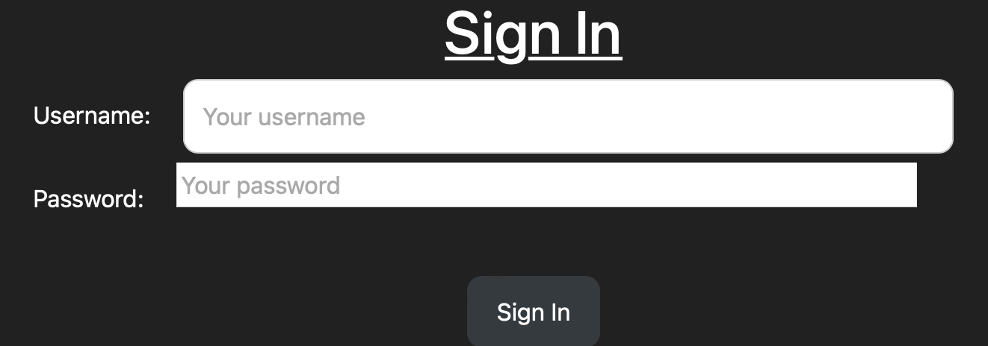

|  |
| --- |
| **Purpose of the test**: Here I will input no data so that we can check if the program can send the correct error message if there is no data in the text box |
| **Erroneous** |
| **Input data** Empty fields in both the username and the password section and then we press sign in |
| **Expected output:** There will be an error message that pops up saying that there are empty fields |
| **Actual output**   |
| **Pass** |
|  |
| **Purpose of test:** Input only the username and then check if the system can check that a certain field is empty |
| **Erroneous** |
| **Input data** username: pranay is inputted without the password |
| **Expected output.**  An alert box saying empty fields would pop up |
| **Actual output**   |
| **Pass** |
| **Purpose of test:** Check if there is a username that does not exist inputted then see if the system will say that the username does not exist |
| **Boundary** |
| **Input data**  Username: non_existent_user  Password: password   |
| **Expected output.**  The system would send out an alert saying that the user does not exist |
| **Actual output**   |
| **Pass** |
| **Purpose of test:** Check if the user will sign in if we give the correct username with the wrong password |
| **Boundary** |
| **Input data**  Username: pranay  Password: blablabla   |
| **Expected output.**  Sends output saying that the wrong password was given |
| **Actual outcome**   |
| **Pass** |
|  |
| **Purpose of test:** Check if the user would get redirected to the file page if they are signed in correctly |
| **Normal** |
| **Input data**  Username: pranay  Password: pass   |
| **Expected output.**  The user would be redirected to the file page |
| **Actual output**    Redirects to the file page |
| **Pass** |
|  |
| **Purpose of test**  Test if the data gets encrypted when the data is sent to the server |
| **Normal** |
| **Input data**  Username**:** pranay  Password: random_password   |
| **Expected data**  Data is encrypted into list of random numbers which was the result of encryption |
| **Actual output**  The console would output the data that was encrypted on the client side. This is represented in JSON. |
| **Pass** |
|  |
| **Purpose of test:** Check if you can access the file page if you are not signed in. |
| **Erroneous** |
| **Input data**  Input /file to the URL in the sign in page to try and access the file page. |
| **Expected output**  The program will redirect the user back to the sign in page, so that the user can sign in successfully. |
| **Actual output** Redirects back to the sign in page   |
| **Pass** |
|  |

Register feature

|  |
| --- |
| **Purpose of the test:** Check if the system would send back that the fields were empty |
| **Erroneous** |
| **Input data**  **Empty fields**   |
| **Expected output**  The system would return that the fields are empty |
| **Actual output**   |
| **Pass** |
|  |
| **Purpose of the test:** Check if when you input a username or password with less than five characters, the system would return an error |
| **Boundary** |
| **Input data**  Username: pra  Password: new_password |
| **Expected outcome**  The system would say that there are not enough characters in the field |
| **Actual outcome** The system detects that there is not enough characters and sends an error message |
| **Pass** |
|  |
| **Purpose of test:** Check if the system can detect if there are spaces in the fields |
| **Erroneous** |
| **Input data**  Username: pra nay  Password: lalala   |
| **Expected output**  The system will say that there are banned characters, which includes spaces |
| **Actual output** |
|  |
| **Pass** |
|  |
| **Purpose of test:** Check if the system detected if there are 18 or more characters in the field |
| **Input data**  Username: pranayvakaishereandhere (this is more than 18 characters)  Password: hihello   |
| **Expected output**  The system would say that there are too many characters in the field |
| **Actual output**   |
| **Pass** |
|  |
| **Purpose of test:** Check if we input the username that already exists in the register queue, how the system responds |
| **Erroneous** |
| **Input data**  First we put someone into the register requests queue  Username: nishant  Pranay: new_password  A picture containing text  Description automatically generated  Graphical user interface, application  Description automatically generated with medium confidence  The program says that it has been successfully added to the queue.  Then we input the same username again  Username: nishant  Password: any_password  A picture containing text  Description automatically generated |
| **Expected outcome**  The user is told that someone with that username already exists |
| **Actual outcome**   |
| **Pass** |
|  |
| **Purpose of test:** Check if when the user puts a username with a user that already exists in the credentials, it will alert the user that the username exists |
| **Erroneous** |
| **Input data**  Username: pranay  Password: some_password   |
| **Expected output**  System says that the user exists |
| **Actual output**   |
| **Pass** |
|  |
| **Purpose of test:** Check if when there are 10 people that have registered, the user will be prompted with an error that there have been too many people that have registered |
| **Boundary** |
| **Input data**  Already entered usernames all with the password: safe_password:   * firstuser * seconduser * thirduser * fourthuser * fifthuser * sixthuser * seventhuser * eightuser * ninthuser * tenthuser   Now we input the data:  Username: anand  Password: new_password  A picture containing graphical user interface  Description automatically generated |
| **Expected output**  The user will be prompted with register queue being full. |
| **Actual output**   |
|  |
| **Purpose of test:** Check if when a user that does not conflict any of the error checks, then it will say that the user has successfully updated |
| **Normal** |
| **Input data**  Username: nishant  Password: new_password   |
| **Expected output**  Will say that the username has successfully been added to the queue |
| **Actual output**   |
| **Pass** |
|  |
| **Purpose of test:** Check if the data that is sent from the register form is encrypted. |
| **Normal** |
| **Input data**  Username: nishant  Password: some_password |
| **Expected outcome.**  The user will successfully be added to the register queue and then we see the encrypted data on the console (I wrote a small function that outputs the encrypted values to the console for a test case.) |
| **Actual outcome**    **Encrypted output:** |
| **Pass** |

File sharing page

|  |
| --- |
| **Purpose of test:** Check if when download is pressed without any selected files, none of the data is uploaded |
| **Boundary** |
| **Input data**  None of the files are selected.    We then press download. |
| **Expected output.**  None of the files are changed. |
| **Pass** |
|  |
| **Purpose of test:** Check if when none of the files are selected and the delete button is pressed, none of the files are changed. |
| **Boundary** |
| **Input data**  None of the files are selected.  Then the delete button is pressed. |
| **Expected output.**  None of the files are changed. |
| **Actual output.** |
| **Pass** |
| **Purpose of test:** When files are selected and then download is pressed, check if the file that is downloaded is completely decompressed. |
| **Normal** |
| **Input data.**  queue.py and server.py is selected:  Then the download button is selected. |
| **Expected outcome.**  The files queue.py and server.py is downloaded and put in the downloads folder |
| **Actual outcome**  The files are downloaded to the Downloads folder on the client side.    Both files are decompressed completely as when we look inside, they have all their data. We can see inside the data in the following screenshots. |
| **Pass** |
|  |
| **Purpose of test**  Check if the user can delete multiple files of data using the delete button |
| **Normal** |
| **Input data**  Check the files queue.py and server.py. Then we select the delete button    Select the delete button. |
| **Expected output.**  The files will be deleted from displayed part of the files sharing page. |
| **Actual output**  All the files are deleted.  **Pass** |
|  |
| **Purpose of test:** Check if files within the payload size of 2MB is sent, the files is downloaded. |
| **Normal** |
| **Input data.**  flask_test.py is 516 bytes and so is within 2MB range. |
| **Expected output.**  The file flask_test.py is uploaded to the server and the website is updated |
| **Actual output.**    The file page is updated |
| **Pass** |
|  |
|  |
| **Purpose of test:** Check if the system does not send the file if the file that is sent in is greater than 2MB. |
| **Erroneous** |
| **Input data**  Input file chromedriver which is 14.7MB which is greater than 2MB. |
| **Expected output.**  The file is not updated to the file sharing system. |
| **Actual output** |
| **Pass** |
|  |
| **Purpose of test:** Check if a word document can be sent in |
| **Normal** |
| **Input data**  CPU Exercise.docx file that is 250KB file. |
| **Expected output.**  The file is uploaded to the file system. |
| **Actual output.**  File uploaded to the file system |
| **Pass** |
|  |
| **Purpose of test:** Check if when empty search query is sent, the all the current files are sent in. |
| **Normal** |
| **Input data**  The files beneath are already uploaded:   * flask_test.py * minecraft_terminal.c * Space Invaders.py * index.html   Search query is empty: |
| **Expected output.**  All the files that are uploaded will be showed again. |
| **Actual output.**  All the files that I uploaded before are showed here. |
| **Pass** |
|  |
| **Purpose of test:** Check if when the search query is filled with certain file type, that file type is sent in. |
| **Normal** |
| **Input data**  Same files as before is sent in.  Search query is py for python files. |
| **Expected output.**  The Space Invaders.py file and the flask_test.py file is returned. This is because they both have file in their name |
| **Actual output.** |
| **Pass** |
|  |
| **Purpose of test:** If there is a search query with spaces in between the letters in the query, check if the system returns the same files even if there weren’t spaces. |
| **Boundary** |
| **Input data**  Search query has “p y” to get all the python files. Should return the same files as the previous test. |
| **Expected output.**  The system will return the Space Invaders.py and flask_test.py. |
| **Actual output** |
| **Pass** |
|  |
| **Purpose of test:** Check if when search query with filename of file that does not exist is input, the system returns on files. |
| **Normal** |
| **Input data**  Search query: no_file |
| **Expected output.**  There are no files that are returned. |
| **Actual output**  No files are sent back. |
| **Pass** |

Register requests page.

|  |
| --- |
| **Purpose of test:** Check if the admin user can reject a user by pressing the reject button. |
| **Normal** |
| **Input data**  Register request: username: nishant  Password: new_password    The submit button is then pressed. |
| **Expected output.**  The user will be rejected, and the queue will be shown as empty. When you try and sign in with those credentials, they show as username does not exist. |
| **Actual output.**  When you try and sign in with the username nishant and password new_password, you get an error message. |
| **Pass** |
|  |
| **Purpose of test:** Check if you can sign in if the admin accepts the user request. |
| **Normal** |
| **Input data**  The submit button is then pressed |
| **Expected output.**  When the user signs in with nishant as the username and with the correct password, the user is validated and then redirected to the file page |
| **Actual output**  We then sign in and are redirected to the file page. |
| **Pass** |
|  |

Chatting page

|  |
| --- |
| **Purpose of test:** Check if when the message that is sent in is more than 800 characters, the system will put an alert message. |
| **Boundary** |
| **Input data**  Message = The FitnessGram Pacer Test is a multistage aerobic capacity test that progressively gets more difficult as it continues. The 20 meter pacer test will begin in 30 seconds. Line up at the start. The running speed starts slowly, but gets faster each minute after you hear this signal. [beep] A single lap should be completed each time you hear this sound. [ding] Remember to run in a straight line, and run as long as possible. The second time you fail to complete a lap before the sound, your test is over. The test will begin on the word start. On your mark, get ready, start.The FitnessGram Pacer Test is a multistage aerobic capacity test that progressively gets more difficult as it continues. The 20 meter pacer test will begin in 30 seconds. Line up at the start. The running speed starts slowly, but gets faster each minute after you hear this signal.  The input data is 857 characters and so is larger than 800 characters maximum. |
| **Expected output.**  An alert box saying that the message is greater than 800 characters will be put out. |
| **Actual output** |
| **Pass** |
|  |
| **Purpose of test:** Check if when normal message sent in, it is uploaded to the server and the live website along with the username and the datetime that it was sent. |
| **Normal** |
| **Input data**  Message: This is a test |
| **Expected output.**  The website would be uploaded with the message, along with the metadata |
| **Actual output.**  The message is clearly uploaded along with the metadata. |
| **Pass** |

|  |
| --- |
| **Purpose of test:** Test objective 7.1 and see if the file that my client sent me will compress within 3 milliseconds |
| **Normal** |
| **Input data**  I wrote a small function that checks the time at the beginning of the function and the end of the function, then returns the time elapsed.  Upload the coding_file.txt to the server and see the time it takes. |
| **Expected output.**  The time taken for the file to upload is less than 3 milliseconds |
| **Actual output**  The file is uploaded to the database.    The time taken is about 0.03 seconds, which is more than 3 milliseconds, meaning that the test is failed |
| **Fail** |
|  |
| **Purpose of test:** Check if the compressed version of the file coding_file.txt is less than 70% of the original file size. Checking objective 7.2 |
| **Input data**  I wrote a function that outputs that number of bytes that the file takes by counting the sets of 8 bits that are there.  Upload the file coding_file.txt |
| **Expected output.**  The original coding_file.txt is 8000 bytes, so the compressed would be at least less than 70% of this. |
| **Actual output**    The actual output of the function is 4386 bytes of the compressed format.  We can calculate the percentage of the original file that this is:  (4386 / 8000) * 100 = 54.825  So, the compressed file is 54.825% of the original file, meaning that it is compressed to well under the 70% that we were expecting. |
| **Pass** |
|  |
| **Purpose of test:** Check objective 7.3 and see if a file over 1 MB file can be compressed in under 20 milliseconds |
| **Input data**  Diagram.docx which is 1.6MB |
| **Expected output.**  Data will compress within 20 milliseconds |
| **Actual output**  Takes about 52 milliseconds, which is longer than we were hoping for |
| **Fail** (takes too long) |
|  |
| **Purpose of test:** Check if objective 8.1 is fulfilled by seeing if the keys that are generated are random each time. |
| **Normal** |
| **Input data**  Restart the server 3 times and see if each time the keys are different. |
| **Expected output.**  The encryption keys will vary. |
| **Actual output**  As you can see, the public and the private keys that are generated are different each time, so is secure. |
|  |
| **Purpose of test:** Check if time it takes to generate each set of keys is less than 3 milliseconds. This is checking objective 8.2 |
| **Normal** |
| **Input data**  Restart the server 3 times and use the timing function I wrote to calculate the time taken to create the keys. |
| **Expected output.**  The time will take less than 3 milliseconds on average |
| **Actual output**  Therefore, the average time is 0.0023107528686523438.  Which is less than 3 milliseconds on average |
| **Pass** |

Check if the hyperlinks work correctly.

|  |
| --- |
| **Purpose of test:** Check if each of the hyperlinks go to their corresponding page once you sign in. Also, check if you cannot access the register requests page when signed in as a general user. |
| **Test link: youtu.be/xKTZxprwoWs** (including commentary) |
| **Pass** |

Check if more than two users of different privileges can sign in, chat together, upload files at the same time.

|  |
| --- |
| **Purpose of test:** Test objective 9 and see if different users can access the server at the same time. |
| **Test link: youtu.be/XmksouYZr8M** (including commentary) |
| **Pass** |

Evaluation

To analyse how my project went, I will get another source of opinion, my client. I will then take the advice that my user has given me and alongside my own opinion of how the project went and then create a set of proposed solutions for them.

First, we start with the client feedback. This was done by talking to my client face to face and showing them the program that I made. I gave him some time to analyse the program while showing the different features that he asked for.

I then asked him a set of questions for the different objectives for the program and he then gave me some feedback that I will use.

*Did the sign in page fall within your expectations of the program, can you suggest any future improvements to the program?*

For the sign in page, I was happy to see that there was a sign in page and register feature that I requested for. This includes the sign in feature for the program. The error messages are very clear and concise, telling the user what went wrong within the program. However, because you asked me, in the future what you could include is a counter that counts how many times that the user has requested has tried to sign into the program with false data. You can then take this counter and if it is higher than a certain amount, then you can lock of that account for security or maybe now allow that computer to try and login to the server for a given amount of time. I am thinking how like an when you try and sign into an iPhone too many times with the wrong credentials, then you cannot sign in for a certain amount of time.

The submit buttons are well placed and I can easily tell which of the buttons does what. The fact that they are in the middle of the screen makes it a lot clearer.

The register section seems good. I am pleased to see that there are some checks that are done before the register credentials are sent into the queue. The idea of using a circular queue to prevent wastage of space on the server was a great idea and means that too many people can’t try to register at once and clog up the server, increasing latency. However, I would have gone a step further and given the admin users privilege for how many people can register at once. This would be like a setting that the admins would only have access to and would mean that they can choose between 10 people registering at once and 100 users registering at once.

Overall, the sign in page seems great and I am happy with the way that the validation works.

*How did you find the file sharing page, what was it like to upload the files and update different things?*

For the file sharing page, I am happy that the files are represented on the side of the file sharing system. The fact that there is the username and datetime that it was sent at makes this a lot easier to use and makes identifying who sent the data and when it was sent a lot easier.

The design of the page is very nice. The fact that the actual files and the file operations are separated makes it clear how to manipulate the database.

The checkboxes part of the GUI is very nice as I can easily select which of the files an operation must be completed on such as download and delete.

I know that you compress the file and when we download the data, I am happy to see that they are downloaded completely decompressed and available in my downloads folder. This makes moving files very easy. Deleting the data is almost instant and the websites database is updated for all the users.

However, when it comes to files larger than 1MB, the time that it takes to upload the files is quite long and so maybe you could make some changes to the algorithm so that it becomes more efficient.

Searching through the database work great. For the work I am doing, I usually need to query for files of a certain file type such as py or txt, so being able to search for there in the database and then downloading them makes the process a lot easier. I can tell that you use regular expression for this, and this makes it a lot better as I can search for data in the database with search queries without needing to worry if the characters are capital or not.

For future improvements, you could add a feature where there are different file types where one can be changed by every user and another file type that can only be changed by the person that submitted the file.

Another improvement that can be done is that you should be able to sort the files based on date and time and alphabetically.

Overall, I am happy how the files are organised and how the file sharing system works. The compression works great, and I can see in your testing that my code file that I have sent in was compressed to nearly half of the original bitlength. This would save my company a lot of money on server space.

*How was the register requests page work, how did you find that section of the program?*

I was happy to see that the register requests page worked well and that there was validation to check if the user was an admin user before they could do the operations for the register requests.

The way that the register request was positioned was great for me and I was happy that the user could clearly see the username that was being ticked off in the middle of in the middle of the screen. As I mentioned before, perhaps a setting to change the number of users that can apply at once would be quite useful, rather than hard coding it to 10 people. For this you should probably make a settings page for the admins to access and change values.

*How did you find the chatting application, could you suggest some improvements?*

The chatting application seems to be working great. When the user uploads a certain message, the live chatting feed changed for all the users that have signed in. I like that you added metadata for the other users to see such as the date and time that the message was sent in. I was surprised that the messages were sent so quick as I thought that the encryption algorithm that you used would create a delay in sending the messages.

The positioning of all the messages is quite nice and the grey and black background is quite easy on the eyes, so would be great for the team.

One of the improvements that you could make is to make a separate room for just the admins and one for all the general and the admin users. This is because the admins are probably the higher-ranking people in the team and so would need to have their own private conversations. This would mean that the admins would have another privilege that the general user does not have which is access to all rooms, while the general user would only have access to some rooms.

Evaluation and future improvements.

Evaluating the sign in feature

For the sign in feature, I happy for how the sign in feature works and how it is designed. The fact that I was able to get the lookup for usernames and passwords is O (1) by using a hash function instead of O(n) for the linear search makes the sign in process for the user a lot quicker and takes less time for the clients to sign in. This means that the client is also using less CPU time and means that it decreases latency for the user.

However, there are two things that could have been changed, one that my client suggested and one that was my own idea. For my client’s idea, he said that I should have a counter that counts how many times a client has tried to sign in and then times out the system so that the client must wait to sign in. Taking this idea, I thought of creating a pseudocode design for this so that I have an idea later how to code this.

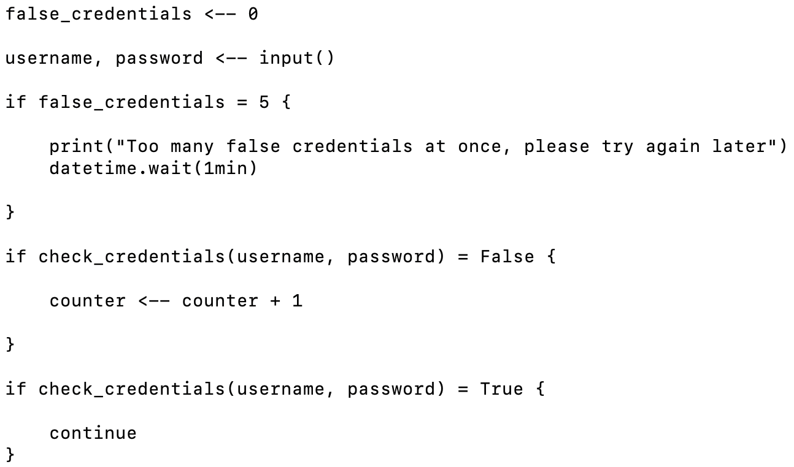

This would be implemented in the second iteration of my project. There is another addition that I was considering using, which is changing the hash function. My current hash function is a variation of the string folding method, where I take the decimal value for each of the characters in the string, multiply them by each other and then find the modulus with the table length. The problem here is that there could be an overflow error for large values greater than 32 bits, so if I expand the program to take usernames that multiply to get orders larger than this, it could cause an overflow error, meaning that some of the larger bits would not contribute to the final value.

Another solution to this would be to write a different hash function which is known as the mid square method. In this case, we would add the decimal values of the characters together and then square it, which would most likely be less than 32 bits. Then we find the middle three digits in this result, giving us the new hash value. This would overcome the chance of their being an overflow error like the string folding method.

Evaluating the register feature

The register feature works well. It takes the username and the password from the client side and does the appropriate checks on the data to make sure that it can be stored in the credentials database. The encryption works and so the encryption is secure from end to end. However, my client hash told me that to improve the register feature, he wants the admin to be able to control how many people can register at once, therefore changing the length of the circular queue in settings so that different numbers of users can be registered at once. This length needs to be accessible to every admin user and will be only one value, so should be stored in a small JSON file.

Here is the pseudocode for such an implementation.

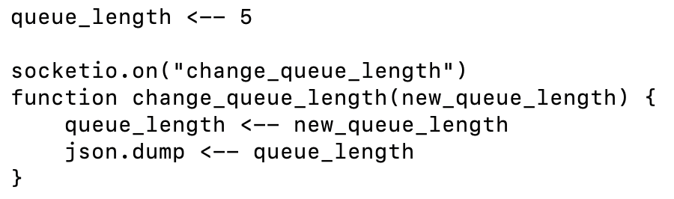This would take the queue length, update the current queue length, and then save it to the JSON file.

Evaluating the file sharing page

For the file sharing page, I seemed to have been able to complete the objectives that I had lined out for myself. The file that was saved was compressed and could decompress just fine. This was saves into an SQL database with a randomly generated id, making accessing the file easy. The metadata was saved and then paired up with its corresponding file. The download and delete functionality words and did their operations quickly, meaning that the server had low latency. However, as my client had mentioned, the uploading of the data took a long time for files that were larger than 1MB. To change this, I could make the Huffman compression algorithm more efficient for the next iteration. There are many ways for Huffman compression to be optimised, but one of the methods is the adaptive Huffman compression.

In my version of Huffman compression, the data is taken in, the probabilities are calculated and then we create the tree. To increase the efficiency of the compression, we could take the data that is to be compressed and then create the tree in small blocks. If the frequency of the characters changes when we go to the next block, the frequency tree changes slightly. This means that we don’t just wait for the entire frequency of the data to be calculated, we make the tree and then we vary it.

Along with this optimisation of the Huffman compression algorithm, we can increase the compression by using run length encoding on the coding. Because all the data that is compressed is in 1s and 0s, we could take this and then create a run length encoding as there is lots of repeated data.

Here is the pseudocode implementation of this.

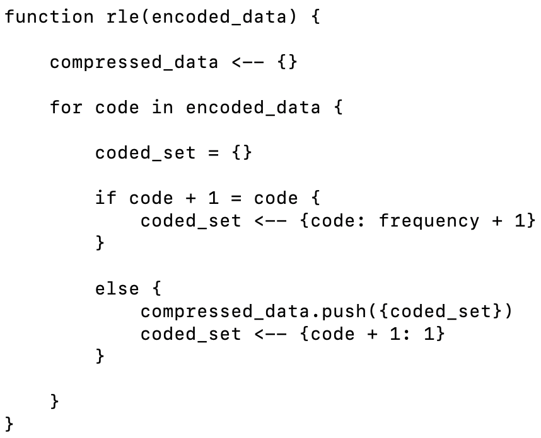Another improvement that my client has suggested is to make a feature where the user can choose if they want to upload a file that can changed by anyone or just them. This a form of private files, so to make this in the future, I would probably make it into a class so that it can be checked if it’s a private or a public file. Here is the pseudocode for this.

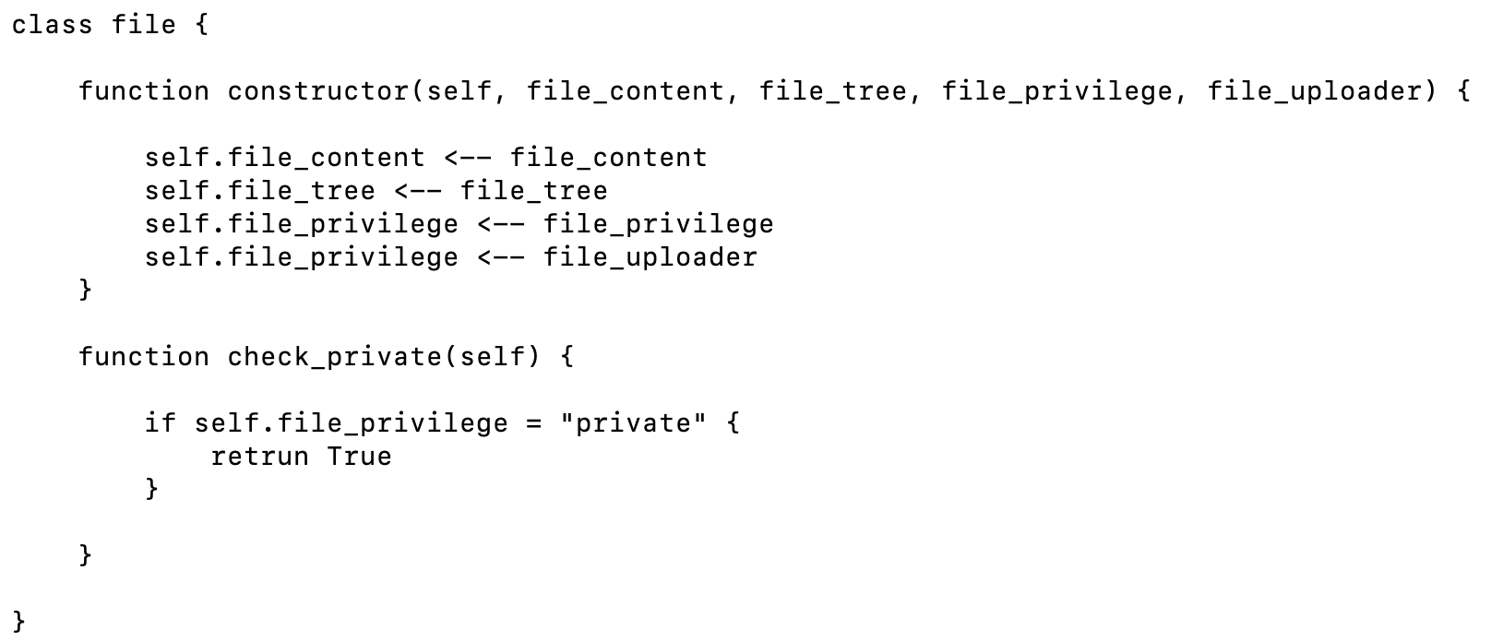The new file will be created in the following class. If the file privilege is private then the function check_private will return true and then means that any operation done to it that is by someone that does not have the file uploader username, will not be executed.

The final update for the file sharing system that my client has suggested is being able to order the database based on the datetime or alphabetically based on the username of the person sending it in. To do this we could take the merge sort algorithm that I made and change it so that we sort the flies based on the usernames and the date that it was sent.

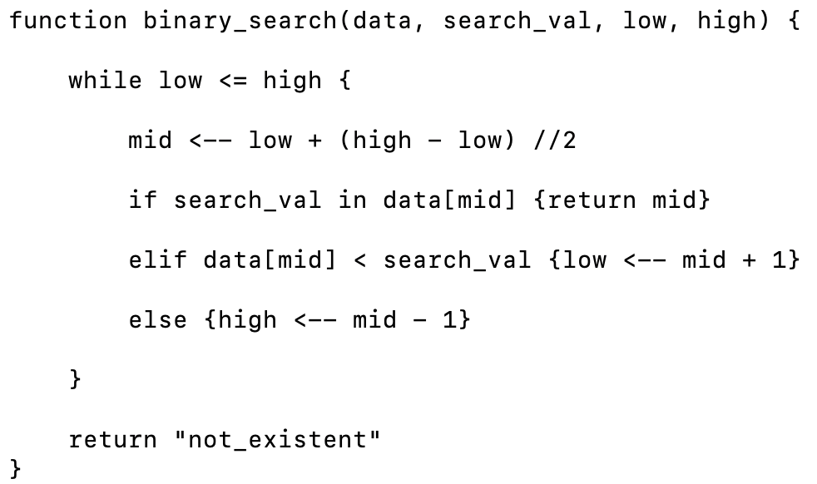The search query feature works well and allows for the user to input a search query and using regular expression, it takes the filename and searches for the file name that matches. However, my current implementation uses the linear search method, which has O(n) time complexity. To optimise this, we could use binary search to get the value, where the time complexity is O(log(n)). This is much quicker and so I will write the pseudocode for this.

Evaluating the register requests feature

For the register requests page, the queue data structure works great. Every time that admin wants to accept or reject a user, there are well placed buttons for the user to press and send in data. Every time a decision is made on the register request it cycles to the next user and makes sure that if there is no one in the queue, it will be displayed as such. This is quick and efficient. I have already talked about making a feature to change the length of the register queue in the evaluation of the register part.

Evaluating the chatting page

The chatting page works well. The messages are updated live on the website if the message is sent in by another user. This means the WebSocket works correctly. The correct meta data for the message including the username of the person that sent it and the date and time of the person that sent it renders correctly. The end-to-end encryption works correctly and the message that is sent from the client is recorder correctly by the database.

My client has suggested one improvement for the future of the software which is to make a separate room for the admins that the general users cannot access. This can be done by inheriting from the pre-existing room class that I use to generate the room and add new properties and methods. A method that I would add is a privilege checker that checks if the privilege of the user that is trying to join is admin or not. If the user is admin, then they are allowed to join to the room, else they are alerted that they do not have admin privileges. Here is the pseudocode for this type of class.

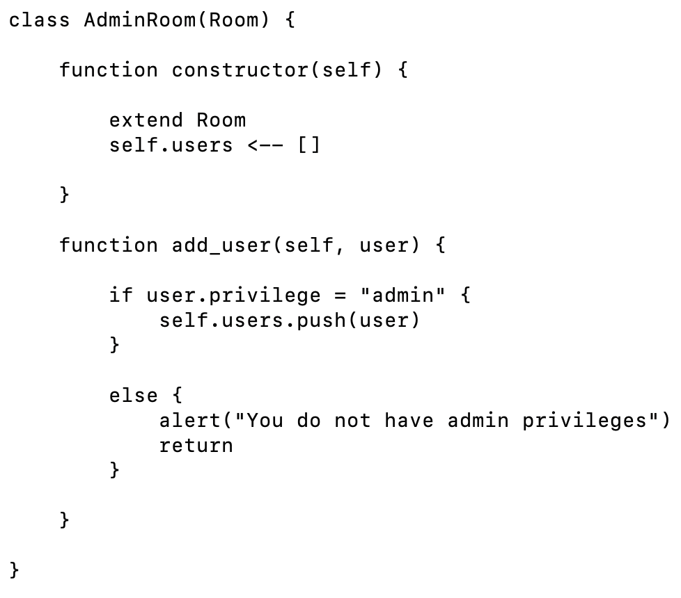

Evaluating the encryption algorithm.

For the encryption algorithm, the data is encrypted and decrypted from end-to-end making the security of the algorithm quite strong. The fact that there is no key exchange of a key that could decrypt the data means that the encryption algorithm is even stronger.

However, there are multiple things that we can do to improve the strength of the RSA key generation algorithm.

On example is if the two prime numbers generated (p and q) are too close to each other. If n is p * q then if p - q is less than 2n1/4, p and q would be easily retrievable using something known as Pollard’s p-1 algorithm. There is some small amount of pseudocode that I can write to make sure that this does not happen.

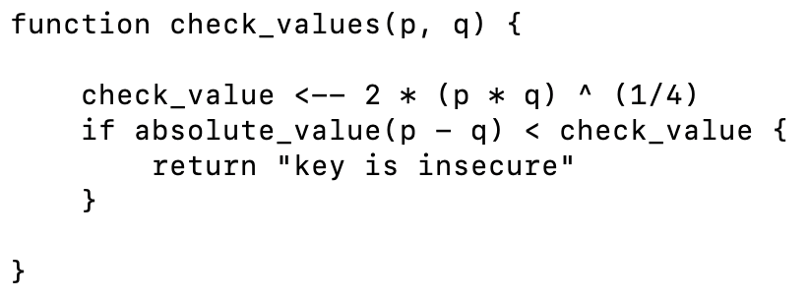Another check for the security of this encryption program is to instead use a deterministic algorithm to find prime numbers. The current algorithm that we are using is the Miller-Rabin primality test which only returns if the number is not prime or probably not prime. To improve the security of this program, we could use the Lucas-Lehmer primality test which guarantees if a number is prime or not. Here is the pseudocode of such a program.

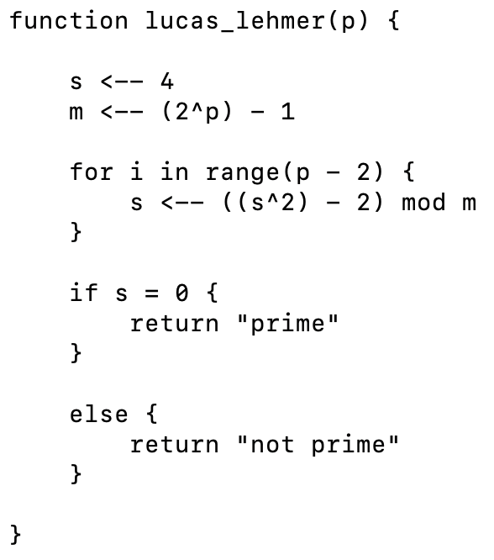

**References**

**RSA encryption algorithm references:**

* <https://en.wikipedia.org/wiki/RSA_(cryptosystem)>
* <https://gist.github.com/Ayrx/5884790> (Miller-Rabin method in python)

**Huffman compression algorithm references:**

* <https://towardsdatascience.com/huffman-encoding-python-implementation-8448c3654328> (this paper was used to understand the concept behind Huffman compression.)
* <https://en.wikipedia.org/wiki/Huffman_coding> (the theory behind Huffman compression)

**Merge sort algorithm:**

* <https://en.wikipedia.org/wiki/Merge_sort>
* <https://www.geeksforgeeks.org/merge-sort/>

**Client server model research:**

* <https://flask-socketio.readthedocs.io/en/latest/> (documentation for flask-socketio)
* <https://en.wikipedia.org/wiki/Client–server_model> (documentation for client server model)
* <https://www.w3schools.com/js/js_events.asp> (JavaScript events)

**SQL database documentation:**

* <https://www.tutorialspoint.com/sqlite/sqlite_python.htm>

**Hash table research:**

* <https://en.wikipedia.org/wiki/Hash_function> (Wikipedia article for how the hash table works and dealing with collisions)